When you sit, Leave space between your neighbors

No Phone or Internet Use during the Exam

Use only a Calculator and a pen or pencil

You may tear the first page.

PHYS 201 Test #2 Name:\_\_\_\_\_\_\_\_\_\_\_\_\_\_\_\_\_\_\_\_\_\_\_\_\_\_\_\_\_\_\_\_\_\_

|  |  |  |  |  |  |
| --- | --- | --- | --- | --- | --- |
| 1. | 2. | 3. | 4. | 5. | Newton’s 2nd Law |
| $$x=\overline{v} t$$ | $$x=\frac{1}{2}\left(v_{0}+v\right)t$$ | $$v=v_{0}+at$$ | $$x=v_{0}t+\frac{1}{2}at^{2}$$ | $$v^{2}=v_{0}^{2}+2ax$$ | $$\sum{\vec{F}}=m\vec{a}$$ |

Force of friction:    
Acceleration due to gravity = g = 9.8 m/s2.

Newton’s law of gravitation is given by: 

Centripetal force is given by, 

Kinetic Energy is given by, 

Potential Energy is given by, 

Work done by a Force,    
  
Power = Work/Time.

Work-Energy Theorem: 

Linear momentum of an object of mass, *m* and velocity, ***v*** is given by: ***p*** = *m* x***v***.

Impulse is defined as the product of the force and time, ***J* = *F***x *t*.

Impulse-Momentum Theorem: 

Area of a triangle = 

**PHYS 201 Test #2 F 2018 Name:\_\_\_\_\_\_\_\_\_\_\_\_\_\_\_\_\_\_\_\_\_\_\_\_\_\_**

A. Select the correct answer for the following multiple choice questions and write your answer in the line next to the question number.

\_\_\_\_1. Which one of the following is Newton’s third law motion?

\_\_\_\_2. Which one of the following is Newton’s law of universal gravitation?

Answers for 1-2

a. Every particle in the universe exerts a repulsive force on every other particle

b. Every particle in the universe exerts an attractive force on every other particle

c. An object will remain in a state of rest or of uniform motion in a straight line unless acted on by an outside net force.

d. The net force acting on an object is equals to the product of the mass of the object and the acceleration of the object.

e. When one object exerts a force on a second object, the second object exerts a force on the first that has an equal magnitude but opposite direction.

f. Frictional forces are in the opposite direction of motion.

\_\_\_\_3. Which one of the following is a unit for work?  
\_\_\_\_4. Which one of the following is a unit for impulse?

Answers for 3-4  
a. kg.m2/s2 b. kg/(m.s2) c. kg.m/s2 d. kg.m2/s3 e. kg.m/s3 f. kg.m/s

\_\_\_\_5. Which one of the following is a non-contact force?

a. pushing b. static frictional force c. Tension   
 d. kinetic frictional force e. normal force f. gravitational force

\_\_\_\_6. Which one of the following is an example for a conservative force?

a. electric force b. frictional force c. pushing

d. pulling e. tension in a cord

\_\_\_\_7. Which one of the following is a vector?  
a. Impulse b. Work c. Energy d. Density e. Power

\_\_\_\_8. What provides the centripetal force for a car moving around a flat-curve?  
\_\_\_\_9. What provides the centripetal force for a satellite circling the Earth?  
Answers for 8-9  
a. Normal force b. Kinetic frictional force  
c. Static frictional force d. Gravitational force

\_\_\_\_10. Which one of the following terms is used to indicate the natural tendency of an object to remain at rest or in motion at a constant speed along a straight line?  
a. Velocity b. Speed c. Inertia d. Force e. Acceleration

\_\_\_\_11. What is represented by the slope of the Work VS. Time, graph?

a. Impulse b. Work c. Energy d. Density e. Power

\_\_\_\_12. What is represented by the area under a Force VS. Time, graph?

1. Velocity b. Acceleration c. Work d. Impulse e. Displacement

13-15) A net external [force](javascript:parent.xlinkeyword('u0007')) is applied to a 55.0-kg object that is initially at rest by means of a motor. The net force [component](javascript:parent.xlinkeyword('u0002')) along the [displacement](javascript:parent.xlinkeyword('u0005')) of the object varies with the magnitude of the displacement as shown in the drawing.

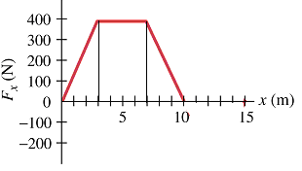

\_\_\_\_13. What is the maximum net external force applied?

a. 0 N b. 10 N c. 200 N d. 300 N e. 400 N

\_\_\_\_14. How much [work](javascript:parent.xlinkeyword('u0010')) is done by the motor in moving the object from 0 to 10.0 m?  
a. 600 J b. 1200 J c. 1600 J d. 2800 J e. 4000 J

\_\_\_\_15. What is the speed of the object after the above force is applied?  
a. 7.63 m/s b. 10.1 m/s c. 12.1 m/s d. 58.2 m/s e. 102 m/s

\_\_\_\_16. Which one of the following energy transformation takes place in a light bulb?  
a. Radiant energy is converted into electrical energy

b. Electrical energy is converted into mechanical energy

c. Radiant energy is converted into thermal energy

d. Mechanical energy is converted into electrical energy  
e. Electrical energy is converted into radiant energy

\_\_\_\_17. Estimate the cost of electricity for operating ten 9-W LED light bulbs for 4 hours a day for 20 days a month for one year. Assume a cost of 9 cents per kWh.

a. $ 0.39 b. $ 0.65 c. $ 0.78 d. $ 0.86 e. $ 1.95 f. $7.78 g. $778

\_\_\_\_18. Two masses (2-kg and 5-kg) are attached by a massless cord



passing over a massless, frictionless pulley of an Atwood's machine

and released. What will be the acceleration of the masses?  
a. 0.43 m/s2 b. 4.2 m/s2 c. 5.88 m/s2

d. 1.96 m/s2 e. 9.8 m/s2 f. 2.8 m/s2

\_\_\_\_19. What is the angle between the acceleration and velocity of an object in uniform circular motion?   
a. 0 b. 300 c. 450 d. 900 e. 1800

\_\_\_\_20. A car is turning along a banked-frictionless exit ramp. Draw a free-body diagram for the car, weight = W and normal force = N, in the diagram on right.

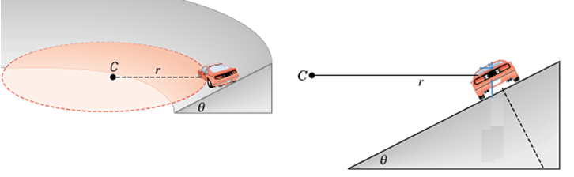

\_\_\_\_21. Identify the centripetal force for the above question:  
a. W b. W Cos θ c. W Sin θ d. N Cosθ e. N Sinθ

|  |  |
| --- | --- |
| \_\_\_\_22. Two cars are traveling at the same constant speed *v*. Car A is moving along a straight section of the road, while B is rounding a circular turn. Which statement is true about the acceleration of the cars? | sat_c05_q1_01_1 |

|  |  |
| --- | --- |
| a. | The acceleration of both cars is zero, since they are traveling at a constant speed. |

|  |  |
| --- | --- |
| b. | Car A is accelerating, but car B is not accelerating. |

|  |  |
| --- | --- |
| c. | Car A is not accelerating, but car B is accelerating. |

|  |  |
| --- | --- |
| d. | Both cars are accelerating. |

Newton’s law of gravitation is given:    
23. Define weight.\_\_\_\_\_\_\_\_\_\_\_\_\_\_\_\_\_\_\_\_\_\_\_\_\_\_\_\_\_\_\_\_\_\_\_\_\_\_\_\_\_\_\_\_\_\_\_\_\_\_\_\_\_

\_\_\_\_24. Express the SI unit of G in terms of kg, m, s.  
a. kg.m2/s2 b. m3/(kg.s2) c. kg.m/s2 d. kg.m2/s3 e. kg.m/s3 f. kg.m/s

\_\_\_\_25. In another solar system a planet has twice the earth's mass and half the earth's radius. Your weight on this planet is \_\_\_\_\_\_\_ times your earth-weight. Assume that the masses of the earth and the other planet are uniformly distributed.   
a. 1 b. 2 c. 3 d. 4 e. 8   
\_\_\_\_\_\_\_\_\_\_\_\_\_\_\_\_\_\_\_\_\_\_\_\_\_\_\_\_\_\_\_\_\_\_\_\_\_\_\_\_\_\_\_\_\_\_\_\_\_\_\_\_\_\_\_\_\_\_End of MC questions

B. Calculate the surface gravity for an unknown planet whose mass = 4.18 x 1024Kg, and radius = 5052 km.

C. A 65-kg package is pulled along a horizontal surface at a constant velocity. The pulling force has a magnitude, F = 95 N, which is applied at a 250 angle as shown below. Frictional force is also present.   
1. Draw a free-body diagram for the package.  
2. Resolve the 95-N force into horizontal and vertical components, in the diagram.  
3. Determine the normal force.  
4. Determine the frictional force.  
5. Determine the coefficient of kinetic friction between the box and surface.

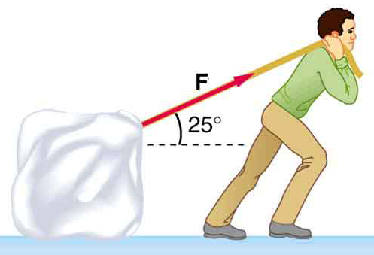

D. Starting from rest, a student of mass 45 kg, is jumping off a platform and gaining a vertical jump velocity of 5.5 m/s. During this jump her center of mass moves through a vertical distance of 0.65 m.   
1. How long she is in contact with the platform?

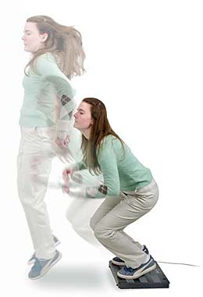

2. What is her acceleration during the jump?

3. What is the magnitude and direction of the force exerted on her?

4. What is the impulse exerted on her?

5. What is the magnitude and direction of the force is exerted on the platform?

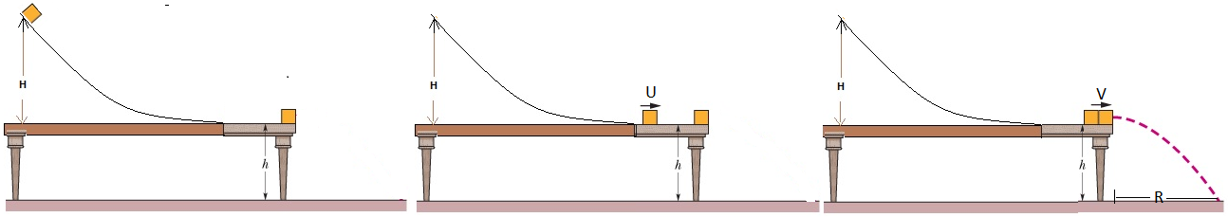

E. In the figure above, a 3.0 kg block slides down a frictionless track, height H = 0.70 m, and collides with a 2.0 kg block at rest on the edge of the table, height *h* = 0.50 m. The two blocks stick together after the collision, and travel, as shown above, and strikes the floor. (Acceleration due to gravity = 9.8 m/s2, down)  
  
1. Using the conservation of mechanical energy, find the velocity (U) of the 3.0 kg block, as it comes to the bottom of the track.

2. Using the conservation of momentum, find the speed of the combined blocks (V), just after the impact.

(Projectile Motion)  
3. How long the blocks are in the air?

4. How far from the edge of the table (R), horizontally, the blocks will strike the floor?

F. A 34.0-kg skater is moving due east at a speed of 3.50 m/s. A 46.0-kg skater is moving due south at a speed of 2.80 m/s. They collide and hold on to each other after the collision.  
  
1. Sketch a diagram of the above situation, showing the skaters before and after the collision.  
  
2. What type is this collision?\_\_\_\_\_\_\_\_\_\_\_\_\_\_\_\_\_\_\_\_\_\_\_\_\_\_\_\_\_\_  
  
3. What quantity is conserved in this collision?\_\_\_\_\_\_\_\_\_\_\_\_\_\_\_\_\_

4. Find the velocity (speed and direction) of the skaters after the collision, assuming that friction can be ignored.  
  
5. Calculate the energy loss during this collision.