When you sit, Leave space between your neighbors.
No Phone or Internet Use during the Exam.
Use only a Calculator and a pen or pencil.
Tear this page and use it as your worksheet for MC questions. For the open ended questions/problems show your work in the space provided under the question/problem.

PHYS 201 Fall 2016 Test #1 Name:_________________________
A. Select the correct answer for the following multiple choice questions and write your answer in the line next to the question number.

____1. What is the SI base unit for temperature?
a. kg b. K c. ⁰C d. ⁰F e. g

____2. Today, the standard kilogram is defined in terms of
  - the distance from the earth’s equator to the north pole
  - the electromagnetic waves emitted by cesium-133 atoms
  - a standard platinum-iridium cylinder
  - the speed of light e. the speed of sound

____3. Which one of the following is a SI derived unit?
a. kg b. cm³ c. mol d. A e. m³
____4. Imagine you measure the length of a stick 5 times and obtain the following measurements: 4.40 m, 4.43m, 4.47m, 4.39m, and 4.30m. The stick’s actual length is 5.80 m. How would you characterize the accuracy and precision of your measurements?
a. high accuracy, high precision b. high accuracy, low precision
c. low accuracy, high precision d. low accuracy, low precision
____5. The speed limit on a college campus is 25 MPH. When a student drives her car at the speed limit, how far she will go in two seconds? (1 M = 1609 m and 1 H = 3600 s)
a. 11 m b. 22 m c. 25 m d. 50 m e. 56 m
____6. Which one of the following is a scalar?
a. distance b. displacement c. acceleration d. velocity e. weight

____7. What is the angle between the vectors A and -2A when they are drawn from a common origin?
a. 0⁰ b. 90⁰ c. 180⁰ d. 270⁰ e. 360⁰
____8. A rifle, at a height H above the ground, fires a bullet (A) parallel to the ground. At the same instant and at the same height, a second bullet (B) is dropped from rest. In the absence of air resistance, which bullet strikes the ground first?
a. A b. B c. both at the same time
____9. In the above question which bullet will have the greater speed at the ground level?
Answers for 8 & 9
a. A b. B c. both will have the same speed
_____10. Speeding tickets are issued using which one of the following?
a. Average velocity b. Instantaneous velocity
c. Average speed d. Instantaneous speed
____11. A person is jogging along a straight line, and her displacement is denoted by the vector A in the drawings below. Which drawing represents the correct vector components, A_{x} and A_{y}, for the vector A?
a. | b. | c. | d.
_____12. A person looking out the window of a stationary train notices that raindrops are falling vertically down at a speed of relative to the ground. When the train moves at a constant velocity, the raindrops make an angle of when they move past the window, as the drawing shows. How fast is the train moving?
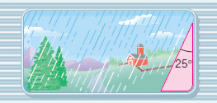
a. 2.1 m/s b. 2.3 m/s
c. 4.5 m/s d. 5.0 m/s

_____13. In the graph below, at which point is velocity zero?
- a
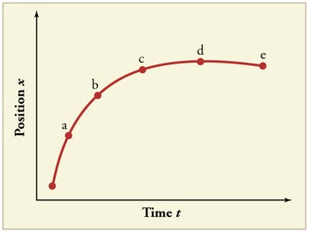
- b
- c
- d
_____14. For the motion described in the graph,
decide whether the moving object is
a) accelerating
b) decelerating
c) moving at a constant velocity
d) moving at a constant speed
____15. In which of the following equations the units on the left side is not consistent with the units on the right side? (t = time, x = displacement, v = velocity, a = acceleration)
a. b. v² = 3ax c. d. x = vt e. v = at
_____16. Acceleration is defined as,
a. Rate at which the speed changes
b. Rate at which the velocity changes
c. Rate at which the position changes
d. Rate at which the distance changes
e. Rate at which the displacement changes
17-22) Deal with the one-dimensional motion of an object, for which the velocity is graphed as a function of time, below.
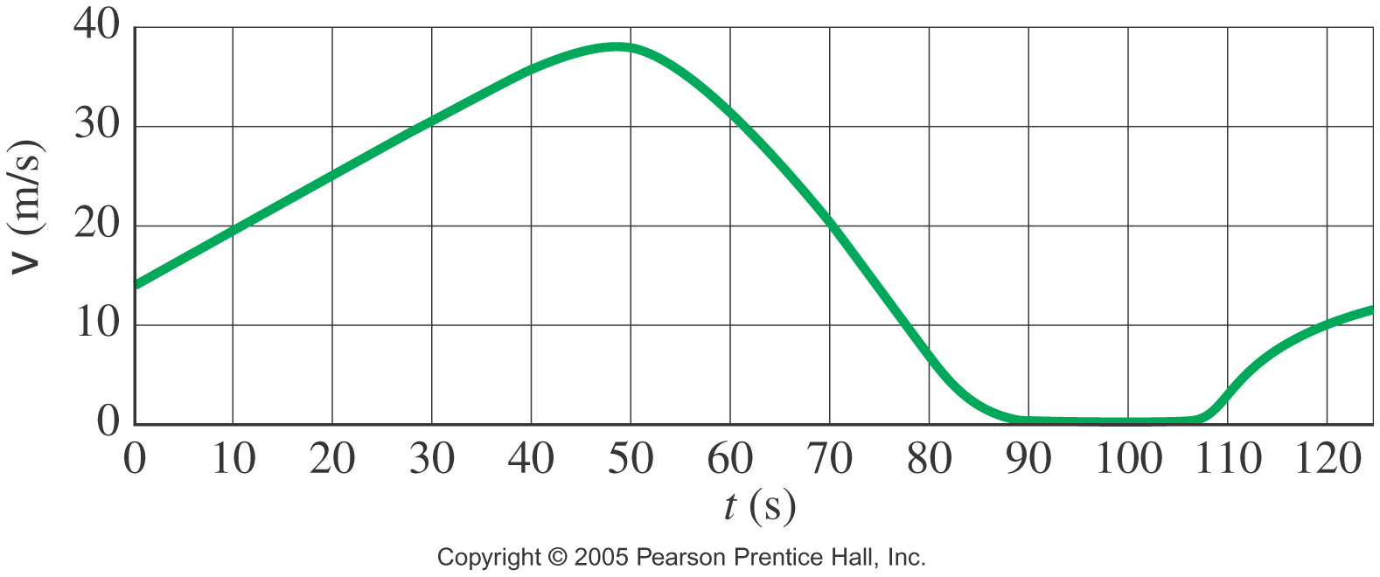

___17. The above graph is,
a. time versus velocity b. velocity versus time
___18. What is the instantaneous velocity of the object at 20 s?
a. 0 m/s b. 20 m/s c. 25 m/s d. 30 m/s e. 38 m/s
____19. What is the instantaneous acceleration of the object at 20 s?
a. 0 m/s² b. 0.5 m/s² c. 1.0 m/s² d. 10 m/s² e. 25 m/s²
____20. What is the average acceleration of the object during the time interval 70-90 s?
a. 0 m/s² b. 0.5 m/s² c. 1.0 m/s² d. -1.0 m/s² e. -2.0 m/s²
____21. Approximately how far the object travels during the first 100 seconds?
a. 0 m b. 100 m c. 1000 m d. 1500 m e. 2000 m
___22. What is happening to the velocity from 110 to 120 s?
___23. What is happening to the acceleration from 110 to 120 s?
a. increasing b. decreasing c. stay the same

B. A mountain-climbing expedition establishes two intermediate camps, labeled and in the drawing, above the base camp. What is the magnitude and direction of , the displacement between camp and camp ?
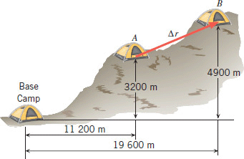

C. For the three vectors shown below (magnitudes: A = 14, B = 18, C = 15) complete the table:
Vector | X-component | Y-component
A
B
C
A + B + C

D. Equations of Kinematics for constant acceleration are given below:
1. | 2. | 3. | 4. | 5.
$$x=\overline{v} t$$ | $$x=\frac{1}{2}\left(v_{0}+v\right)t$$ | $$v=v_{0}+at$$ | $$x=v_{0}t+\frac{1}{2}at^{2}$$ | $$v^{2}=v_{0}^{2}+2ax$$
1. Derive the 4th equations using the equations 2 & 3.

2. A car is traveling at 25 m/s, and the driver sees a traffic light turn red. After 0.45 s (the reaction time), the driver applies the brakes, and the car is brought to rest in another 3.5 s. What is the stopping distance of the car, as measured from the point where the driver first sees the red light?

3. An astronaut on a distant planet wants to determine its acceleration due to gravity. The astronaut throws a rock straight up with a velocity of + 16.0 m/s and measures a time of 27.6 s before the rock returns to his hand.
a. What is the acceleration due to gravity on this planet?
b. Sketch the velocity VS. time graph, for the motion.

1. | 2. | 3. | 4. | 5.
$$y=\overline{v} t$$ | $$y=\frac{1}{2}\left(v_{0}+v\right)t$$ | $$v=v_{0}+at$$ | $$y=v_{0}t+\frac{1}{2}at^{2}$$ | $$v^{2}=v_{0}^{2}+2ay$$
E. A basketball is shot with an initial velocity 18.0 m/s at a launch angle of 35.0⁰, which follows the trajectory shown. The hoop’s vertical height from the launch point, y = 3.50 m. Ignore air resistance. The acceleration due to gravity = 9.8 m/s², down.
1. Find the horizontal and vertical components of the
initial velocity, V_{ox} and V_{oy.}
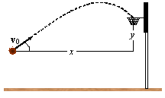

2. What is the vertical velocity of the basketball at the hoop?

3. What is the hang time of this shot?

4. What is the hoop’s horizontal distance from launch point, x = ?

5. How much time it takes to reach the highest point of the trajectory? & How high is it?

