When you sit, Leave space between your neighbors.
No Phone or Internet Use during the Exam.
Use only a Calculator and a pen or pencil.
Tear this page and use it as your worksheet for MC questions. For the open ended questions/problems show your work in the space provided under the question/problem.

PHYS 201 Fall 2018 Test #1 Name:_________________________
A. Select the correct answer for the following multiple choice questions and write your answer in the line next to the question number.

____1. Today, the standard second is defined as,
____2. Today, the standard kilogram is defined as,
Answers for 1 & 2
  - one ten-millionth of the distance from the north pole to the equator of the Earth.
  - the distance between two fine lines on a standard meter bar made of platinum-iridium.
  - the length traveled by light in vacuum during the time interval of 1/299792458 of a second.
  - 1 650 763.73 wavelengths of a particular orange-red light emitted by atoms of krypton-86 in a gas discharge tube.
  - the time taken by 9192631770 light oscillations of a particular wavelength emitted by a cesium-133 atom.
  - the standard bar made of platinum-iridium alloy
  - the standard cylinder made of platinum-iridium alloy

____3. What is the SI base unit for temperature?
a. ⁰K b. ⁰F c. ⁰C d. K

____4. Which one of the following is a SI derived unit?
a. kg b. cm³ c. mol d. A e. m³

____5. Which one of the following is not a SI base unit?
a. second b. ampere c. killogram d. killometer e. mole
____6. Imagine you measure the length of a stick 5 times and obtain the following measurements: 4.40 m, 4.43m, 4.47m, 4.39m, and 4.30m. The stick’s actual length is 4.41 m. How would you characterize the accuracy and precision of your measurements?
a. high accuracy, high precision b. high accuracy, low precision
c. low accuracy, high precision d. low accuracy, low precision
____7. The speed limit on a college campus is 15 MPH. Express this speed in kmPH.
(1 M = 1609 m = 1.609 km)
a. 6.7 kmPH b. 16 kmPH c. 24 kmPH d. 34 kmPH
____8. Which one of the following is a scalar?
a. displacement b. acceleration c. velocity d. weight e. pressure

____9. What is the angle between the vectors A and 3A when they are drawn from a common origin?
a. 0⁰ b. 90⁰ c. 180⁰ d. 270⁰ e. 360⁰
____10. For the motion described in the graph,
decide whether the moving object is
a) accelerating
b) decelerating
c) moving at a constant velocity
d) moving at a constant speed
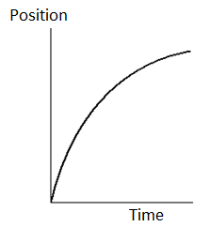
.
____11. Velocity is defined as,
____12. Acceleration is defined as,
Answers for 11 & 12
a. Rate at which the speed changes
b. Rate at which the velocity changes
c. Rate at which the distance changes
d. Rate at which the displacement changes
13-18) Deal with the one-dimensional motion of a race, duration of 25 s, where the velocity is graphed as a function of time, below.
____13. The name of the graph is,
a. time versus velocity b. velocity versus time

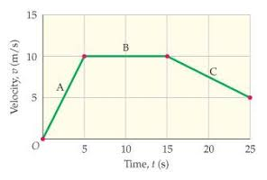
____14. What is the instantaneous acceleration of the
runner at 3 s?
a. -2 m/s² b. 2.0 m/s² c. 0.5 m/s² d. -0.5 m/s²
____15. What is the instantaneous velocity of the runner
at 20 s?
a. 5 m/s b. 10 m/s c. 7.5 m/s d. -7.5 m/s
____16. What is the instantaneous acceleration of the
runner at 20 s?
a. 0 m/s² b. 2.0 m/s² c. 0.5 m/s² d. -0.5 m/s² e. -2 m/s²
____17. What is the average acceleration for the race?
a. 0 m/s² b. 0.2 m/s² c. 0.5 m/s² d. 2.0 m/s² e. 5.0 m/s²
____18. How far is the race?
a. 25 m b. 50 m c. 100 m d. 200 m e. 250 m
____19. The figure below illustrates the concept of satellite launch where the trajectories for increasing launch speeds are shown.
Which path is that of a satellite?
a. A b. B c. C d. D e. E
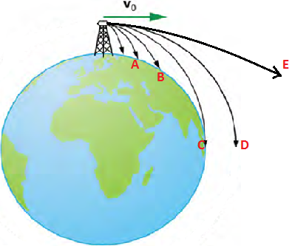
____20. A ball (I) is rolled along the surface of a table and leaves the edge horizontally. At the same instant the ball I leaves the table, a second ball (II) is dropped from rest at the edge of the table. In the absence of air resistance, which ball will strike the ground first?
a. I b. II c. both at the same time
____21. In the above question which ball will have the lower speed at the ground level?
a. I b. II c. both will have the same speed
____22. Three vectors A, B, and C are shown below in each of the diagrams. Which one represents the relationship: C = A + B ?
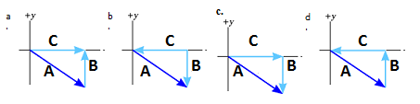
23-25) A car traveling at 85 km/h overtakes a 0.75 km long train traveling in the same direction on a track parallel to the road. The velocity of the train is 75 km/h, eastward.
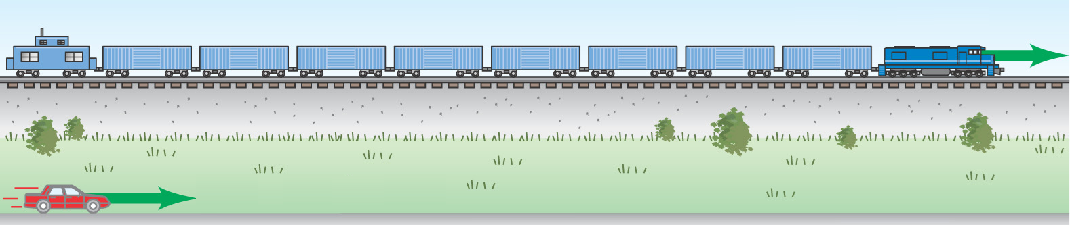

____23. What is the velocity of the car relative to the train?
____24. What is the velocity of the train relative to the car?
Answers for 23 & 24
a. 85 km/h eastward b. 75 km/h eastward c. 160 km/h westward
d. 160 km/h eastward e. 10 km/h westward f. 10 km/h eastward
____25. How long does it take the car to pass the train?
a. 0.53 min b. 0.75 min c. 3.3 min d. 4.5 min e. 5.4 min
_________________________________________________________End of MCQ’s__
B. For the four vectors shown below (magnitudes: A = 8.00 m, B = 15.0 m, C = 12.0 m, and D = 10.0 m) complete the table:
Vector | X-component | Y-component
A
B
C
D
A + B + C+D

C. Equations of Kinematics for constant acceleration are given below:
1. | 2. | 3. | 4. | 5.
$$x=\overline{v} t$$ | $$x=\frac{1}{2}\left(v_{0}+v\right)t$$ | $$v=v_{0}+at$$ | $$x=v_{0}t+\frac{1}{2}at^{2}$$ | $$v^{2}=v_{0}^{2}+2ax$$
1. Derive the 5th equations using the equations 2 & 3.

2. A stuntman sitting on a tree limb wishes to drop vertically onto a horse galloping under the tree. The initial speed of the horse is 10.0 m/s and the man is initially 3.00 m above the level of the saddle. Due to the rustling noise of the leaves, the moment the stuntman drops, the panicked horse accelerates at 4.0 m/s². The acceleration due to gravity = 9.8 m/s², down.
a. How long is the stuntman in the air?

b. What must be the horizontal distance between the saddle and the limb when the man makes his move, to accomplish the stunt?

1. | 2. | 3. | 4. | 5.
$$y=\overline{v_{y}} t \\ x=\overline{v_{x}} t$$ | $$y=\frac{1}{2}\left(v_{0y}+v_{y}\right)t$$ | $$v_{y}=v_{0y}+a_{y}t$$ | $$y=v_{0y}t+\frac{1}{2}a_{y}t^{2}$$ | $${v_{y}}^{2}=v_{0y}^{2}+2a_{y}y$$
D. During a fireworks display, a shell is shot into the air with an initial speed of 60.0 m/s at an angle of 65.0º above the horizontal, as illustrated in the figure. The fuse is timed to ignite the shell just as it reaches its highest point above the ground. Ignore air resistance. The acceleration due to gravity = 9.8 m/s², down.
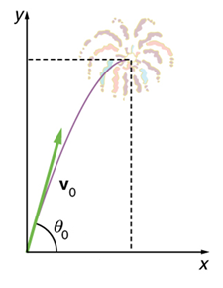
(a) Find the horizontal and vertical components of the
initial velocity, V_{ox} and V_{oy.}

(b) Calculate the height at which the shell explodes.

(c) How much time passed between the launch of the shell and the explosion?

(d) What is the horizontal displacement of the shell when it explodes?

