PHYS 201 Stress & Strain Name:__________________________

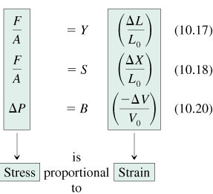
1. The block in the drawing rests on the ground. Which face, A, B, or C, experiences (a) the largest stress and (b) the smallest stress when the block is resting on it? Explain.
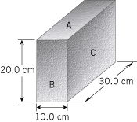

2. An 8.0-kg stone at the end of a steel wire is being whirled in a circle at a constant tangential speed of 12 m/s. The stone is moving on the surface of a frictionless horizontal table. The wire is 4.0 m long and has a radius of 1.0×10^{–3} m. Find the strain in the wire.

