PHYS 201 SFQ on air column vibrations Name:________________________

1. Draw a pictorial representation of longitudinal standing waves (fundamental and two higher modes) in a tube of air that is closed at one end.

2. Sound enters the ear, travels through the auditory canal, and reaches the eardrum. The auditory canal is approximately a tube open at only one end. The other end is closed by the eardrum. A typical length for the auditory canal in an adult is about 2.9 cm. The speed of sound is 343 m/s. What is the fundamental frequency of the canal? (Interestingly, the fundamental frequency is in the frequency range where human hearing is most sensitive.)

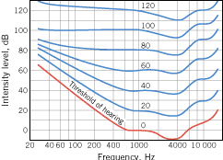

PHYS 201 SFQ on String Vibrations Name:________________________

Speed of transverse waves on a stretched string is given by,

1. Describe each term in the above equation.

2. Show that the above equation is valid unit wise (ie dimensionally correct).

3. A string has a linear density of 8.5×10^{–3} kg/m and is under a tension of 280 N. The string is 1.8 m long, is fixed at both ends, and is vibrating in the standing wave pattern shown in the drawing. Determine the (a) speed, (b) wavelength, and (c) frequency of the traveling waves that make up the standing wave.
