PHYS 201 Bernoulli’s Principle Name:__________________________

1. Define pressure.

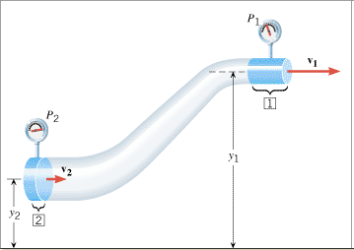

2. Describe each of the terms in the Bernoulli’s equation below.



*P =_____________________________ ρ = _________________________*

*v =_____________________________ y = _________________________*

*g = _____________________________*

3. What is the unit for the term *ρgy*in the Bernoulli’s equation?

4. An airplane wing is designed so that the speed of the air across the top of the wing is 251 m/s when the speed of the air below the wing is 225 m/s. The density of the air is 1.29 kg/m3. What is the lifting force on a wing of area 24.0 m2?

