PHYS 201 Fall 2016 SFQ on Equilibrium Name:______________________________

1. In an isometric exercise a person places a hand on a scale and pushes vertically downward, keeping the forearm horizontal. This is possible because the triceps muscle applies an upward force http://edugen.wiley.com/edugen/courses/crs1507/art/math/cutnell3158c09/math193.gifperpendicular to the arm, as the drawing indicates. The forearm weighs 25.0 N and has a center of gravity as indicated. The scale registers 115 N. Determine the magnitude of http://edugen.wiley.com/edugen/courses/crs1507/art/math/cutnell3158c09/math193.gif

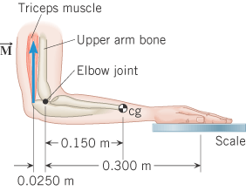

2. A man holds a 148-N ball in his hand, with the forearm horizontal (see the drawing). He can support the ball in this position because of the flexor muscle [force](javascript:top.newWin('keywords','content/index/index7.htm',20,20)) **M**, which is applied perpendicular to the forearm. The forearm weighs 21.0 N and has a center of gravity as indicated. What is the magnitude of M?

