PHYS 201 Ch7 Work & Energy Name:________________________________Due 10/11
1. Calculate the distance the 65.0-kg baseball player slides, given that his initial speed is 6.00 m/s and the force of friction against him is a constant 450 N.
a) Using energy considerations b) Using kinematic equations
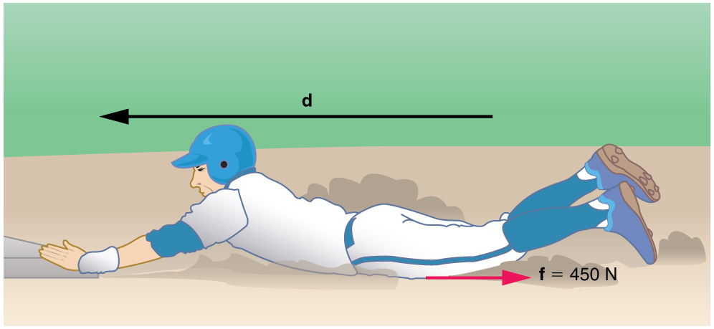

2. (P8) Suppose the ski patrol lowers a rescue sled and victim, having a total mass of 90.0 kg, down a 60.0º slope at constant speed, as shown in Figure 7.37. The coefficient of kinetic friction between the sled and the snow is 0.100. (a) How much work is done by friction as the sled moves 30.0 m along the hill? (b) How much work is done by the rope on the sled in this distance? (c) What is the work done by the gravitational force on the sled? (d) What is the total work done?
