PHYS 201 Friday 8/29/14 Name:________________________________

1. Watch the following video: http://www.youtube.com/watch?v=nfMkORv6ybc

2. Sketch a right-triangle and name the lengths of the sides as a and b and the hypotenuse as c. Name the angle opposite of side a as θ. Also, write down the Pythagorean Theorem for the right-triangle and define sin θ, cos θ, and tan θ in terms of a, b, & c.
Right-Triangle | Pythagorean Theorem | sin θ | cos θ | tan θ

3. (P17, Ch1) The two hot-air balloons in the drawing are 48.2 and 61.0 m above the ground. A person in the left balloon observes that the right balloon is above the horizontal. What is the horizontal distance x between the two balloons?
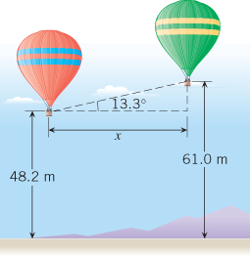
4. (P19, Ch1) The drawing shows sodium and chlorine ions positioned at the corners of a cube that is part of the crystal structure of sodium chloride (common table salt). The edge of the cube is 0.281nm (1nm=1 nanometer=10^{–9}m) in length.
a. Find the distance (in nanometers) between the sodium ion located at one corner of the cube and the chlorine ion located on the diagonal at the opposite corner.
b. What is the value of the angle θ in the above drawing?
