PHYS 201 Name:__________________________
1. State Hooke’s law.

2. Identify the type of force necessary for simple harmonic motion.

3. A steel ball is dropped onto a concrete floor. Over and over again, it rebounds to its original height. Is the motion simple harmonic motion? Justify your answer.

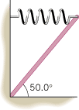
4. A 10.1-kg uniform board is wedged into a corner and held by a spring at a 50.0° angle, as the drawing shows. The spring has a spring constant of 176 N/m and is parallel to the floor. Find the amount by which the spring is stretched from its unstrained length.

