PHYS 201 Hwk 1 Ch9 Due 10/31 Name:________________________
22. A man holds a 178-N ball in his hand, with the forearm horizontal (see the drawing). He can support the ball in this position because of the flexor muscle force , which is applied perpendicular to the forearm. The forearm weighs 22.0 N and has a center of gravity as indicated. Find
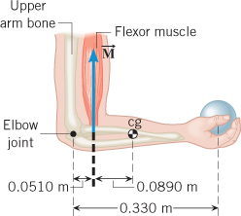
(a) | the magnitude of and
(b) | the magnitude and direction of the force applied  by the upper arm bone to the forearm at the elbow  joint.

25. A 1220-N uniform beam is attached to a vertical wall at one end and is supported by a cable at the other end. A 1960-N crate hangs from the far end of the beam. Using the data shown in the drawing, find
(a) | the magnitude of the tension in the wire and
(b) | the magnitudes of the horizontal and vertical components of the force that the wall exerts on the left end of the beam.

