PHYS 201 Bernoulli’s Principle Name:__________________________
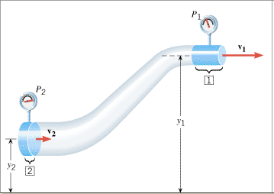
1. Define pressure.

2. Describe each of the terms in the Bernoulli’s equation below.
P =_____________________________ ρ = _________________________

v =_____________________________ y = _________________________

g = _____________________________

3. What is the unit for the term ρgy in the Bernoulli’s equation?

4. (P63) An airplane wing is designed so that the speed of the air across the top of the wing is 251 m/s when the speed of the air below the wing is 225 m/s. The density of the air is 1.29 kg/m³. What is the lifting force on a wing of area 24.0 m²?
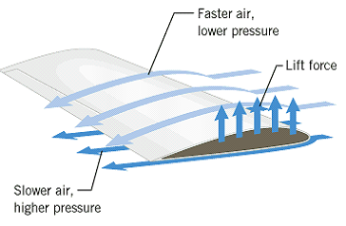

5. (P72) An airplane has an effective wing surface area of that is generating the lift force. In level flight the air speed over the top of the wings is , while the air speed beneath the wings is . What is the weight of the plane?

6. During a hurricane wind is blowing at 115 MPH over a roof of a house of area 175 m². Calculate the upward force acting on the roof. If you need help, watch the following video: (https://www.youtube.com/watch?v=cUMspps8d8A)

