PHYS 102 WORK & POWER and PENDULUM
Name:___________________________ Partner(s):____________________
WORK & POWER: To determine the work done and power developed by a person during walking & running up the steps.
Apparatus: foot-ruler, stop-watch, scale, and person.
Theory: Here we will look at WORK as defined below. We will assume that work only occurs when the force is sufficient to move the object. Work is a measure of what is done, not the effort applied in attempting to move the object. Work can be said to be energy in transit. Work has the same unit as energy.
Work = Force X Distance; Power = Work/Time; 1 horse power = 1 hp = 746 W.
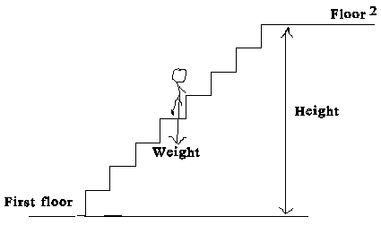
UNITS:
 | Time | Distance | Mass | Weight | Velocity | Acceleration | Work | Power
cgs | s | cm | g | dyne | cm/s | cm/s² | erg | erg/s
SI | s | m | kg | newton, N | m/s | m/s² | joule,J | J/s = W
BE/USC | s | ft | slug | pound, lb | ft/s | ft/s² | ft.lb | ft.lb/s
PROCEDURE
1. Find the weight of the person who is going to do the walking and running.
2. Walk out to the steps and measure the height of each steps, # of steps, and determine the height for one level.
3. Time the walking and running.
4. Repeat 1-3 for two levels, and complete the data table.
DATA: (Use SI units)
Same person needs to do all the walking and running.
 | From 2nd floor to 3rd floor of Sims |  | From 1st floor to 3rd floor of Sims
 | Walking | Running | Walking | Running
Weight
Height
Time
Work
Power
Horse Power
Answer the following questions:
1. Explain the unit horse power, hp including its origin.

2. Explain why there is a difference in the hp for walking and running?

3. What will happen to the hp as the person uses a large number of levels?

4. Explain why mountain roads are designed round & round, not just straight up?
PENDULUM
Purpose: To investigate what factors affect the period of a simple pendulum.
Apparatus: Pendulum: clamp, stand, string, and balls; stop-watch, balance, PC, and meter stick.
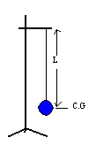
Theory: How to make a simple pendulum?
Take a mass, fix a string, and hang it from a support.
The length, L is measured from the support point to
the center of gravity (C.G) of the hanging mass.

When you displace the mass, the pendulum will oscillate. The period, T of the oscillations is the time the pendulum takes to complete one oscillation. If you time just one oscillation, the measured value of T won’t be accurate because of the reaction times involved in starting and stopping the stop-watch. You need to time at least 10 oscillations to measure the period, T.
Q: One finds that a pendulum takes 23 seconds for 10 oscillations. What is the period, T?
A: ____________________________
The amplitude, A of the oscillations is the maximum distance the mass moves from its equilibrium position. See figure below.
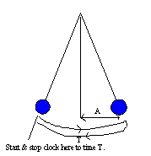 | You can also see how to time oscillations to measure the period, T in the figure. T is the time for one complete oscillation. If you start the clock on one side then you need to wait until the mass goes to the other side and comes back, to count one. The clock will continue to run and you will continue to count. When the mass comes back the 10th time to the starting side you will stop the clock. The clock reading is the total time for 10 T’s.

DATA
I. Influence of amplitude, A on the period.
Length of pendulum, L = ______ Mass of pendulum, M = ______ Gravity, g = ________
Amplitude, A (cm) | 10 T | Period, T
5
10
15
20
25
30
II. Influence of mass, M on the period:
Length of pendulum, L = _____ Amplitude of pendulum, A = ____Gravity, g = _______
Mass, M | 10 T | Period, T

III. Influence of length, L on period.
Amplitude of pendulum, A = _____ Mass of pendulum, M = ______Gravity, g = ______
Length, L (cm) | 10T | T
0
10
20
40
60
80
100
120
140
160

IV. Influence of gravity, g on period. For this, go to the virtual pendulum website and collect the data there.
Length of pendulum, L = _____ Mass of pendulum, M = ____ Amplitude = ______
Gravity, g (m/s²) | T
1
2
3
4
6
8
10
12
14
15
Conclusion on a separate last page.

