PHYS 102 VIDEO REVIEW and WORK & POWER
Name:___________________________ Partner(s):____________________
VIDEO REVIEW: Watch the following video on "Absolute Zero" and write a 2-page review.
http://video.pbs.org/video/1050757560/

WORK & POWER
Purpose: To determine the work done and power developed by a person during walking & running up the steps.
Apparatus: foot-ruler, stop-watch, scale, and person.
Theory: Here we will look at WORK as defined below. We will assume that work only occurs when the force is sufficient to move the object. Work is a measure of what is done, not the effort applied in attempting to move the object. Work can be said to be energy in transit. Work has the same unit as energy.
Work = Force X Distance; Power = Work/Time; 1 horse power = 1 hp = 746 W.
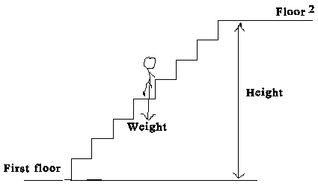
UNITS:
 | Time | Distance | Mass | Weight | Velocity | Acceleration | Work | Power
cgs | s | cm | g | dyne | cm/s | cm/s² | erg | erg/s
SI | s | m | kg | newton, N | m/s | m/s² | joule,J | J/s = W
BE/USC | s | ft | slug | pound, lb | ft/s | ft/s² | ft.lb | ft.lb/s
PROCEDURE
1. Find the weight of the person who is going to do the walking and running.
2. Walk out to the steps and measure the height of each steps, # of steps, and determine the height for one level.
3. Time the walking and running.
4. Repeat 1-3 for two levels.
5. Complete the data table.
DATA: (Use SI units)
Same person needs to do all the walking and running.
 | From 2nd floor to 3rd floor of Sims |  | From 1st floor to 3rd floor of Sims
 | Walking | Running | Walking | Running
Weight
Height
Time
Work
Power
Horse Power

Answer the following questions:
1. Explain the unit horse power, hp including its origin.

2. Explain why there is a difference in the hp for walking and running?

3. What will happen to the hp as the person uses a large number of levels?

4. Explain why mountain roads are designed round & round, not just straight up?

