VIBRATING STRING Name:_____________________________

Partners:___________________________ Course:_____________ Time:___________

Purpose: To investigate waves in a stretched string and determine the wave speed.

Apparatus: String vibrator, clamp for string vibrator, string, mass set, mass hanger (50-g), electronic balance (accuracy 0.01-g), meter stick, and pulley w/clamp.

Theory: Stringed musical instruments are played by plucking or bowing a stretched string. In this investigation a string vibrator will make the string to vibrate at a frequency of 60 Hz. The tension will be provided by a hanging mass. The vibrations will travel along the string and get reflected at the other end. The reflected waves and the incoming waves will interfere and form standing waves. By varying the tension, *T* standing waves with different number of loops can be obtained. The standing waves for two and three loops are shown below. One loop length is half the wavelength.

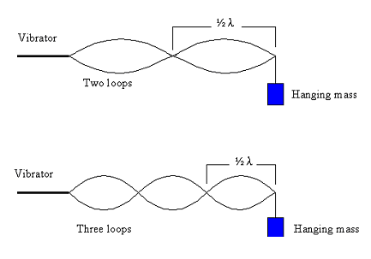

In terms of hanging mass, *m* and acceleration due to gravity, *g* tension, *T* is given by:    
    
   
In terms of frequency, f and wavelength, λ the wave speed, *v* is given by:     
 

In terms of tension, *T* and strings linear density, *μ* the wave speed, *v* is given by:   
 

Linear Density: Linear density, *μ* is a property of the string which tells us whether the string is "heavy" or "light". You may know that the four violin strings are not the same. Some are thick and others are thin. The heavy strings are used for low tones and the light ones are for high tones. In this investigation you will determine *μ*, by measuring the length and mass of the string before attaching it to the string vibrator, to 3 significant figures.

DATA: USE SI UNITS.

Length of string = *L* = ________________ Mass of string = *M* = _________________

Linear Density = *μ* = ________________

Frequency = *f* = 60 Hz,   Acceleration due to gravity = *g* = 9.8 m/s2

|  |  |  |  |  |  |  |  |
| --- | --- | --- | --- | --- | --- | --- | --- |
| # of Loops | Loop length | Wavelength, *λ* | Hanging mass, *m* | Tension, | Wave Speed, *V* | | % Difference |
| Using *f* & λ | Using *T* & *μ* |
| 2 |  |  |  |  |  |  |  |
| 3 |  |  |  |  |  |  |  |
| 4 |  |  |  |  |  |  |  |
| 5 |  |  |  |  |  |  |  |
| 6 |  |  |  |  |  |  |  |
| 7 |  |  |  |  |  |  |  |

Conclusion: