PHYS 102 Ohm’s Law Name:______________________________
Partner(s):_______________________________________________________________
A. Introduction of electricity and resistance using a digital multimeter.
Apparatus: Digital multimeter (DMM), 9-volt battery, resistor-set, and banana plug wires.
Theory:
1. Information about digital multimeter is available on this digital multimeter website.
2. Electricity comes in two types. Name these two types.
____________________________________________________________________
3. Name a few terms in electricity.
Terms in Electricity
Physical Quantity | Unit (unit abbreviation)
4. Name a few electrical appliances where resistance is the primary component.
_____________________________________________________________________
_____________________________________________________________________
5. Measure the voltage of a 9-volt battery.________________________
6. Measure the resistance values of the resistor-set and complete the following table:
 | 5 Ω | 10 Ω | 20 Ω
Using a digital multi-meter
In Series | 5 Ω & 10 Ω | 10 Ω & 20 Ω | 5 Ω, 10 Ω, & 20 Ω
Using a digital multi-meter
In Parallel | 5 Ω & 10 Ω | 10 Ω & 20 Ω | 5 Ω, 10 Ω, & 20 Ω
Using a digital multi-meter
B. Purpose: To investigate Ohm’s law and measure resistances.
Apparatus: Variable DC power supply, 5- connecting wires (banana plug), resistance-1, resistance-2, light bulb, voltmeter, and digital multi meter (DMM).
Theory: Georg Simon Ohm (1787-1854), a German physicist, discovered Ohm’s law in 1826. This is an experimental law, valid for direct current (dc) as well as alternating current (ac) circuits.
When you pass an electric current (I) through a resistance (R) there will be a voltage (V) created across the resistance as illustrated below.
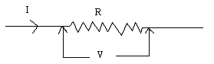
Ohm’s law gives a relationship between V, I and R as follows.
V = I R; Units: V------> volt (v), I------> ampere (A), R-----> ohm (Ω).
For ohmic resistances, V versus I is a linear relationship, and they have a constant resistance. Resistance can be calculated using the Ohm’s law, R = V/I. The slope of the V versus I, line will also give the resistance, R.
For non-ohmic resistances, V versus I is a non-linear relationship, and they have a varying resistance. The resistance at a particular point can be calculated using Ohm’s law, R = V/I, where V and I are the voltage and current at that point.
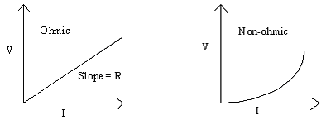
Electric power, P is given by the following equation:
Power = P = Voltage x Current.
Procedure:
1. Leave the power cord unplugged.
2. Set up the following circuit; where the power supply, DMM, and resistance-1 are connected in series and the voltmeter is connected across (in parallel) the resistance.
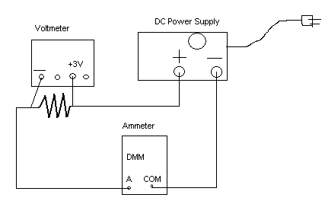
Data & Analysis:
1. Collect the current data for each of the following voltages; 0 volt, 0.2 volt, 0.4 volt, 0.6 volt, 0.8 volt, 1.0 volt, 1.2 volt, 1.4 volt, 1.6 volt, 1.8 volt, 2.0 volt, 2.2 volt, and 2.4 volt and tabulate them in Excel.
2. Repeat the above procedure for the other unknown resistance and tabulate its current values in the third column of your spread sheet.
3. Plot V versus I, for both resistances in one graph and determine the slopes. Print hard-copies of your data table and graph.
4. Replace the resistance with the light bulb and measure the current for each of the following voltages; 0 volt, 0.1 volt, 0.2 volt, 0.3 volt, 0.4 volt, 0.5 volt, 0.6 volt, 0.7 volt, 0.8 volt, 0.9 volt, 1.0 volt, 1.1 volt, 1.2 volt, 1.3 volt, 1.4 volt, 1.5 volt, 1.6 volt, 1.7 volt, 1.8 volt, 1.9 volt, 2.0 volt, 2.1 volt, 2.2 volt, 2.3 volt, and 2.4 volt and tabulate them in a new Excel spread sheet.
5. Calculate the resistance values in the third column and power values in the fourth column.
6. Plot V versus I and Power versus I, together, on another graph and show your graph to the instructor. Print hard-copies of your data table and graph.
7. After attaching your data tables and graphs, write a conclusion.
Conclusion:
1. Begin your conclusion by re-stating the purpose in an appropriate form.
2. Observe your graphs and identify ohmic and non-ohmic resistances.
3. Look at your data table and graph for the light bulb and comment about the type of resistance the filament is made and how the resistance and power changes as the bulb gets brighter.
4. Comment about sources for errors and suggestions for improvements.

