PHYS 102 L9 TORQUE Name:____________________________
Purpose: To investigate torque by doing the following activities:
a. Measuring an unknown mass
b. Measuring the mass of a meter stick
c. Solving a mobile problem
Apparatus: Meter stick, unknown mass, knife edge clamp, knife edge support, mass-hanger, mass set, lab jack, electronic balance, and string loops.
Theory: Introduction to torque
Think about the everyday activity of opening a door, just for a moment.
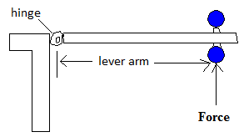
Q: What do you think you do to the door, when you open it?
A: You apply a torque.
Torque = Lever-arm X Force; Torque is a vector. Torque comes in clockwise and counter clockwise directions. Clockwise direction is the direction in which a mechanical clock turns. The opposite direction is called counter clockwise.
The door knob is kept away from the hinge in order to have a greater lever-arm. Imagine how hard it will be to open, if the knob is kept closer to the hinge.
Lever-arm is the perpendicular distance between the line of action of the force and axis of rotation.
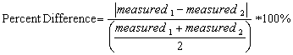
a. Measuring an unknown mass
Meter stick is supported at the center of gravity.
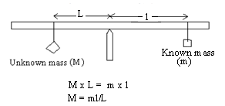
Unknown mass will try to rotate the meter stick counter
clockwise and known mass will try to rotate the meter
stick clockwise.
For balance, counterclockwise torque = clockwise torque.
Unknown mass can be determined using the above equation.

DATA for Unknown Mass
Location of the center of gravity (C.G) = ________ cm
Location of the unknown mass = _________ cm _________cm __________cm
Location of the known mass = _________ cm _________cm __________cm
Known mass, M₂ (g) | Moment-arm for known mass, MA-2 | Moment-arm for unknown mass, MA-1 | Unknown mass, M₁
200 | - | - | -
250 | - | - | -
300 | - | - | -
Average of the unknown mass, M₁ |  |  | -
Unknown mass measured using electronic balance |  |  | -
% difference |  |  | -

b. Measuring the mass of a meter stick (M)
Now you need to move the support point away from the center of gravity (C.G). This way you get the rotation effect of M, mass of the meter stick.
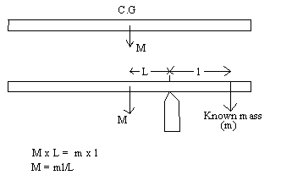

DATA for Mass of Meter Stick
Location of the center of gravity (C.G) = ________ cm.
Location of the support point = ________ cm __________cm _________cm
Location of the known mass = ________ cm __________cm _________cm
Known mass, m (g) | Moment-arm for known mass, l | Moment-arm for mass of meter stick, L | Mass of meter stick, M
100 | - | - | -
150 | - | - | -
200 | - | - | -
Average of the mass of meter stick, M |  |  | -
Mass of meter stick measured using electronic balance |  |  | -
% difference |  |  | -

C. For the mobile shown the beams have negligible masses. The mass of A is 0.6 kg. Determine the masses of B, C, and F.
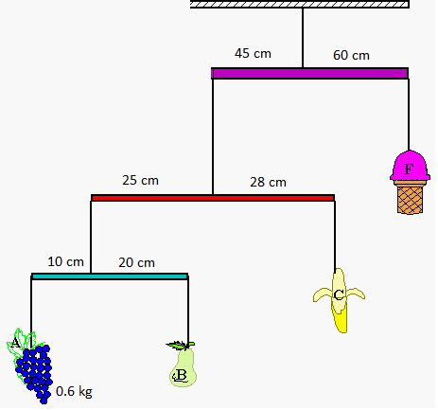
Conclusion:

