PHYS 102 L8: Centripetal Force Name:________________________________
Purpose: To measure the centripetal force by means of static and kinetic methods.
Apparatus: Centripetal force apparatus, mass set, meter stick, stop-watch, and scale.
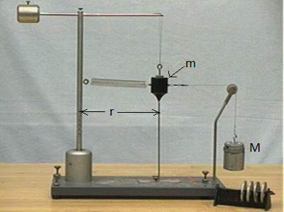http://demolab.phys.virginia.edu/demos/demos.asp?Demos=D&Subject=1&Demo=1D50.51
Theory:
Centripetal force is given by, $F_{c}=m\frac{v^{2}}{r}$ ; kinetic method.
By means of static method it is given by, $F_{c}=Mg;where g=acceleration due to gravity.$
Procedure:
1. Find the mass of the black mass using the scale and record it in the spread sheet.
2. Hang the black mass, m freely to the lowest radius, and set the radius indicator under the mass.
3. Measure the radius and record it in the spread sheet.
4. Connect the spring and hang the mass, M until the black mass hangs above the radius indicator.
5. Remove the hanging mass, M, and rotate the black mass, so that it will stay above the radius indicator, while rotating. During this rotation, measure the time for 10 rotations.
6. Complete the data table.
7. Write a conclusion.

