PHYS 102 Centripetal Force Name:________________________________
Purpose: To measure the centripetal force by means of static and kinetic methods.
Apparatus: Centripetal force apparatus, mass set, meter stick, stop-watch, and scale.
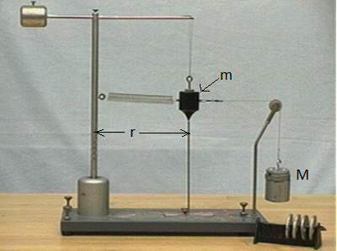
Theory:
The centripetal force is given by, $F_{c}=m\frac{v^{2}}{r}$ ; kinetic method.
By means of static method, it is also given by, $F_{c}=Mg;$g = 9.8 m/s².
Answer the following questions regarding the centripetal force equation: $F_{c}=m\frac{v^{2}}{r}$
1. Name all the quantities (terms) in the above equation.

2. Show that the above equation is correct unit-wise.

3. Write down an equation for v in terms of r and the period, T of the circular motion.

2. Sketch the following graphs: Centripetal force: $F_{c}=m\frac{v^{2}}{r}$
a. $F_{C}$ versus m, when v and r are constant. | a. $F_{C}$ versus r, when m and v are constant. | a. $F_{C}$ versus v, when m and r are constant.
Procedure:
1. Find the mass of the black mass using the scale and record it in the spread sheet.
2. Set the lowest radius and hang the black mass, m freely above the radius indicator.
3. Measure the radius and record it in the spread sheet.
4. Connect the spring to the black mass and hang the mass, M until the black mass hangs above the radius indicator. Record the hanging mass, M.
5. Remove the hanging mass, M, and rotate the black mass, so that it will stay above the radius indicator, while rotating. During this rotation, measure the time for 10 rotations.
6. Repeat 2-5, for the next radius. Do the measurements for a total 5 radii.
7. Calculate the centripetal force using the static and kinetic methods, and find the %Difference.
8. Compare and contrast this circular motion with that of planetary motion.
9. Write a conclusion.

