PHYS 101H Face-centered cubic crystal structure Name:________________________
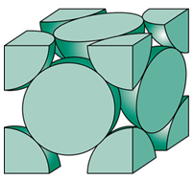
1. How many atoms are inside the cubic unit cell of FCC?

2. Show the cube edge length, a and the atomic radius, R in
the figure.

3. Show that the cube edge length, a and the atomic radius, R are
related by: $a=2R\sqrt{2}$

4. Calculate the density of lead, Pb, which has a FCC crystal structure. Its atomic radius = 0.175 nm and atomic weight = 207.2 g/mol. (Avagadro’s number = 6.022 x 10²³) [http://www.ptable.com/]

