PHYS 101H Body-centered cubic crystal structure Name:________________________
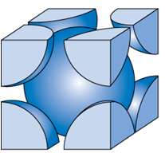
1. How many atoms are inside the cubic unit cell of BCC?

2. Show the cube edge length, a and the atomic radius, R in
the figure.

3. Show that the cube edge length, a and the atomic radius, R are
related by: $a=\frac{4}{\sqrt{3}}R$

4. Calculate the density of iron, Fe, which has a BCC crystal structure. Its atomic radius = 0.126 nm and atomic weight = 55.845 g/mol. (Avagadro’s number = 6.022 x 10²³) [http://www.ptable.com/]

