***Electrostatic Charge and Magnetic Fields***

**A.** **Electrostatic Charge**

**Purpose**: Investigate the charging of a metal container by contact and by induction using a charge sensor.

You will use a charge sensor to determine the polarity of the charge producers and to measure the amount of charge transferred to a metal container by induction and by contact.

**Apparatus**: PC w/interface, charge sensor, cable assembly, glass rod, hard-rubber rod, silk, course material, calorimeter: jacket and lid.

**Procedure:**

**a)** **Charge Polarity**

1. Connect the charge sensor to analog channel A, and set the gain to 1.
2. Connect the cable assembly to the BNC port on the sensor. To do this: line up the connector on the end of the cable with the pin on the BNC port. Push the connector onto the port and then twist the connector clockwise about one-quarter turn until it clicks into place.
3. Connect the alligator clips (red and black) of the cable assembly to the calorimeter jacket, place the lid on the table, and place the calorimeter jacket on the lid.
4. Open “DataStudio” – select “create activity” –Add sensor –charge sensor – visibility voltage
5. Double-click on the Graph display.
6. Press the ‘zero’ button on the charge sensor to discharge the sensor.
7. Un-ground the jacket by removing the black alligator clip from the calorimeter, leave it un- connected.
8. Click “Start” – if the voltage is not zero, press the zero button on the charge sensor again.
9. Charge the hard-rubber rod with fur and lower the rod inside the jacket without touching the inside, and hold it there for a few seconds and then remove it. Observe the graph display.
10. If the voltage didn’t come back to zero, ground the calorimeter jacket by re-zeroing the charge sensor.
11. Charge the glass rod with fur (use the smooth side for rubbing and the rough side for holding) and lower the rod inside the jacket without touching the inside, and hold it there for a few seconds and remove it. Observe the graph display.

**b)** **Charging by Contact**

1. Click “Start” – if the voltage is not zero, press the zero button on the charge sensor again.

2. Charge the hard-rubber rod with fur and lower the rod inside the jacket and make contact inside at many places, while turning the rod. The rod is an insulator, so you need to move the rod and make contact to transfer the charge. Just touching it won’t transfer much charge. Observe the graph display.

3. Ground the jacket. If the voltage is not zero, press the zero button on the charge sensor again. Data recording is still going on.

4. Charge the glass-rod with fur and lower the rod inside the jacket, and make contact inside at many places, while turning the rod. The glass rod is an insulator, so you need to move the rod and make contact to transfer the charge. Just touching it won’t transfer much charge. Observe the graph display.

5. Ground the jacket with the black alligator clip and then un-ground it. If the voltage is not zero, press the zero button on the charge sensor again.

6. Stop recording data.

**Charging by Contact Data:** (Look at the Charging by Contact graph., Answer the following questions on the worksheet.)

1. What is the value of voltage produced by the transfer charge from the rubber rod?

b. What is the value of voltage produced by the transfer charge from the glass rod?

1. Delete the data from the graph display.

**c) Charging By Induction**

1. Click “Start” – if the voltage is not zero, press the zero button on the charge sensor again.

2. Charge the hard-rubber rod with fur and lower it inside the jacket without touching the inside and hold it there. While holding the rod inside, ground the jacket, then remove the ground, and then remove the rod. Observe the graph display.

3. Ground the jacket with the black alligator clip and then un-ground it. If the voltage is not zero, press the zero button on the charge sensor again.

4. Start a new graph (charge on the y axis, time on the x axis). Perform at least 4 actions which cause

the charge to fluctuate. Annotate the action occurring at the time of change.

1. **Print and turn in**. ***Use the labeling function in data Studio to annotate the collection location for each***

***of the 4 areas. All requested information must be electronically presented.***

1. Stop recording data.

**Charging By Induction Data:** (Look at the Charging by Induction graph and answer the following questions on the worksheet.)

* 1. What is the peak value of voltage produced by the rubber rod while it is inside?
  2. What is the peak value of voltage produced by the induced charge from the rubber rod?
  3. What is the polarity of the induced charge?

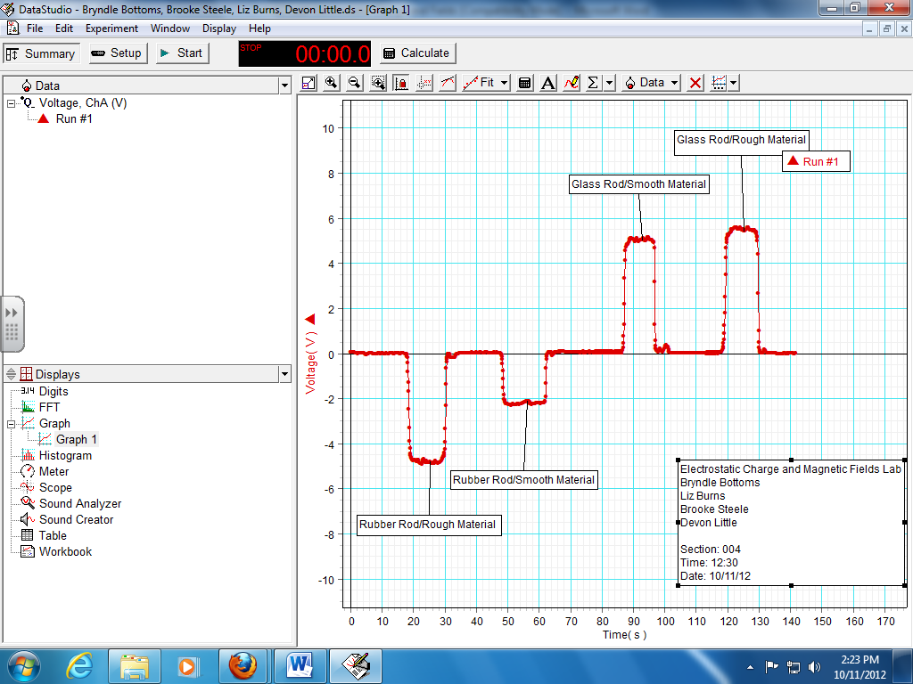

**B. Magnetic Field Lines:**

Purpose: To map the magnetic field lines of permanent magnets.

Apparatus: One magnet, compass, sheet of white paper.

Procedure:

1. Identify the north and south poles of the compass needle using Earth’s magnetic field.
2. Place a sheet of paper on the lab table, place a bar-magnet on it, trace the outlines of the magnet.
3. Draw a dot somewhere near the magnet and place the head (or tail) of the compass needle over the dot.
4. Draw a dot at the location of the tail and head of the compass needle.
5. Move the compass needle head to this new dot, and again draw a dot at the location of the compass needle tail and head.

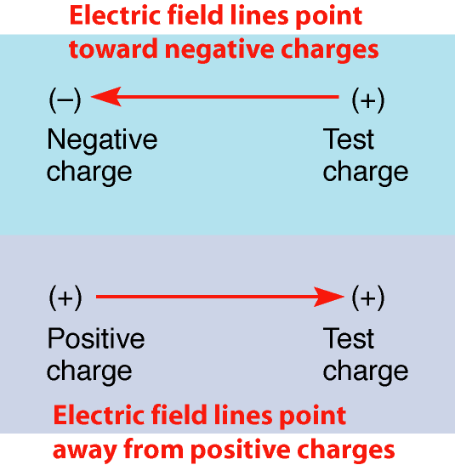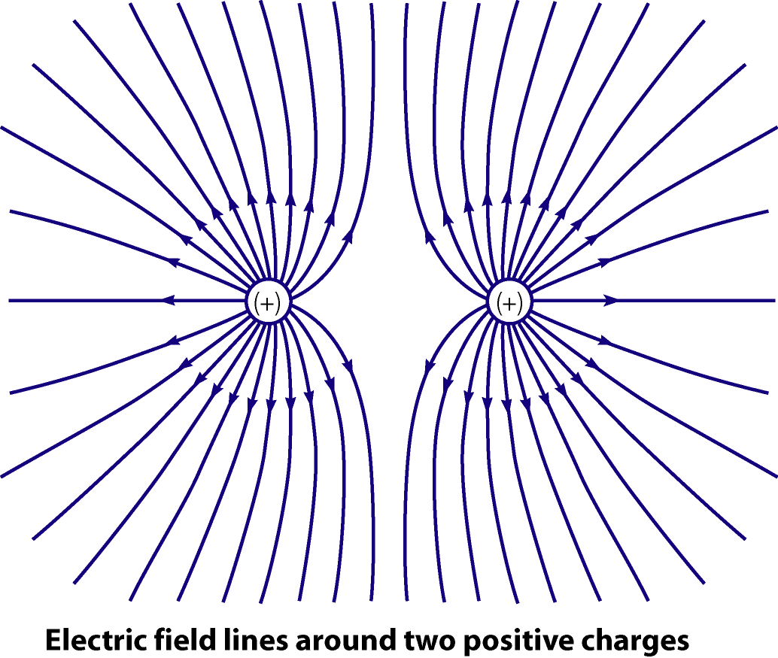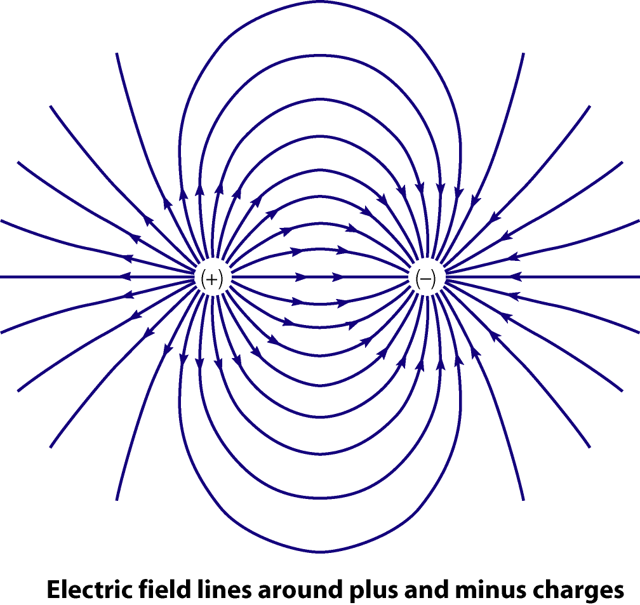

1. Repeat steps 4-5 until you have at least 30 points.
2. Remove the compass from the paper and draw lines connecting the dots with arrows indicating the direction that the compass points.
3. View how iron fillings line-up along the magnetic field line by observing the front desk display. It was created in this manner: the magnet was placed on the table with a sheet of paper on the magnet. Iron filings were sprinkled on the paper. Observe the formation of field lines.

***Electrostatic Charge and Magnetic Fields WORKSHEET***

Partner(s) First and Last names Section __________ Date ___________ Time ___________

_____________________________________________________________________________

_____________________________________________________________________________

**A.** **Electrostatic Charge**

**b)** **Charging by Contact:** (Look at the Charging by Contact graph and answer the following questions)

1. What is the voltage produced by the transfer charge from the rubber rod/rough material? ________
2. What is the voltage produced by the transfer charge from the rubber rod/smooth fabric? ________
3. What is the voltage produced by the transfer charge from the glass rod/smooth material? ________

**c) Charging By Induction** **Data:** (Look at the Charging by Induction graph and answer the following questions)

1. What is the peak voltage produced by the rubber rod/rough material while it is inside? ________
2. What is the peak voltage produced by the induced charge from the rubber rod/silk? ________
3. What is the peak voltage produced by the induced charge from the glass rod/smooth material? ________
4. What is the peak voltage produced by the induced charge from the glass rod/rough material? ________
5. What is the polarity of the induced charge on rubber rod/rough material (pos or negative)? ________
6. ***Turn in your charge by induction graph. Use the labeling function in data Studio to annotate the collection location for each of the 4 areas. All requested information must be electronically presented. Include the following information on every paper submitted: Partner(s) First and Last names, Section, Date, and Time***

**B. Magnetic Field Lines:**

1. ***Turn in your magnetic lines paper***

**Include the following information on every paper submitted: Partner(s) First and Last names, Section, Date, and Time**