**CHEM524 Test 2 Name: __Key____________**

**Test due on *Friday, April 22, 2011***

**Answer each of the following questions clearly and in order. You may type your answers into a Word document and attach hand drawn figures on a separate sheet of paper, but the figures must be clearly labeled and referenced in your answers. *If I have to guess what question a figure goes with, I will not grade it.* You may not refer to any outside sources of material (textbooks, internet or class notes) unless specifically told to do so. You may ask me to clarify questions, but not to help you clarify your answers.**

1. What is the crystallographic phase problem? You **do not** need to include the electron density equation in your answer. Briefly explain each of the methods used by crystallographers to overcome it. Use all necessary/relevant equations and create any necessary figures to allow full understanding of your answer.

**For complete credit on this question, you needed to include the following in your answer:**

1. **What a diffraction experiment measures and what is needed to calculate the electron density function for the molecule. Specifically you needed to mention amplitude and phase and what they mean.**
2. **Methods employed to determine an initial estimate of the phase values: Heavy atom methods (SIR/MIR/SAD/MAD) and molecular replacement.**
3. **The means by which the phase angles are calculated by isomorphous replacement, anomalous dispersion and molecular replacement must be discussed in a way that shows your knowledge of the material. A figure showing the vector representation of the structure factor on the complex number plane and the FPH=FH+FP equation should be shown and then AD could refer to the same figure since the methods are similar.**
4. Compare and contrast the techniques of nuclear magnetic resonance and x-ray crystallography for protein structure determination. I am not asking you to explain the theoretical basis for the techniques; I want to know practical aspects of each (ie: what do you have to do to perform a structure determination by each method?) You must remember the differences between the techniques with respect to determining structural information and include it in your answer.

**For complete credit on this question, you needed to include the following in your answer:**

1. **The basic differences between the techniques: NMR is solution based whereas crystallography is not; NMR can show dynamic changes in protein structure, whereas crystallography in its base form cannot; crystallographic experiments can determine the structure of very large proteins/complexes whereas NMR cannot be used for proteins larger than 50 kDa; Both methods need soluble protein to start but crystallography has a bottleneck on the front end with the problem of identifying crystallization conditions, NMR doesn’t have this front end problem; NMR data analysis takes much longer than crystallographic data analysis due to the number of constraints that must be included in the structure building and refinement process, whereas in a crystallographic experiment, if an initial phasing model can be determined, structure building and refinement can be quite rapid.**
2. **Proteins for NMR experiments must be grown in radiolabelled media (15N ammonium salts, 13C glucose, etc) whereas proteins for crystallographic experiments do not necessarily need to be grown in special media.**
3. **Multidimensional NMR must be used to provide accurate data for structure determination (NOESY, COSY, HETCOSY, etc). Synchrotron x-ray sources must be used for anomalous dispersion experiments or high resolution data collection.**
4. What is meant by the term “promiscuity” in protein evolution? When a protein evolves substrate specificity, what kinetic parameter(s) is(are) changing? Name 2 protein scaffolds that are highly susceptible to evolutionary change and give examples of each. You may use the internet and your class notes to help you answer this question.

**For complete credit on this question, you needed to include the following in your answer:**

1. **The term “promiscuity” is used to describe an enzyme that can bind more than one substrate and then catalyze a specific chemical reaction. When a protein loses such promiscuity and evolves substrate specificity, the k1 and k-1 kinetic terms are changing in a way that reduces binding events for many substrates (k-1 increases and k1 decreases) and increases successful binding events for a particular substrate (k1 increases and k-1 decreases).**
2. **This kinetic tuning is due to specific mutations, often on loops surrounding the active site. Two protein scaffolds where this behavior is commonly observed are the TIM barrel and the beta-propeller. Triose phosphate isomerase, trypsin, chymotrypsin, elastase provide examples of TIM barrels. The beta-barrel motif is composed of multiple WD40 repeats which serve to give it the distinctive shape for which it is named. Certain G-proteins have a beta subunit that is a beta propeller, the TAFII transcription factor and E3 ubiquitin ligase are exampels of proteins containing this motif.**
3. Explain the basics of a paleobiochemistry experiment. Include ALL relevant techniques.

**For complete credit on this question, you needed to include the following in your answer:**

**i) There are three major steps to a paleobiochemistry experiment. The first is a statistical analysis of the gene family of interest. Maximum parsimony, Bayesian and maximum likelihood statistical methods are employed to determine the most likely ancestral gene sequence. Once a candidate gene sequence is determined, recursive PCR is used to construct the ancestral gene. This technique involves building small oligonucleotides (60 bases in length) that span the target sequence and then using PCR to zip them together. This step is necessary because modern oligonucleotide synthesizers lose product fidelity at sizes greater than 60 bases long. The final step involves protein expression, purification and characterization.**

1. Draw the reaction mechanism of the alcohol dehydrogenase.

**For complete credit on this question, you needed to include the following in your answer (See 28Mar2011 Lecture):**

Step 1:

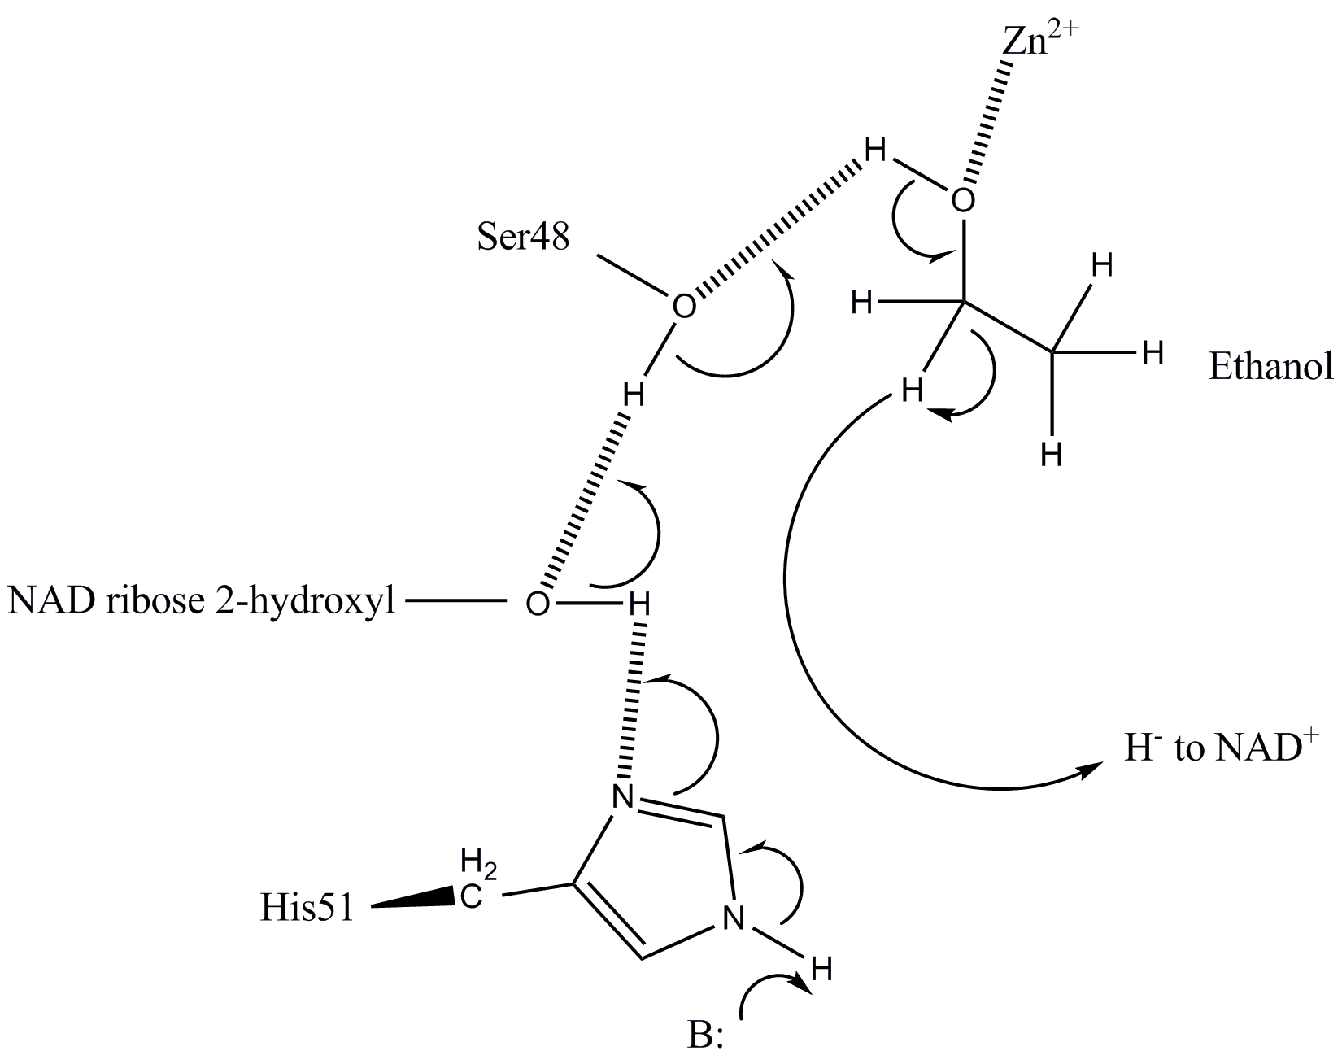

Step 2:

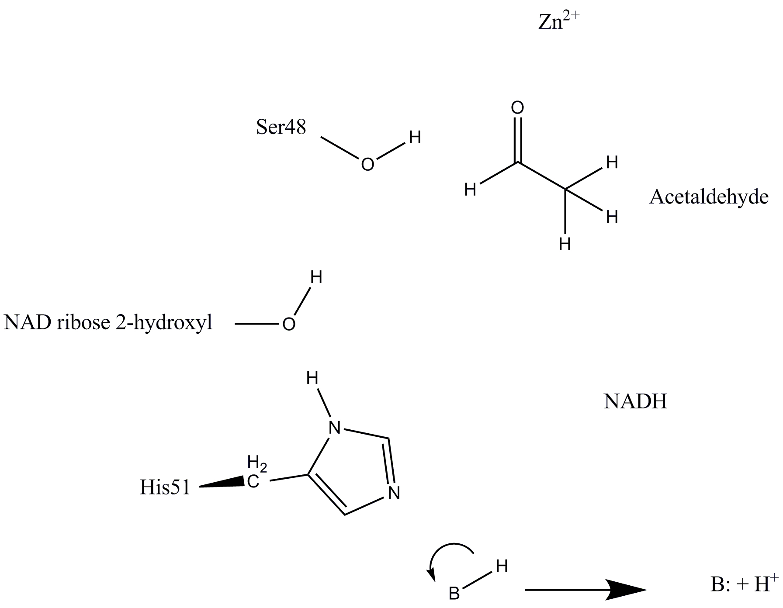

1. Draw the reaction mechanism of pectate lyase C. What do you think the pH optimum of this enzyme is? Why?

**For complete credit on this question, you needed to include the following in your answer:**

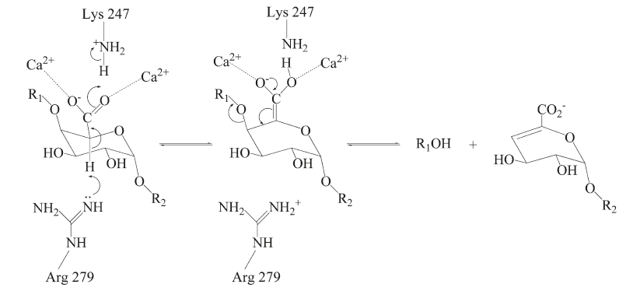

**The pH optimum of the enzyme should be basic in order to prevent protonation of Arg279 prior to the reaction even beginning.**

1. What is the definition of an asymmetric unit of a protein crystal? What does the term ‘mosaicity’ mean in terms of a protein crystal? How does mosaicity affect the quality of the collected data? What is a crystallographic B-factor and what physical phenomena does it reflect?

**For complete credit on this question, you needed to include the following in your answer**

1. **The asymmetric unit of a protein crystal is defined as the smallest unit that can be rotated and translated to generate one unit cell using only the symmetry operators allowed by the crystallographic symmetry. The asymmetric unit may be one molecule or one subunit of a multimeric protein, but it can also be more than one.**
2. **Mosaicity refers to the imperfect packing of a crystal. It is sometimes referred to as a measure of long range order within the crystal. Small rotations, translations of the unit cells in the crystal lattice will increase the mosaicity of the crystal as will non-protein inclusions (ions, small molecules, etc.)**
3. **The crystallographic B-factor is also referred to as the temperature factor. The temperature factor is a measure of atomic displacement and can represent atomic motion (thermal motion) or static disorder within the crystal. Protein domains within the crystal that may be mobile (such as loops) have very high B-factors and as such, the coordinates for those atoms need to be examined with care. It is found in the structure factor equation below:**



1. What is the difference between the retaining and inverting glycosyl hydrolase mechanisms? Go ahead and draw each to make it easier to understand.

**For complete credit on this question, you needed to include the following in your answer:**

1. **Both mechanisms require a proton donor and a catalytic base.**
2. **In both mechanisms, the position of the proton donor is identical. It is within hydrogen bonding distance of the glycosidic oxygen.**
3. **In retaining enzymes, the nucleophilic base is within hydrogen bonding distance to the anomeric carbon involved in the glycosidic bond to be hydrolyzed. In inverting enzymes, the base is far enough away to allow a water molecule to come in. In these inverting enzymes, the catalytic base actually deprotonates a water molecule and the activated hydroxyl attacks the anomeric carbon. As a result, the distance between the proton donor and the catalytic base in retaining enzymes is half that of inverting type hydrolases. See figure below.**

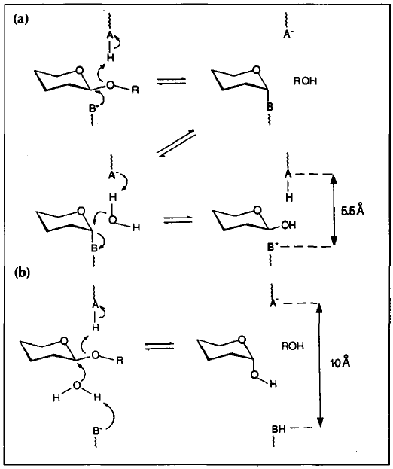

Figure : Mechanisms of glycosyl hydrolases. In part (a), the mechanism of a retaining type enzyme is shown. In part (b), the mechanism of an inverting type enzyme is shown. Figure adapted from Davies and Henrissat, (1995), Structure 15: 853-859.

1. What are the three types of active site topologies seen in glycosyl hydrolases? Do the different topologies have an effect on the mode of action of the enzymes? Explain.

**For complete credit on this question, you needed to include the following in your answer:**

1. **Pocket topology. In this topology, often described as a crater topology, the active site is a small indentation on the enzyme surface. This type of topology restricts the enzyme to binding one of the ends of the polysaccharide substrate and releasing small mono- or disaccharide products in an exolytic mechanism.**
2. **Cleft topology. In this topology, the enzyme has a cleft formed by mainchain loops or a single loop and the body of the enzyme. The walls of the cleft have a role in properly binding substrates. Enzymes with this topology often cleave via an endolytic mechanism which gives a range of released products.**
3. **Tunnel topology. In this topology, the enzyme has a tunnel through which the substrate enters, is bound and subsequently cleaved. Since there are so many possible contacts that are made between the substrate and enzyme, proteins with this type of topology do not completely release the substrate polymer after cleavage, but rather slide the substrate through the tunnel and cleave it again in a processive manner. Enzymes with this topology release small oligosaccharide products, not unlike enzymes with the pocket topology.**
4. Draw a clearly defined crystallographic phase diagram and explain each of the areas of the plot. Using hanging-drop vapour diffusion as an example, explain a crystal growth experiment specifically addressing what is happening in the drop and how it is reflected in the phase diagram.

**For complete credit on this question, you needed to include the following in your answer:**

**i) In a hanging drop crystallization experiment, a volume of protein solution is mixed with a volume of crystallization solution, thereby diluting the concentration of the components of the crystallization solution by one-half (Top left figure below with the oval and the two droplets). The cover slip bearing the two drops is then placed over a reservoir containing a large (with respect to the drop volume) volume of crystallization solution and the well is sealed. As the drop equilibrates, water evaporates from the drop which increases the concentration of both protein and precipitant. In the phase diagram below this is represented by a movement from the purple area to the green nucleation zone. In this zone, protein molecules are at a sufficient concentration to form crystal nuclei. As these nuclei form and grow, the localized protein concentration decreases as protein molecules join the growing crystal faces. This causes a drop from the nucleation zone to the growth zone seen in the phase diagram below. In the red zone seen in the upper right of the figure below, the crystallization drop separates into a two-phase system consisting of a protein phase and precipitant phase. Quite often, the protein will precipitate in this area of the curve.**

