CHEM523 Exam 3 Fall 2021 Name: _______________________________

You are going to take this test at home and bring it to class (or email it to me if
you decide to skip class) on Thursday, December 2 by 9:30AM. You may briefly
review things that you think you need to brush up on before turning the page and
starting the section. Once you start this test, you are on your honor to refrain from
opening the internet, textbooks, cell phone, asking your friends, asking ghosts that
you might know, asking your pet, asking your neighbor’s pet, asking your neighbor’s
pet’s pet, talking to your cereal, inquiring about the exam to your priest, bothering
the deity (or deities, I don’t judge) you worship, talking about the exam with your
favorite taxidermied platypus, or emailing me anything. In short, take some time and
review, then dive into the following questions without using anything but the big,
beautiful neural blobs tucked away in your cranial vaults. Think of this page as a pit
stop before you make the final run for the checkered flag and all of the glory and honor
that comes with it.

Things I’d review before unsealing this tome:

- Mechanism of nucleic acid replication
- Lipid structure
- RNA Polymerase
- Cell signaling pathways
- Specific sugars, disaccharides and polysaccharides you were told to know
- Big picture of the entire DNA replication machinery (all enzymes/molecules involved)

But that’s just me, you do what you feel is best.

Y’all got this, now get out there and show ‘em what for!

Section 1: Fun! Answer the following 14 multiple choice questions by circling the entire answer. Each question is worth 2 points. Think about all of the possible answers and circle the entire answer, not just the letter. If you are using a Rocketbook page, your answer must be in the form of:
1. Answer: X where “X” is your choice of answer.

1. Peripheral membrane proteins:
A) are generally noncovalently bound to membrane lipids.
B) are usually denatured when released from membranes.
C) can be released from membranes only by treatment with detergent(s).
D) may have functional units on both sides of the membrane.
E) penetrate deeply into the lipid bilayer.

2. The shortest α helix segment in a protein that will span a membrane bilayer has about _____ amino acid residues.

A) 5
B) 20
C) 50
D) 100
E) 200

3. Which of these statements is generally true of integral membrane proteins?
A) The secondary structure in the transmembrane region consists solely of α-helices or β-sheets.
B) The domains that protrude on the cytoplasmic face of the plasma membrane nearly always have covalently attached oligosaccharides.
C) They are unusually susceptible to degradation by trypsin.
D) They can be removed from the membrane with high salt or mild denaturing agents.
E) They undergo constant rotational motion that moves a given domain from the outer face of a membrane to the inner face and then back to the outer.

4. The fluidity of the lipid side chains in the interior of a bilayer is generally increased by:
A) a decrease in temperature.
B) an increase in fatty acyl chain length.
C) an increase in the number of double bonds in fatty acids.
D) an increase in the percentage of phosphatidyl ethanolamine
E) the binding of water to the fatty acyl side chains.

5. When a bacterium such as E. coli is shifted from a warmer growth temperature to a cooler growth temperature, it compensates by:
A) increasing its metabolic rate to generate more heat.
B) putting longer-chain fatty acids into its membranes.
C) putting more unsaturated fatty acids into its membranes.
D) shifting from aerobic to anaerobic metabolism.
E) synthesizing thicker membranes to insulate the cell.

6. Which of the following monosaccharides is a ketose?
A) glucose
B) fructose
C) galactose
D) mannose

7. How many carbon atoms are in the simplest carbohydrates?
A) 1
B) 2
C) 3
D) 4
E) 5

8. Sucrose is composed of the following simple sugars:
A) galactose only
B) glucose only
C) fructose only
D) galactose and glucose
E) glucose and fructose
F) galactose and fructose

9. Triacylglycerols are composed of:
A) a glycerol backbone.
B) three fatty acids.
C) amide linkages between the fatty acids and the glycerol.
D) A and B above.
E) A, B, and C above.

10. Which of the following is not a feature of signal transduction?
A) Integration of multiple pathways toward the same downstream response
B) Signal amplification
C) Covalent binding between the ligand and the receptor
D) Desensitization or adaptation of the receptor
E) Variable affinity for different signaling components

11. Which of the following is not true for G protein–coupled receptors (GPCRs)?
A) Agonists mimic the effect of the natural ligand.
B) Antagonists block the normal effect of the natural ligand.
C) GPCRs interact with heterodimeric G proteins.
D) GPCRs are have seven transmembrane helices.
E) There exist >100 orphan GPCRs in the human genome with no known ligand.

12. Which of the following are involved in desensitization of the β-adrenergic receptor?
A) β-adrenergic receptor kinase
B) Arrestin
C) GTPase activating proteins (GAPs)
D) A and B above
E) A, B, and C above

13. Autophosphorylation of receptor tyrosine kinases depends on which of the following?
A) Dimerization of the receptor
B) ATP
C) Ligand binding
D) Transmission of conformational changes through the membrane
E) All of the above

14. Which of the following statements concerning signal transduction by the insulin receptor is not correct?
A) Activation of the receptor protein kinase activity results in the activation of additional protein kinases.
B) Binding of insulin to the receptor activates a protein kinase.
C) Binding of insulin to the receptor results in a change in its quaternary structure.
D) The receptor protein kinase activity is specific for tyrosine residues on the substrate proteins.
E) The substrates of the receptor protein kinase activity are mainly proteins that regulate transcription.

Section 2: Games! Answer the following questions thoroughly, completely and as succinctly as possible.

15) (10 points) Draw the mechanism of the reaction catalyzed by DNA polymerase that occurs between deoxyribose at the end of a DNA chain and a deoxyribonucleoside triphosphate. Include the chemical structure of the phosphate group, the structure of the sugar (the nitrogenous base may be drawn as a rectangle that says “Base”), amino acids and ions that may be involved and show the rearrangements of electrons that occur.

16) (10 points) Draw the structure of phosphatidylethanolamine containing one palmitate and one stearate in the chemical form expected at pH 7.

17) (6 points) What is a lipid raft and why are they crucial for the cell?

18) (9 points) Answer the following questions about bacterial RNA Polymerase.

i) What is a sigma subunit?

ii) What is the region of DNA that the RNA polymerase binds called?

iii) There are two key sequence regions in your answer to part ii of this question, what are they?

19) (18 points) Answer the following questions about the beta-adrenergic pathway.

- What is the ligand that triggers the pathway?

- Once the ligand is bound, what happens on the cytosolic side of the plasma membrane?

- What is the effector enzyme and what is the second messenger of the pathway?

- What triggers the effector enzyme?

- The second messenger activates what protein? How many second messenger molecules does it take to activate this protein and why?

f) Name 2 of the 3 possible ways that the signal can be stopped (NOT dampened, but stopped).

20) (12 points) Answer the following questions about the insulin receptor tyrosine kinase pathway.

a) What makes the receptor different from the one found in the beta-adrenergic pathway?

b) What is the substrate of the insulin receptor tyrosine kinase?

c) Ras is a crucial protein in the pathway. What type of protein is it and what does it do? (Hint: there are homologues in GPCR mediated pathways)

21) (10 points) Lysozyme is an enzyme that catalyzes the hydrolysis of the b-1,4 glycosidic bond between N-acetyl-muramic acid and N-acetyl glucosamine in the cell walls of bacteria using aspartate and glutamic acid residues in the enzyme and a solvent water molecule. Draw the NAM-NAG substrate and the reaction mechanism for the hydrolysis of the glycosidic bond between the sugar monomers.

22) (10 points) Draw a possible enzyme catalyzed mechanism for the hydrolysis of myristic acids from a triglyceride. You only need to show the mechanism for the hydrolysis of a single myristic acid, I will assume that the remaining two fatty acids are hydrolyzed in the same manner.

23) (5 points) Draw the Fisher projection and the Haworth projection for one of the following sugars. Write the name of the sugar under the Haworth projection.

Your choices are: β-D-galacturonic acid, α-D-ribose, β-D-mannose

24) (2 points) What is a glycosidic bond?

25) (4 points) Draw one of the following disaccharides: maltose, sucrose, trehalose, lactose. Write the name of the disaccharide underneath it, making certain to include the linkage in the name.

26) (4 points) What are the differences between cellulose and glycogen?

Section 3: Picture time! Please fill in the blanks in the image below.
27) (10 points) Label the components of the following diagram (10 total parts, 27A through 27J)
27A

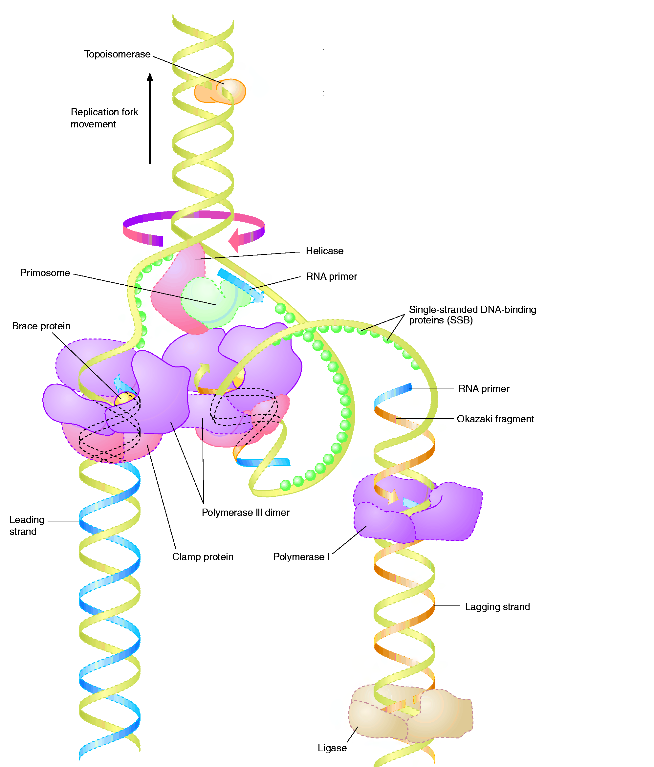
This protein relieves torsion of the chromosome:

___________________________________

27B, C

2 parts: This protein hydrolyzes ________ to unwind the double strands:

___________________________________

DNA ___________

_____________ Strand
DNA Pol ______
DNA Pol ______

______________ Strand

___________________________________
This protein stabilizes unwound DNA:
___________________________________

27J
27I
27H
27G
27F
27E
27D

