CHEM523 Final Exam Name: ___________________________

Answer all of the following questions. Each question is worth 5 points. You have 2.5 hours to complete this exam. Submit your answers via Rocketbook to hurlbertj@winthrop.edu within 2 hours and 35 minutes of your scheduled exam time. Late exams will not be accepted. If you have a question, my cell phone number is 803-979-1503. Text me your name and a brief question. I will try to answer via text message. Should it become necessary to speak with you in person, I will send you a link to a Zoom room as soon as I can. Continue working on the exam until I get back to you because your time limit will not be extended.

- For the pentapeptide Asp-Ser-Arg-Gln-Gly:
- What is the full name of the carboxyl-terminal residue?
- What is the net charge of the peptide if it was solvated at pH 1?
- What is the net charge of the peptide if it was solvated at pH 7?
- Write the sequence using one-letter symbols.
- Draw the complete structure of the pentapeptide at physiological pH.

2) Draw the structure of a glycerophospholipid at physiological pH with: a lauric acid ester, a stearic acid ester and a phosphocholine head group.

3) Draw the Haworth structures and full chemical names of Sucrose and Lactose (the full chemical names give the sugars involved and the linkages between them, see question 6 if you’re confused).

Sucrose |  | Lactose

4) This question has 2 parts:

- What is the biological importance of a sugar being a reducing sugar or a non-reducing sugar? If you can’t answer this question, jump to part b and think about what is going on there and then come back to this part.

- A1C is the term used to describe the glycosylation of the alpha-amino group of the first valine residue in the beta-subunit of hemoglobin and is a common metric used to diagnose the success of medical treatment of a diabetic patient. Propose a non-enzymatic reaction that results in the formation of a N-glycosidic bond between the anomeric carbon of D-glucose to the alpha-amino group of valine-1 and the creation of an alcohol on carbon 1 of D-glucose. Draw a possible mechanism for this reaction.

5) This question has 2 parts.

- Briefly describe how proteins fold. Your answer must lay out the facts in a logical, chronological form that fully describes the chemical entities, forces and energies involved. You must include a description of the hydrophobic effect and the roles of the solvent and polypeptide.

- What was the Anfinsen experiment and what did it prove?

6) β-Galactosidase is a glycosyl hydrolase that hydrolyzes the glycosidic bond of β-D-galactosylosyl-(1,4)-β-D-galactopyranose, releasing two β-D-galactopyranose residues.

a) Draw the chemical structures of the substrate and the products formed in the reaction.

b) Based upon what you know about enzyme mechanisms, draw a likely reaction mechanism for the enzyme. The enzyme uses a general acid base mechanism (In other words, at the start of the reaction, one nucleophile is deprotonated and one is protonated) that is similar to the mechanism used by lysozyme. You must include all necessary amino acid side chains, substrate atoms, and arrows.

7) Describe the three types of non-covalent enzyme inhibition by:

a) Drawing the double-reciprocal plots of the enzymatic reaction in the absence and presence of two concentrations of inhibitor
b) Giving the molecular species each type of inhibitor binds to (eg: E, ES)
c) Giving the kinetic parameters affected by each type of inhibitor

8) This question has three parts:

- For an enzyme with the following kinetic data, determine the Km and Vm:

[S] (mM) | Vo (mM product formed/min)
0.10 | 0.0020
1.00 | 0.0160
2.00 | 0.0352
5.00 | 0.1056
10.00 | 0.1770

- Define the steady state assumption

- What is meant by the term “Free-energy of binding”?

9) Nearly every topic we have discussed this semester has come down to Intermolecular forces. You have seen these forces in every aspect of chemistry and molecular biology. What are the four primary intermolecular forces from lowest energy to highest energy?

10) Speculate on why it is that when allosteric regulation is needed, proteins with quaternary structures rather than single-domain proteins have often evolved to fill the need. Discuss the evolutionary advantage of allostery with respect to the desire of the cell to remain at equilibrium. (Yes, I am looking for an answer that includes a very specific graph of activity versus substrate concentration for an allosteric enzyme and a non-allosteric enzyme and a ratio of values within that graph that we discussed in lecture)

11) What is the effect of pH on the binding of oxygen to hemoglobin (the Bohr Effect)? Specifically, I want to know the conformational changes that occur when oxygen binds to iron in hemoglobin. Briefly describe the mechanism of this effect using specific details, amino acids and chemical reactions in terms of the physiological compartments where it is most important.

12) What are the 5 things all signal transduction pathways have in common?

13) Describe the beta-adrenergic pathway, making sure to include details about: the ligand, the receptor, other proteins in the pathway, important molecules generated and how the system is desensitized. In short, give me everything about the pathway as we discussed it in hepatocytes.

OR

Describe the insulin tyrosine receptor kinase pathway, making sure to include details about: the ligand, the receptor, other proteins in the pathway, important molecules generated and how the system is desensitized. In short, give me everything about the pathway as we discussed it in hepatocytes.

14) Label the components of the following diagram (10 total parts)

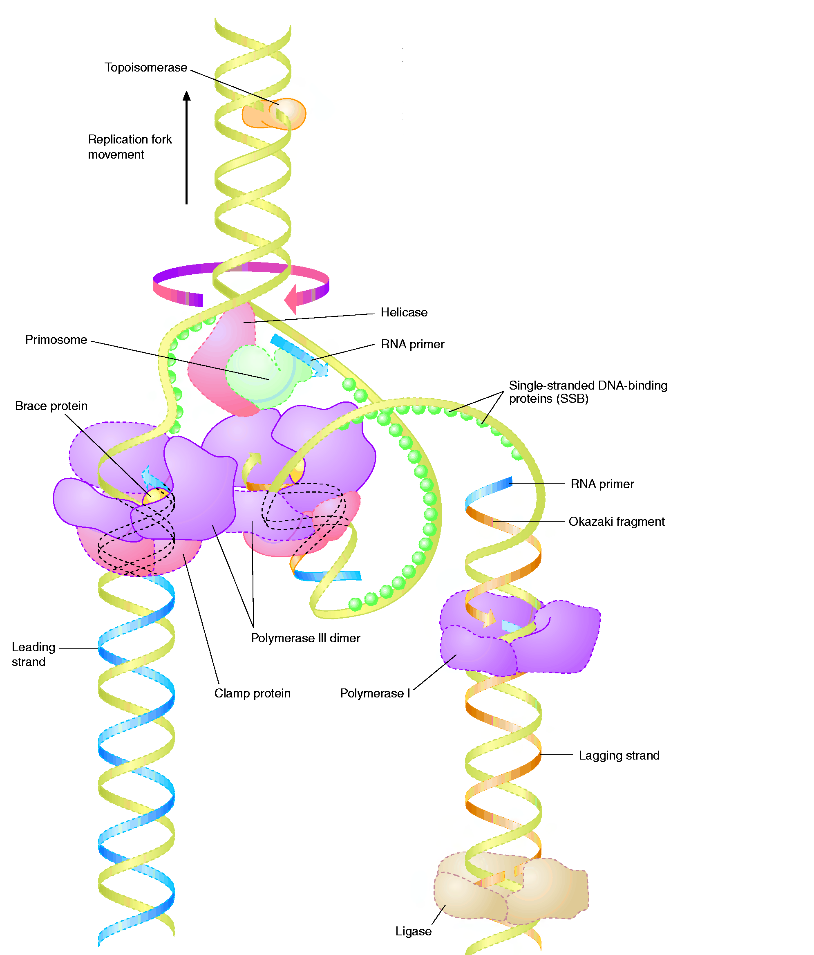
a) This protein relieves torsion of the chromosome:

___________________________________

2 parts: This protein hydrolyzes b) ________ to unwind the double strands:

c) ________________________________(name of the protein)

f) ___________ Strand

i)____________ Strand

e) _______________________________
d) This protein stabilizes unwound DNA:
___________________________________

g) DNA Pol ____ ______

h) DNA Pol _________

j) DNA ___________

15) What is a lipid raft and why are they important to a cell?

16) An undecapeptide that was identified from patients that became sick after eating at Shrimp Boat (“Ain’t no chicken like Shrimp Boat Chicken!”. It’s good, yeah, but why not call it “Chicken Coop” instead of Shrimp Boat?) was sequenced using traditional methods.

- When the undecapeptide is hydrolyzed and analyzed by ion-exchange chromatography, the following amino acids are detected: Asp, Glu, two Ile, two Arg, a Phe, a Met, a Pro, a Ser and a His.

- Cleavage of the undecapeptide with trypsin yielded a dipeptide, a hexapeptide and a tripeptide. Two cycles of Edman degradation of the hexapeptide yielded an Ile and a Glu.

- Cleavage of the intact peptide with cyanogen bromide yielded proline and a decapeptide.

- Treating the intact undecapeptide with chymotrypsin yields a Phe, and a decapeptide. Two cycles of Edman degradation of the decapeptide yielded an Arg and an Ile

- When the intact hexapeptide is treated with carboxypeptidase A, a proline residue and a decapeptide are produced.

- Cleavage of the intact peptide with V8 protease gave a tetrapeptide, an Asp and a hexapeptide. Two cycles of Edman degradation of the hexapeptide yield a Ser and a His.

Write out the undecapeptide’s amino acid sequence, using one-letter amino acid abbreviations.

17) The serine proteases are a novel group of enzymes that have fascinated chemists and biochemists for years. Answer the following questions about this interesting group of enzymes.

- Explain how this family of enzymes serves to illustrate the two different types of molecular evolution.

- What are the catalytic residues of these enzymes?

18) Draw the mechanism for the trypsin catalyzed hydrolysis of the tripeptide: PhenylalanylLysylGlycine. You must draw the substrate and products as they would be at physiological pH, but for the mechanism steps, you can simply show the substrate as an amide group with R and R’ on either side, and show all relevant amino acid side chains, and additional molecules necessary to catalyze the reaction.

19) Answer the following 3 questions about sugars.

- What is (are) the chemical difference(s) between glycogen and amylopectin? What is the relationship between the chemistry of each polysaccharide and the function of the polysaccharide.

- What are proteoglycans and what distinguishes the repeating units of proteoglycans from other disaccharides?

- What amino acids can sugars be attached to?

20) Describe how you would perform an ELISA to determine if someone had previously had COVID-19.

21) Describe a 3 step purification protocol that you would use to purify a 350 amino acid protein with an isoelectric point of 8.2 and a glucose binding tag. Include all purification resins needed, buffers needed in each step and how you would elute the protein from each resin. Your protocol must be in a logical order to receive full credit.

23) Draw the mechanism for the addition of a deoxynucleotide triphosphate to a growing piece of DNA catalyzed by DNA Pol I. Be certain to include all necessary substrates, reactants, products, amino acids and relevant ions.

24) Develop an enzyme catalyzed mechanism to hydrolyze the stearic acid moiety from the phosphoglyceride you drew to answer Question 2. Draw the mechanism out making sure to show all necessary items.

25) What are the 5 ways to modulate the activity of an enzyme and give an example of each.

