CHEM523 Test 2 Name: _____________________________

Answer each of the following questions as completely and succinctly as possible. You may use a scientific calculator or a spreadsheet program to plot any kinetic data necessary. THIS IS NOT AN OPEN BOOK/OPEN NOTE/OPEN INTERNET test. You have 75 minutes to complete the exam and an additional 5 minutes to scan your answers and send me your test via Rocketbook.

Section 1: Stretch your mental muscles and get ready. 5 points each

- What is the Michaelis-Menton equation and what does a Michaelis-Menton plot of enzyme activity look like? Be sure to label all axes and important points on the plot.

- What is the Lineweaver-Burk equation and what does a Lineweaver-Burk Plot of enzyme activity look like? Be sure to label all axes and important points on the plot.

- What are the 3 types of reversible inhibition? Draw a Lineweaver-Burk plot for each type of inhibition, making sure to include a line corresponding to no inhibitor present for each case.

- What is an enzyme and how do they work?

- What amino acids are phosphorylated in proteins? Why only those and not others?

Section 2: Now that you’re warmed up, time to pick up the pace. 5 points each.

- Answer the following 2 questions (6a and 6b) about an enzyme-catalyzed reaction. You will need to use Excel or a scientific calculator to determine the linear regression equation of the data.

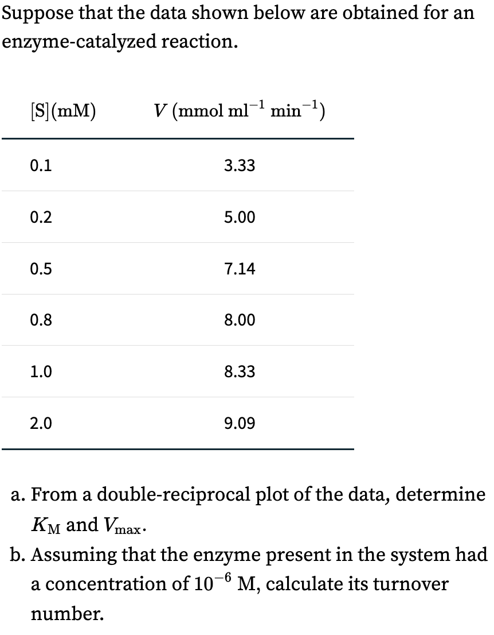

7) Suppose that the data shown below are obtained for an enzyme-catalyzed reaction in the presence and absence of inhibitor X.

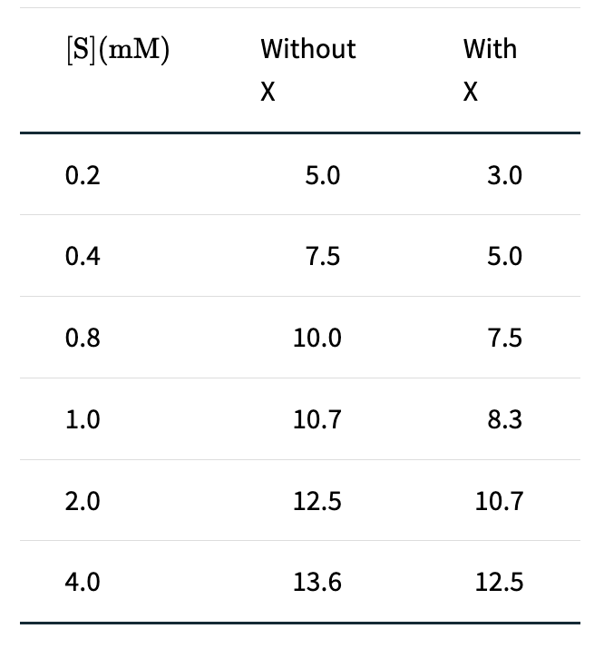

- Using double-reciprocal plots of the data, determine the type of inhibition that has occurred. Just tell me the type of inhibition, I don’t need to see your plot.
- Does inhibitor X combine with E, with ES, or with both? Explain.

8) If you were studying an enzyme that catalyzed the reaction of ATP and fructose 1-phosphate to form fructose 1,6-bisphosphate and ADP and discovered that a plot of the initial velocity of formation of fructose 1,6-bisphosphate versus ATP concentration was not hyperbolic, but rather sigmoid, what would you suspect?

9) Answer the following 2 questions about trypsin and its inhibition.

- The following molecule is a known inhibitor of trypsin. Knowing what you know about enzyme inhibitors, what type of inhibitor do you think this molecule is and why?

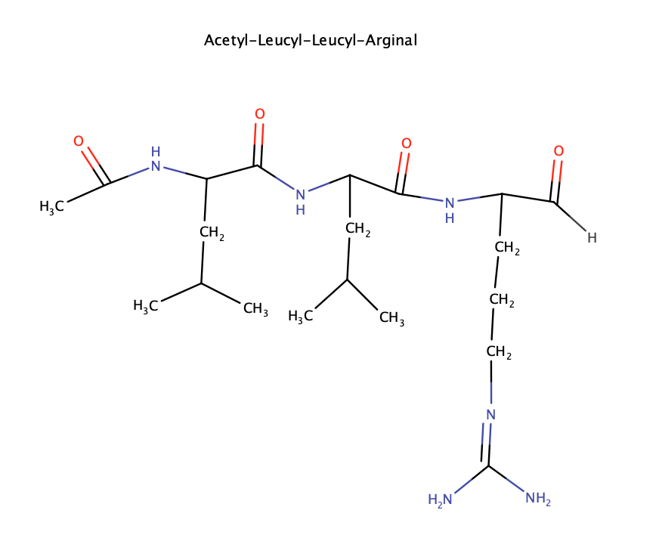

- Show the reaction mechanism that occurs when the inhibitor interacts with trypsin.

Section 3: Maximum Effort! 10 points each
10) What are the 3 rules for mechanisms we discussed in class?

11) Draw the mechanism for carbonic anhydrase.

12) Draw the mechanism for one of the following enzyme catalyzed reactions: metalloprotease catalyzed hydrolysis of a peptide bond, aspartyl protease catalyzed hydrolysis of a peptide bond, protein kinase phosphorylation of a protein substrate.

13) What are the 5 ways to modulate the activity of an enzyme and give an example of each.

14) What is the importance of the ratio of [S]0.8_{Vmax}/[S]0.1_{Vmax} for allosteric enzymes versus non-allosteric enzymes?

15) Explain the two types of molecular evolution we discussed in class using the serine proteases as the basis for your answer.

