CHEM523 Fall 2021 Test 1 Name:_______________________

Answer the following questions completely and thoroughly. You have 75 minutes to take the test. This is a closed note, closed book, closed computer test. You are on your honor as students to follow these rules. Each question is worth 10 points. There are a total of 120 points on this exam.

- The following question has three parts:
- (3 pts) What are the four IMFs we discussed in class from lowest energy to highest energy?
- (3 pts) What are the Coulombic energy equations for each IMF?
- (4 pts) Give an example of each IMF using amino acids.

- For the pentapeptide Glu-Met-Arg-Thr-Gly:
- What is the full name of the carboxyl-terminal residue?
- What is the net charge of the peptide if it was solvated at pH 1?
- What is the net charge of the peptide if it was solvated at pH 7?
- Write the sequence using one-letter symbols.
- Draw the complete structure of the pentapeptide at physiological pH.

- Draw and discuss the significance of the Ramachandran plot. Be certain to include what regions of the Ramachandran plot are significant and why they are significant.

For questions 4 and 5, refer to the table below:
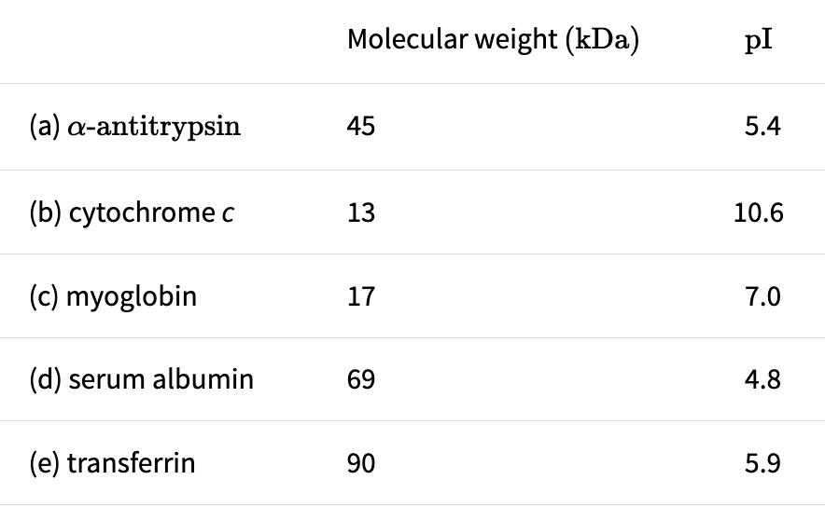

- The following five proteins, which are listed with their molecular weights and isoelectric points, were separated by SDS-polyacrylamide gel electrophoresis. Give the order of their migration from the top (the point of sample application) to the bottom of the gel.

(Give your answer as: Top of gel-Protein name, Protein name, Protein name, Protein name, Protein name, Protein name-Bottom of gel)

- Describe a two-step chromatographic purification that would allow you to purify alpha-antitrypsin from the other proteins. Your answer must include buffer pH values, chromatographic resins and how you would elute the protein from the resins.

- A hexapeptide that is part of a mouse polypeptide hormone is analyzed by a number of chemical and enzymatic methods.
- When the hexapeptide is hydrolyzed and analyzed by ion-exchange chromatography, the following amino acids are detected: Tyr, Cys, Glu, Ile, Lys, Met

- Two cycles of Edman degradation of the intact hexapeptide released the PTH-derivatives of methionine and isoleucine.

- Cleavage of the intact protein with cyanogen bromide yields methionine and a pentapeptide.

- Treating the intact hexapeptide with trypsin yields a dipeptide, which contains tyrosine and glutamate, and a tetrapeptide.

- When the intact hexapeptide is treated with carboxypeptidase A, a tyrosine residue and a pentapeptide are produced.

Write out the hexapeptide’s amino acid sequence, using one-letter amino acid abbreviations.

- Describe an antibody-based test that could be used to identify if a patient has had COVI-19 in the past. Draw a schematic of the test like we had in the lecture notes.

- Describe the Anfinsen experiment and explain what it revealed making certain that your explanation supports that revelation.

- Describe the process of protein folding from the moment the polypeptide emerges from the ribosome until it reaches its final folded state. All necessary thermodynamic terms, structural states and explanations must be included in your answer for full credit to be given.

- Name and describe the two models of cooperativity we discussed in class and relate each model to the equilibrium binding of oxygen by hemoglobin (Think back at the figures from your lecture notes and textbook about the binding of oxygen in each model).

- What is the biochemical basis for the following fractional saturation curves of hemoglobin at pH 7.2 and pH 7.4? Explain all relevant chemical reactions, cellular compartments, and amino acids involved or your answer will be incomplete.

- Draw the fractional saturation curves for myoglobin and hemoglobin, making sure to mark the p50 values for each protein and relevant physiological pO₂ values. Once complete, explain why each protein plays the role it plays in oxygen transport using your graph as the reference point.

