CHEM523 Exam #1 Name: _______________________

Section 1. Fun! (6 questions, 50 points total) (Here we go!)

Answer the following questions with the best possible answer given the choices available.

1. (4 points) The artificial sweetener NutraSweet®, also called aspartame, is a simple dipeptide, aspartylphenylalanine methyl ester, on which the free carboxyl of the dipeptide is esterified to methyl alcohol. Draw the structure of aspartame, showing the ionizable groups in the form they have at pH 7.

2. (2 points each) Answer 1 of the following 3 questions about the fibrous proteins we discussed in lecture. If you answer all 3, you'll receive bonus points.

i) Why is silk fibroin so strong, but at the same time so soft and flexible?

ii) What gives collagen its high tensile strength?

iii) α-keratin has a unique amino acid in it. What is this amino acid and what disease is caused by a deficiency of it?

3. (12 points) Answer the following questions about protein folding:

i) What was the Anfinsen experiment? What did his work show?

ii) Describe the chronology of the folding of a globular protein. You must use the terms and concepts we discussed when describing how a protein goes from a linear sequence of amino acids to a compact, functional molecule.

iii) What is meant by the terms "Motifs" and "Domains"? What are the differences between the two?

4. (8 points) This question has 2 parts.

i) What is the effect of pH on the binding of oxygen to hemoglobin (the Bohr Effect)? Specifically, I want to know the conformational changes that occur when oxygen binds to iron in hemoglobin.

ii) Briefly describe the mechanism of this effect using specific details, amino acids, chemical reactions in terms of the cellular compartments where it is most important.

5. (12 points) Answer the following 3 questions about enzyme-catalyzed reactions:

i) Write out the enzyme-catalyzed chemical reaction with all terms (E, S and P), the correct arrows and all rate constants over their respective errors.

ii) Draw and label a reaction coordinate diagram for an enzyme-catalyzed reaction, S -> P.

iii) How does an enzyme decrease the ΔG* (transition state free energy) for the chemical reaction? In other words, what traits of enzymes allow them to be efficient catalysts?

6. (12 points) Answer the following questions about enzyme kinetics.

i) The Michaelis-Menten constant, K_{m}, is actually a summary of three terms. What is the mathematical representation of the Michaelis constant and what does it represent for most enzyme catalyzed reactions?

ii) Write out the Michaelis-Menton equation and show what a plot of initial velocity as a function of substrate concentration would look like. Label the Vm and the Km on your plot.

iii) What is the Lineweaver Burk approximation of the Michaelis-Menton equation? Using this equation, how would you determine Vm and Km for a given enzyme? (Drawing a figure and label it would be the easiest way to answer this question)

Section 2. Games! (8 questions, 50 points total) Wheeeeeeee!
Answer the following questions as completely and thoroughly as possible. You must be concise and use complete sentences.

7. (10 points) Answer the following questions about serine proteases. You must give specific chemical and biological names in your answers.

i) How do these enzymes stabilize the transition state?

ii) What structural motif is the hallmark of this family of enzymes?

iii) Only one amino acid in your answer to question (ii) is the nucleophile for the reaction, what role do the other amino acids in the motif play? What specific and unique interaction do they have?

iv) Serine proteases are a perfect example of the two types of molecular evolution. What are these types and give specific examples of how the serine proteases serve as an example of each.

v) Complete the reaction mechanism for a typical serine protease below:

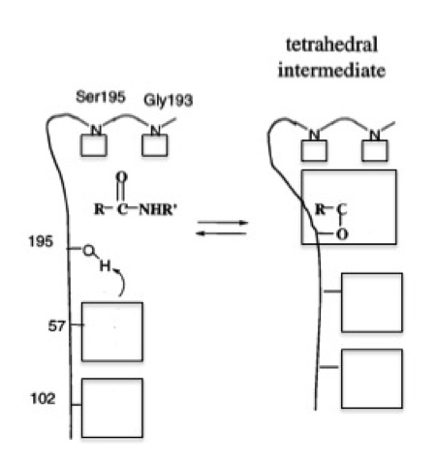

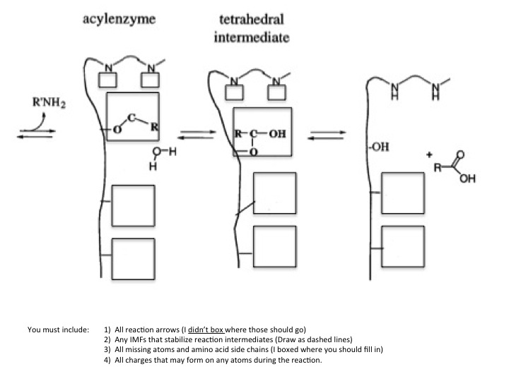

8. (6 points) Draw Lineweaver-Burk plots for each of the three types of non-covalent inhibition at 2 concentrations of inhibitor. You must draw the chemical reaction for each type of inhibition (E + I or E + S, etc.) and give the name of the type of inhibition under each of the plots.

9. (8 points) Answer the following questions about RNAse A.

i) RNAse A catalyzes a reaction that is an example of a General ________-________ type of reaction mechanism (fill in the blanks please).

ii) Complete the reaction mechanism for RNAse A given below by drawing all necessary reaction arrows and putting the correct chemical species in the boxes provided.

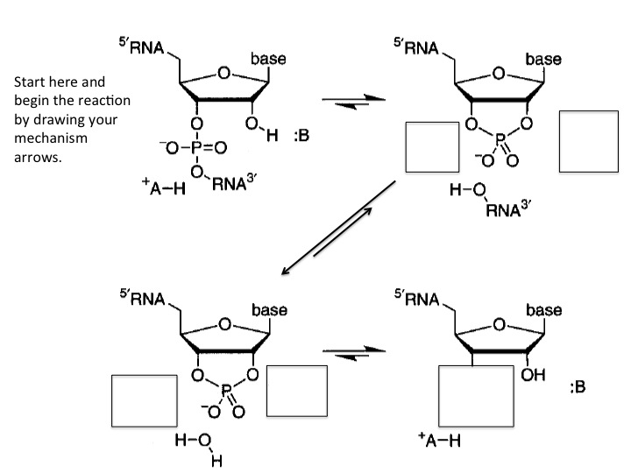

10. (4 points) Take your pick: Lysozyme or HIV protease. What are the catalytic amino acids involved in the reaction mechanism of your chosen enzyme? You must have the correct protonation state for each amino acid or no credit will be given!

11. (8 points) Name the intermolecular forces we have discussed this semester from highest energy to lowest energy. Give the Coulombic energy equations for each.

12. (3 points) Acid hydrolysis of an oligopeptide 7 residues long gave the following amino acids:
Asp Leu Lys Met Phe Tyr

The following facts were observed:
a) Trypsin treatment had no apparent effect.

b) The PTH derivative released by Edman degradation was: PTH-Phe

c) Brief chymotrypsin treatment yielded several peptides, including a dipeptide and a tetrapeptide. The amino acid composition of the tetrapeptide was Leu, Lys, and Met.

d) Cyanogen bromide treatment yielded a dipeptide, a tetrapeptide, and free Lys.

What is the amino acid sequence of this peptide?

13. (4 points) What are the 3 ways that protein activity can be regulated? Describe one of these in greater detail citing specific chemical examples.

14. (4 points) Name and describe 2 specific chromatographic methods you could use to purify a protein.

15. (3 points) Answer the following:

i) The number of amino acids per turn of an α-helix: ________

ii) Which is more stable: An antiparallel β-sheet or a parallel β-sheet? ___________

iii) How many types of β-turns did we study and what are their sequences? (write them below)

