CHEM523 Test 3 Name: _______________________________

Answer each of the following questions with the most correct answer.

Section 1: Fun! Answer the following 15 multiple choice questions for 4 points each. Circle the letter of the answer you have chosen AND put the letter of your chosen answer on the correct space of the answer sheet. Do not circle more than one answer or neither will be counted.

- In the binding of oxygen to myoglobin, the relationship between the concentration of oxygen and the fraction of binding sites occupied can best be described as: (A)

- hyperbolic.
- linear with a negative slope.
- linear with a positive slope.
- random.
- sigmoidal.

2) Myoglobin and the subunits of hemoglobin have: (E)

- no obvious structural relationship.
- very different primary and tertiary structures.
- very similar primary and tertiary structures.
- very similar primary structures, but different tertiary structures.
- very similar tertiary structures, but different primary structures.

3) The Meselson-Stahl experiment established that: (C)

- DNA polymerase has a crucial role in DNA synthesis.
- DNA synthesis in E. coli proceeds by a conservative mechanism.
- DNA synthesis in E. coli proceeds by a semiconservative mechanism.
- DNA synthesis requires dATP, dCTP, dGTP, and dTTP.
- newly synthesized DNA in E. coli has a different base composition than the preexisting DNA.

4) Which one of the following statements about enzymes that interact with DNA is true? (C)

- E. coli DNA polymerase I is unusual in that it possesses only a 5' → 3' exonucleolytic activity.
- Endonucleases degrade circular but not linear DNA molecules.
- Exonucleases degrade DNA at a free end.
- Many DNA polymerases have a proofreading 5' → 3' exonuclease.
- Primases synthesize a short stretch of DNA to prime further synthesis.

5) Prokaryotic DNA polymerase III: (C)

- contains a 5' → 3' proofreading activity to improve the fidelity of replication.
- does not require a primer molecule to initiate replication.
- has a β subunit that acts as a circular clamp to improve the processivity of DNA synthesis.
- synthesizes DNA in the 3' → 5' direction.
- synthesizes only the leading strand; DNA polymerase I synthesizes the lagging strand.

6) Which one of the following statements about E. coli RNA polymerase (core enzyme) is false? (B)

- It can start new chains de novo or elongate old ones.
- It has no catalytic activity unless the sigma factor is bound.
- It uses nucleoside 5'-triphosphates as substrates.
- Its activity is blocked by rifampicin.
- Its RNA product will hybridize with the DNA template.

7) The sigma factor of E. coli RNA polymerase: (A or B)

- associates with the promoter before binding core enzyme.
- combines with the core enzyme to confer specific binding to a promoter.
- is inseparable from the core enzyme.
- is required for termination of an RNA chain.
- will catalyze synthesis of RNA from both DNA template strands in the absence of the core enzyme.

8) Which subunit of E. coli RNA polymerase contains the catalytic site? (D)
Α) α
Β) β
) β'
D) interface of the β & β' subunits
E) σ

9) During the T to R conformational shift of human hemoglobin, Fe(II) drags the F-helix via a bond to the side chain of ________. (C)

A) Leu F7
B) Leu F4
C) His F8
D) Leu FG3
E) Val FG5

10) If the binding of O₂ to hemoglobin was characterized by a Hill constant of -1: (D)

A) hemoglobin would not be able to release bound O₂.
B) the O₂ binding curve would be hyperbolic.
C) the sequential model of allosterism would be eliminated as a reasonable model.
D) the binding of the first O₂ would decrease the affinity of the hemoglobin for O₂.
E) the binding of the first O₂ would increase the affinity of the hemoglobin for O₂.

11) Which of the following statements best describes the role of sigma factors in bacterial gene expression? (C)
- Sigma factors determine which DNA polymerase is used during transcription.
- Sigma factors mediate the excision of intronic sequences.
- A cell’s complement of sigma factors determines which of its genes are transcribed.
- Sigma factors bind to the TATA box and initiate transcription.
- none of the above

12) The term rRNA refers to ______ RNA. (A)
- ribosomal
- retroviral
- recombinant
- rho factor
- Righteous!

13) At replication forks in E. coli: (E)

- DNA helicases make endonucleolytic cuts in DNA.
- DNA primers are degraded by exonucleases.
- DNA topoisomerases make endonucleolytic cuts in DNA.
- RNA primers are removed by primase.
- RNA primers are synthesized by primase.

14) An Okazaki fragment is a: (D)

- fragment of DNA resulting from endonuclease action.
- fragment of RNA that is a subunit of the 30S ribosome.
- piece of DNA that is synthesized in the 3' 5' direction.
- segment of DNA that is an intermediate in the synthesis of the lagging strand.
- segment of mRNA synthesized by RNA polymerase.

15) The proofreading function of DNA polymerase involves all of the following except: (E)

- a 3' 5' exonuclease.
- base pairing.
- detection of mismatched base pairs.
- phosphodiester bond hydrolysis.
- reversal of the polymerization reaction.

Section 2: Games!
Answer the following 7 questions completely, unambiguously and clearly. Your answers must be well organized and concise.

16) (10 points) Draw the mechanism of the reaction catalyzed by DNA polymerase that occurs between deoxyribose at the end of a DNA chain and the 5' phosphates of a deoxyribonucleoside triphosphate. Include the chemical structure of the phosphate group, the structure of the sugar (the nitrogenous base may be drawn as a rectangle that says “Base”), and show the rearrangements of electrons that occur.

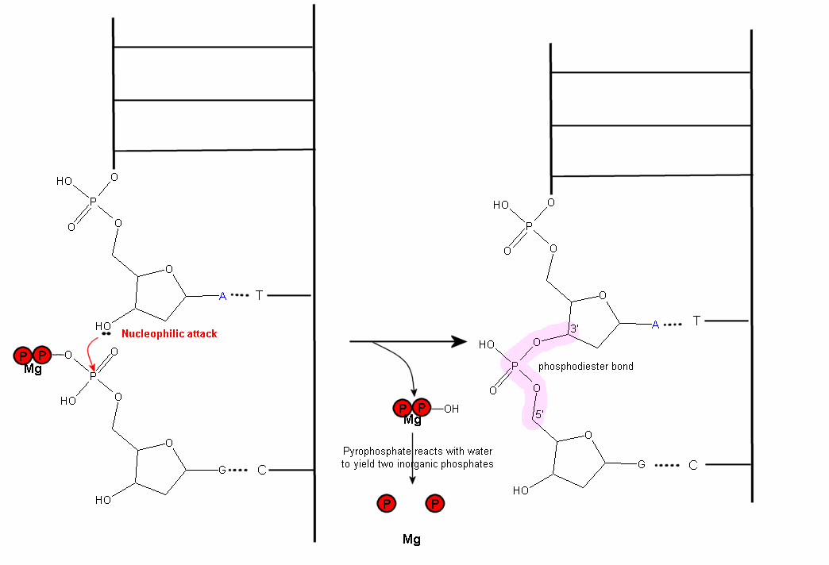

17) (2 points) List two proteins or enzymes, other than DNA polymerase III, that are found at the replication fork in E. coli; describe each of their functions with no more than one sentence.

18) (4 points) Compare and contrast ρ-dependent and ρ-independent termination of transcription in prokaryotes.

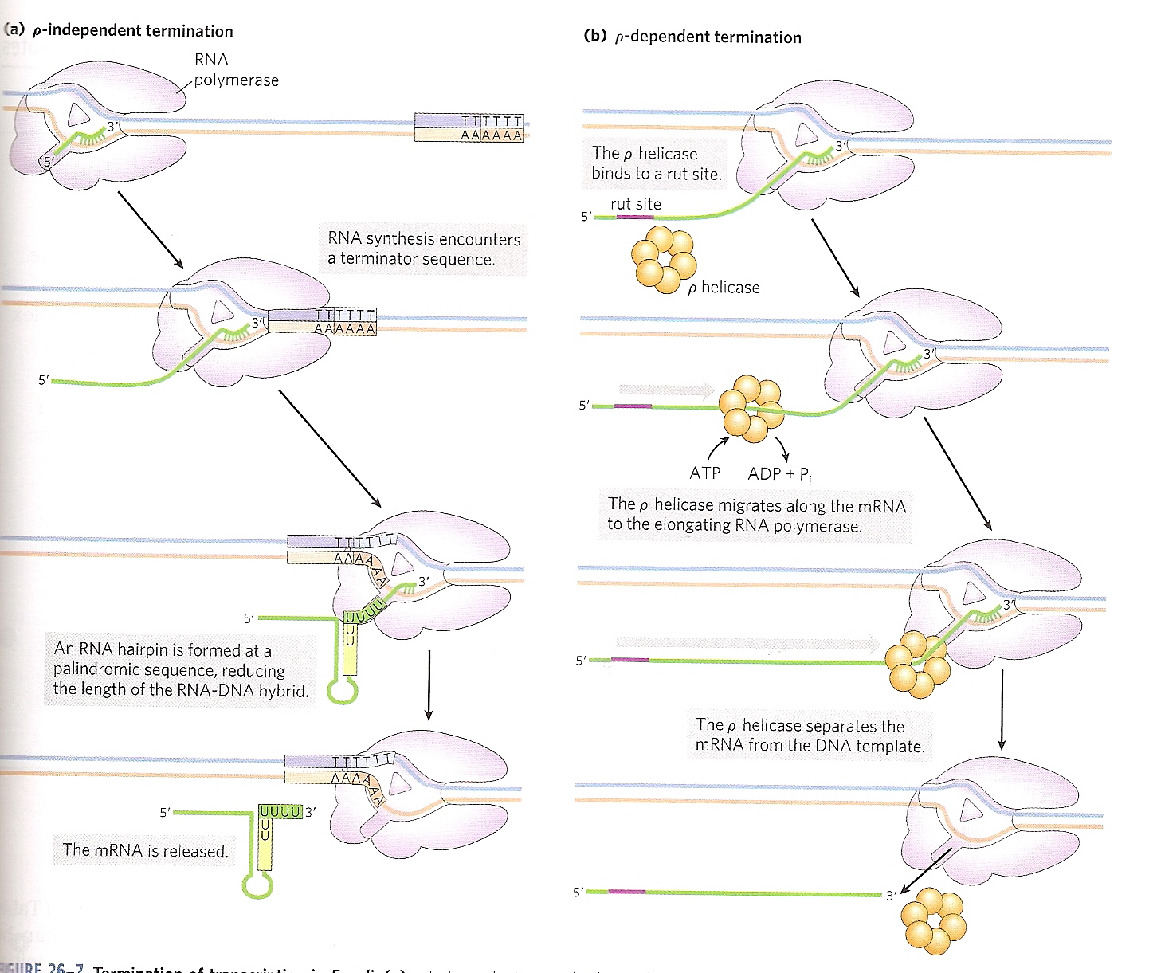

19) (4 points) (a) What is the Bohr Effect? (b) Briefly describe the chemical basis of this effect.

(a) The affinity decreases with decreasing pH. (b) At lower pH (i.e., higher H⁺ concentration) there is increasing protonation of protein residues such as histidine, which stabilizes the low affinity conformation of the protein subunits.

20) (4 points) Describe briefly the two principal models for the cooperative binding of ligands to proteins with multiple binding sites. Use figures to help illustrate your point.

In the concerted model, binding of a ligand to one site on one subunit results in an allosteric effect that converts all of the remaining subunits to the high-affinity conformation. As a result, all of the subunits are either in the low- or high-affinity conformation. In the sequential model, each subunit is changed individually to the high affinity conformation. As a result, there are many possible combinations of low- and high-affinity subunits.

21) (8 points) Draw a schematic of the lac operon and show what the operon would look like under the following conditions. Your diagram must show proteins and relative mRNA levels in addition to clearly labeling the regions of DNA that define the operon.
i) High [Glucose] and no lactose present

ii) Low [Glucose] and no lactose present

iii) High [Lactose] and no glucose present

iv) No lactose and no glucose present
Same as case ii

22) (8 points) What is attenuation? Describe how attenuation works to regulate the trp operon. Please use figures to aid in your explanation.

