CHEM523 Final Exam Name: ___________________________

Answer the following questions. Each question is worth 10 points. You have 3 hours to complete this exam.

1) Below are seven amino acids. Indicate all characteristics that apply to each amino acid by writing the appropriate letter(s) in the blanks provided. Note: Each entry may have more than one letter associated with it.

Amino acid Characteristics

lysine _____________ a) forms disulfide bonds

arginine ____________ b) is charged at pH=7

proline ____________ c) non-polar/hydrophobic

aspartic acid ____________ d) ring of side chain covalently linked to peptide backbone
tryptophan _____________

cysteine _____________ e) has a ring

glutamic acid _____________ f) absorbs light at wavelength 280 nm

g) contains sulfur

h) polar/hydrophilic

2) The fictitious enzyme NMDase carries out the following reaction:

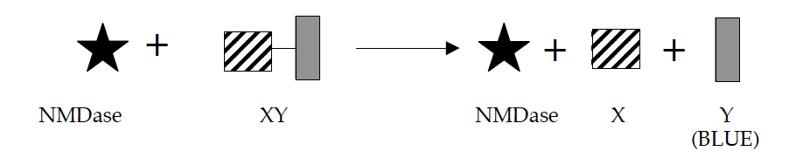

Experimentally, the progress of the reaction can be measured by looking at the production of product Y. Product Y is BLUE, and its accumulation can be measured in the spectrophotometer at A₅₉₅.
An important first step in the conversion of XY to X + Y by NDMase is the binding of enzyme to substrate. One residue suspected to be important for substrate binding is His199.
To test this hypothesis, you have created mutant NMDase enzymes with the following amino acid substitutions at position 199: His199 Trp199; His199Asp199; His199Gly199; and His199Lys199.

a) Draw the side chains of the following amino acids at pH 7.0. Indicate any charges expected in aqueous solution by filling in the property blank (positive, negative, neutral).

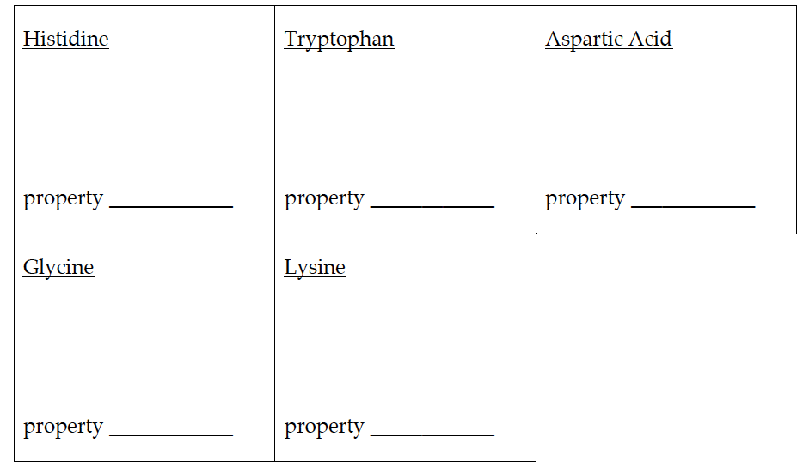

b) Two of these substitutions inhibit the ability of the enzyme to bind substrate. Predict which two mutant NMDase enzymes can no longer bind substrate. Explain your reasoning concisely and specifically.

3) You have a crude lysate sample (CL) containing a mixture of six proteins (1, 2, 3, 4, 5, and β-galactosidase), and your goal is to obtain purified β-galactosidase. Some characteristics of these proteins are shown in the table below:

Protein | Concentration of ammonium  sulfate (AS) required for  precipitation | Molecular  Weight (kDa) | Isoelectric  point (pI)
1 | 45% | 38 | 3.7
2 | 80% | 22 | 4.8
3 | 65% | 4 | 5.3
4 | 20% | 75 | 6.8
5 | 30% | 55 | 9.50
β-galactosidase | 45% | 115 | 5.3

We discussed salting out in class, but here is a refresher:
Salting out occurs in aqueous solutions of high ionic strength that reduce the molecule's solubility causing certain proteins to precipitate. Ideally, the type of salt being used and the concentration of the salt can be varied to selectively precipitate the molecule. In reality, salting out is an effective means for initial molecule purification, but lacks the ability for precise isolation of a specific protein. A common salt used in this process is ammonium sulfate.

You begin your purification by performing an ammonium sulfate (AS) precipitation. You add the appropriate concentration of AS to your CL sample, incubate overnight at 4°C, then centrifuge to generate a supernatant (AS-S) and pellet (AS-P).

a) What concentration of AS will you use to precipitate β-galactosidase? _______

b) After addition of that concentration of AS and centrifugation, which protein(s) will be in the supernatant (AS-S)? ________________________

c) Which protein(s) will be in the pellet (AS-P)? ________________________

One way to purify β-galactosidase from any contaminating proteins in the AS-P sample would be to separate the proteins based on their molecular weight.

d) What type of column/chromatographic method separates on this basis? _______________________________
e) Which protein (from your AS-P) would elute first from this type of column? _________________
Instead, you decide to use ion exchange chromatography to further purify β-galactosidase from other proteins in your AS-P sample. You first run an anion exchange column equilibrated using column buffer with a pH of 5.0.

f) What charge does the matrix of an anion exchange column have? _________

g) At pH 5.0, which protein(s) from the AS-P will stick to the column? _________

h) Explain your answer to part g) in one or two sentences.

i) State how you would elute a protein bound to an anion exchange column, and explain how this elution method works in one or two sentences.

You identify the fraction containing β-gal from your anion exchange column, and decide to run it over a cation exchange column to complete your purification.

j) Describe how you would use a cation exchange column to purify β-galactosidase away from any remaining contaminating protein(s). Be specific about:
- the pH at which you’d equilibrate the column
- why you chose this pH
- which protein(s) would bind and which protein(s) would flow through the column under these conditions, and why.

4)
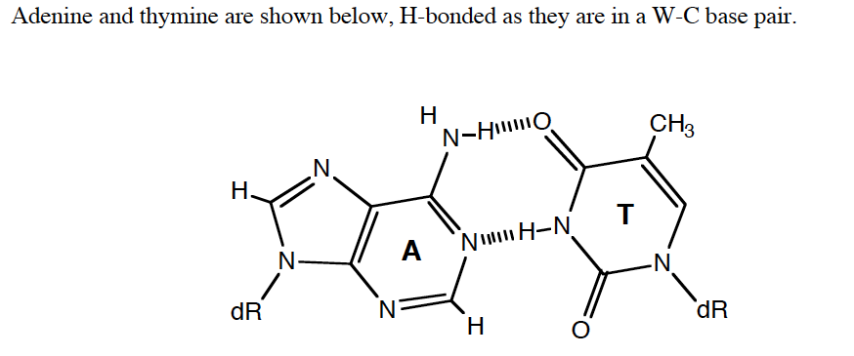

- On the structure above, identify the major and minor groove sides of the base pair and label the hydrogen bond donors and acceptors in each groove.
- Asparagine residues in DNA binding domains are often found to recognize adenine in duplex DNA. In the space below, draw a plausible structure for the interaction of an asparagine side chain with the major groove of adenine.

7) Many membrane proteins are attached in the hydrophobic interior of the lipid bilayer by one or more α-helices which span the membrane.

- How can we sometimes identify the trans-membrane α-helices strictly by examination of the protein sequence, even for a new protein with no homology to any others? Use what you know about the geometry of the α-helix and the properties of transmembrane proteins.

- When β-sheets are found in membranes, they are usually complete barrels, not one or two strands. Why (contrast with α-helices in membranes)?

8) Draw the structure of proline. Why does proline break the α-helix? Why does it break the β-sheet? (These are two different answers)

9) Briefly (in 30 words or less) describe the following protein domains with respect to amino acid sequence (if appropriate), secondary structural elements, and function:

A) Leucine Zipper

B) HTH Domain

C) Zn²⁺ finger domain

10) Draw the Haworth structures of Maltose and Lactose.

Maltose |  | Lactose

11) Draw a schematic of the Central Dogma of Molecular Biology.

12) Briefly describe how proteins fold. Your answer must lay out the facts in a logical, chronological form that fully describes the chemical entities, forces and energies involved. You must include a description of the hydrophobic effect and the roles of the solvent and polypeptide. Finally, relate your description to features of the current best model of the protein folding funnel we discussed in class.

13) Calculate the pH at the equivalence point of the titration of 25.00 mL of 0.195 M napthalic acid, C₁₀H₉COOH, with 0.15 M NaOH. [pK_{A} for C₁₀H₉COOH = 4.2]

14) β-Mannosidase is a glycosyl hydrolase that hydrolyzes the glycosidic bond of β-D-mannosyl-(1,4)-β-D-mannopyranose, releasing two mannopyranose residues.

a) Draw the chemical structures of the substrate and the products formed in the reaction.

b) Based upon what you know about glycosyl hydrolases, draw the likely reaction mechanism for the enzyme. You must include all necessary amino acid side chains, substrate atoms, and arrows.

15) Describe the three types of non-covalent enzyme inhibition by:

a) Drawing the double-reciprocal plots of the enzymatic reaction in the absence and presence of two concentrations of inhibitor
b) Giving the molecular species each type of inhibitor binds to
c) Giving the kinetic parameters affected by each type of inhibitor

16) Write out:

a) The Michaelis-Menton equation and show what a plot of V₀ versus [S] for an enzyme that follows Michaelis-Menton kinetics. Clearly label Vm and Km on the plot.

b) The Lineweaver-Burk equation and show what a plot of 1/V₀ versus 1/[S] looks like. Label the slope and intercept terms for the plot.

18) Nearly every topic we have discussed this semester has come down to Intermolecular forces. You have seen these forces in every aspect of chemistry and molecular biology.

- What are the four primary intermolecular forces from lowest energy to highest energy?

- What are the Coulombic energy equations that describe each IMF?

19) Speculate on why it is that when allosteric regulation is needed, proteins with quaternary structures rather than single-domain proteins have often evolved to fill the need.

21) What is the Bohr Effect?

24) Why don’t proteins get cavities? Specifically, in terms of the thermodynamic forces stabilizing proteins, explain why an Ile Ala mutation in the hydrophobic core of a protein tends to decrease Tm (i.e. make the folded protein less stable relative to unfolded).

25) Draw the chemical reaction that occurs at the peptidyl transferase center of the ribosome. All that needs to be drawn fully is the ribose ring and amino acid conjugated to it. Label the sites of the ribosome. Amino acid side chains do not need to be drawn.

26) What are the 5 stages of Protein synthesis in a cell?

28) Draw the reaction mechanism of trypsin cleaving the peptide: Gly-Arg-Gly. You do need to show amino acid side chains, all relevant intermediates and any essential interactions between the protein, substrate and intermediate.

29) List two post-translational modifications and state how they work/what their functions are.

30) Draw the reaction mechanism for the 3’-5’ exonuclease reaction catalyzed by the exonuclease domain of DNA Pol I. (Hint: Tyr 423 of DNA Pol I activates a water molecule which then serves as a nucleophile to begin the cleavage of the base from the strand. Two metal ions are involved in the reaction as well.)

31) The following questions are about the lac operon. You may use the schematic of the operon below to help you in your answers.

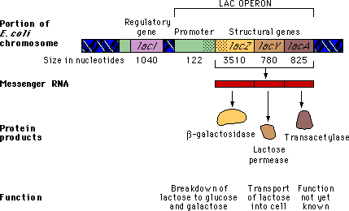
Mutations typically disable a gene. Predict the phenotype of the following mutants. If you answer correctly, you can watch an animation demonstrating the phenotype of that mutant.
i) Predict the phenotype of a lacI mutant.
a. The lac genes would be expressed efficiently only in the absence of lactose.
b. The lac genes would be expressed efficiently only in the presence of lactose.
c. The lac genes would be expressed continuously.
d. The lac genes would never be expressed efficiently.

ii) Predict the phenotype of a lacI S or "super-repressor" mutant. A lacI S mutant synthesizes a repressor that cannot bind to the inducer.
a. The lac genes would be expressed efficiently only in the absence of lactose.
b. The lac genes would be expressed efficiently only in the presence of lactose.
c. The lac genes would be expressed continuously.
d. The lac genes would never be expressed efficiently.
iii) Predict the phenotype of an operator mutant (O c) which would prevent the binding of the repressor.
a. The lac genes would be expressed efficiently only in the absence of lactose.
b. The lac genes would be expressed efficiently only in the presence of lactose.
c. The lac genes would be expressed continuously.
d. The lac genes would never be expressed efficiently.
iv) Predict the phenotype of a promoter mutant (lacP) which has a mutation in the promoter for the lac operon.
a. The lac genes would be expressed efficiently only in the absence of lactose.
b. The lac genes would be expressed efficiently only in the presence of lactose.
c. The lac genes would be expressed continuously.
d. The lac genes would never be expressed efficiently.
v) Predict the phenotype of a lacZ mutant, which has a mutation in the gene for β-galactosidase.
a. The production of all protein products would be affected.
b. The production of β-galactosidase would be affected, but other protein products would be unaffected.
c. The production of β-galactosidase would be affected, and the production of some other protein products might also be affected.
d. The production of β-galactosidase would be unaffected, but other protein products would be affected.
vi) Predict the phenotype of a lacY mutant, which has a mutation in the gene for lactose permease.
a. The lac genes would be expressed efficiently only in the absence of lactose.
b. The lac genes would be expressed efficiently until the lactose supply in the cell is exhausted.
c. The lac genes would be expressed continuously.
d. Expression of the lac genes would cease immediately.

32) Digestion of proteins in the stomach is accomplished with the aid of the enzyme pepsin. The activity of this enzyme requires the deprotonation of a pair of aspartic acid residues in the active site.

a) This poses a problem at the normal stomach pH of ~2. Why? What is the expected charge on the side chain of aspartic acid at this pH?

b) What is the [OH-] at this pH?

c) To study this interesting biochemical puzzle, you could purify large quantities of pepsin and test it carefully under controlled conditions. To approximate the enzyme's normal biochemical environment, you'd probably want to perform your experiments in a buffer at pH 2. You decide to use phosphoric acid (H₃PO₄, pK_{A1} = 2.15). How many moles of the acid and how many moles of its conjugate base would you need to make 250 mL of a 300 mM buffer solution?

33) What is attenuation? Describe how attenuation works to regulate the trp operon. Please use figures to aid in your explanation.

34) In class this semester we discussed 2 types of signalling pathways. The following questions are related to those pathways.

- Draw a schematic of the Insulin receptor pathway. Be certain to include all necessary proteins and at each step, include specific chemical reactions/modification and relevant information.

- Draw a similar schematic for the beta-adrenergic receptor pathway.

