CHEM520 Homework 3

- The pKa of an acid depends partly on its environment. Predict the effect of each of the following environmental changes on the pKa of a glutamic acid side chain.
- A lysine side chain is brought into proximity.
- The terminal carboxyl group of the protein is brought into proximity.
- The glutamic acid side chain is shifted from the outside of the protein to a nonpolar site inside.

- Does myoglobin exhibit a Bohr effect? Why or why not?

- With the use of site-directed mutagenesis, hemoglobin has been prepared in which the proximal histidine residues in both the α and the β subunits have been replaced by glycine. The imidazole ring from the histidine residue can be replaced by adding free imidazole in solution. Would you expect this modified hemoglobin to show cooperativity in oxygen binding? Why or why not?

- The illustration below shows several oxygen-dissociation curves. Assume that curve 3 corresponds to hemoglobin with physiological concentrations of CO₂ and 2,3-BPG at pH 7. Which curves represent each of the following perturbations?
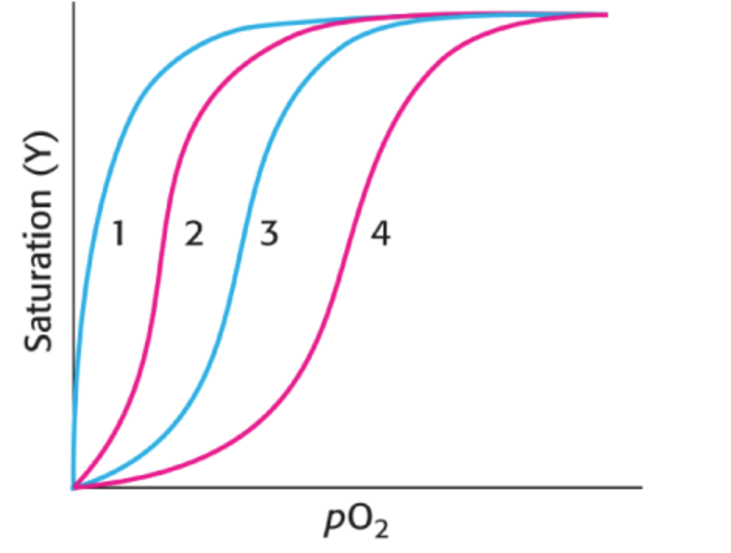

- Decrease in CO₂
- Increase in 2,3-BPG
- Increase in pH
- Loss of quaternary structure

- Lampreys are primitive organisms whose ancestors diverged from the ancestors of fish and mammals approximately 400 million years ago. Lamprey blood contains a hemoglobin related to mammalian hemoglobin. However, lamprey hemoglobin is monomeric in the oxygenated state. Oxygen-binding data for lamprey hemoglobin are as follows:

pO2 (Torr) | Fractional Saturation (Y)
0.1 | 0.006
0.2 | 0.0124
0.3 | 0.019
0.4 | 0.0245
0.5 | 0.0307
0.6 | 0.038
0.7 | 0.043
0.8 | 0.0481
0.9 | 0.053
1 | 0.0591
2 | 0.112
3 | 0.17
4 | 0.227
5 | 0.283
7.5 | 0.42
10 | 0.5
15 | 0.64
20 | 0.721
30 | 0.812
40 | 0.865
50 | 0.889
60 | 0.905
70 | 0.917
80 | 0.927
90 | 0.935
100 | 0.941
150 | 0.96
200 | 0.97

Plot these data to produce an oxygen-binding curve.
At what oxygen partial pressure is this hemoglobin half-saturated?
On the basis of the appearance of this curve, does oxygen binding seem to be cooperative?

