CHEM520 Spring 2023 Homework 2

Answer the following questions on your Rocketbook pages and send me your answers by Tuesday, 24 January at midnight. Late submissions will not be accepted. Be certain to include your name on every page in the top right hand corner.

- When performing his experiments on protein refolding, Christian Anfinsen obtained a quite different result when reduced ribonuclease was reoxidized while it was still in 8 M urea and the preparation was then dialyzed to remove the urea. Ribonuclease reoxidized in this way had only 1% of the enzymatic activity of the native protein. Why were the outcomes so different when reduced ribonuclease was reoxidized in the presence and absence of urea?

- Myoglobin is a monomeric protein that accepts oxygen from the heterotetrameric hemoglobin protein in capillaries and muscle tissue. The α and β subunits of hemoglobin bear a remarkable structural similarity to myoglobin. However, in the subunits of hemoglobin, certain residues that are hydrophilic in myoglobin are hydrophobic. Why might this be the case?

- The following reagents are often used in protein chemistry:

CNBr
Urea
Mercaptoethanol
Chymotrypsin
Trypsin
Performic acid
6 N HCl
Phenyl isothiocyanate

Which reagent is the best suited for accomplishing each of the following tasks?

- Determination of the amino acid sequence of a small peptide.
- Reversible denaturation of a protein devoid of disulfide bonds. Which additional reagent would you need if disulfide bonds were present?
- Hydrolysis of peptide bonds on the carboxyl side of aromatic residues.
- Cleavage of peptide bonds on the carboxyl side of methionines.
- Hydrolysis of peptide bonds on the carboxyl side of lysine and arginine residues.

- The detergent sodium dodecyl sulfate (SDS) denatures proteins. Suggest how SDS destroys protein structure.

- Monoclonal antibodies can be conjugated to an insoluble support by chemical methods. Explain how these antibody-bound beads can be exploited for protein purification.

- Your frustrated colleague hands you a mixture of four proteins with the following properties:

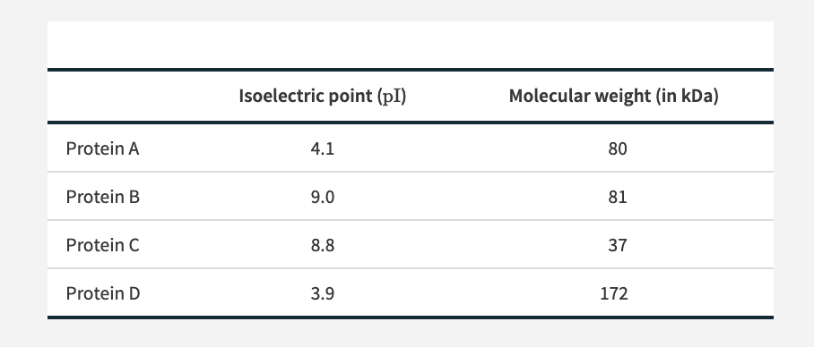

Propose a method for the isolation of Protein B from the other proteins. (b) If Protein B also carried a His tag at its N-terminus, how could you revise your method?

- Determine the sequence of hexapeptide on the basis of the following data. Note: When the sequence is not known, a comma separates the amino acids (Table 3.3).

Amino acid composition: (2R, A, S, V, Y)
N-terminal analysis of the hexapeptide: A
Trypsin digestion: (R, A, V) and (R, S, Y)
Carboxypeptidase digestion: No digestion.
Chymotrypsin digestion: (A, R, V, Y) and (R, S)

