1. Resonance
Draw Lewis structures for all of the remaining resonance structures for each of the following molecules in the boxes provided.

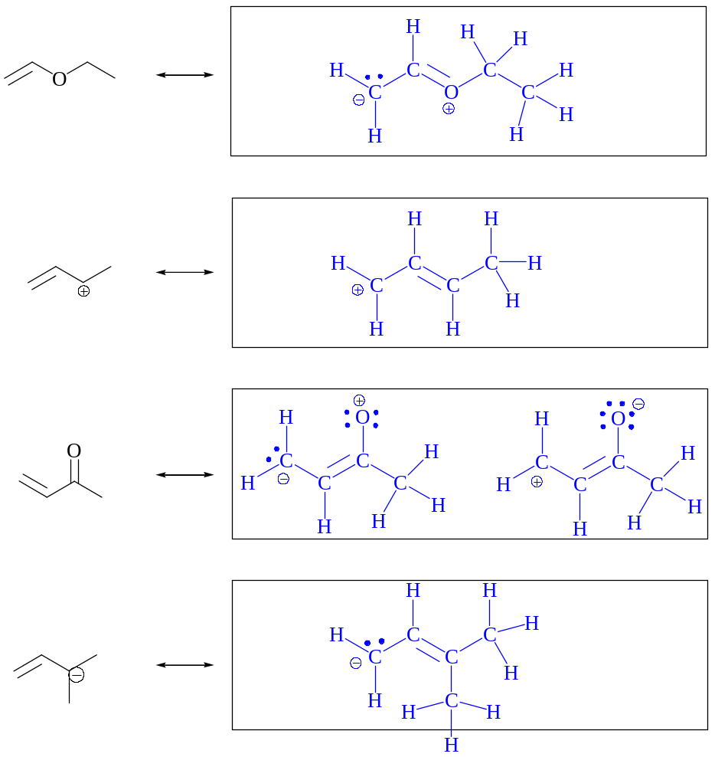

2. Nomenclature
Give the proper systematic name for each of the following structures on the lines.

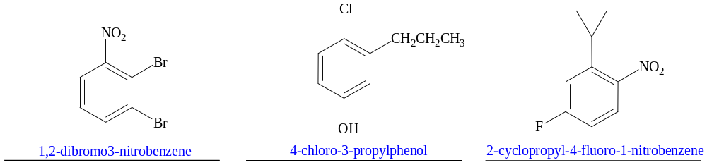

3. Concepts
Label each of the following compounds as AROMATIC or NONAROMATIC on the lines provided.

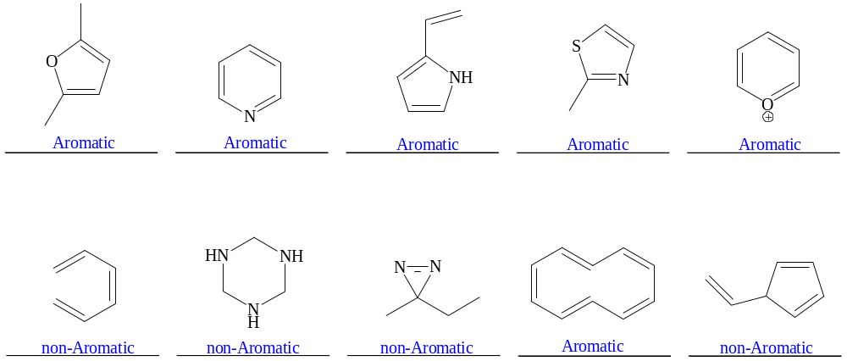

4. Reactions
Draw the major product or products of each of reaction in the boxes provided. If multiple organic products are equally likely, show each.

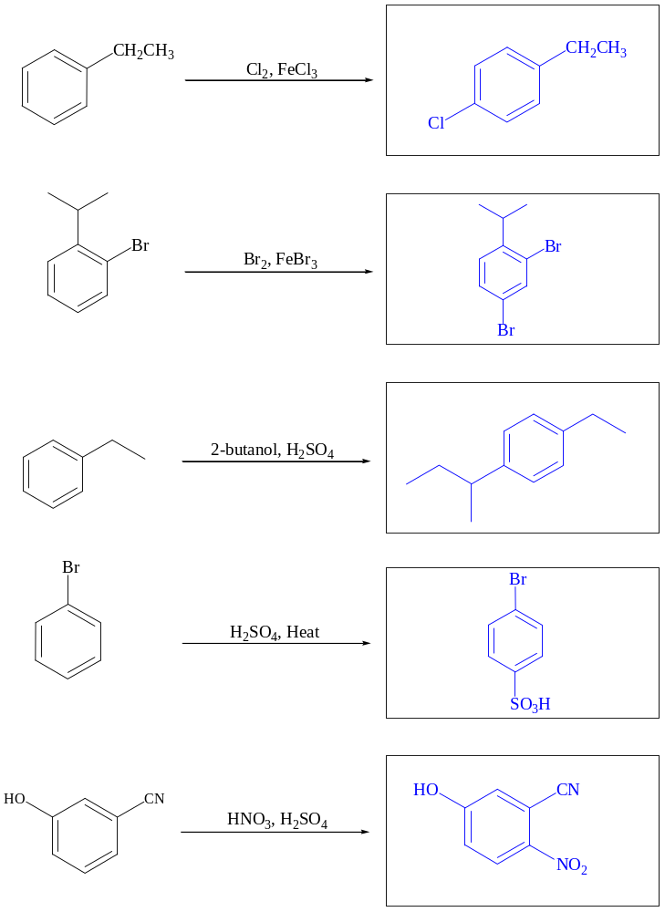

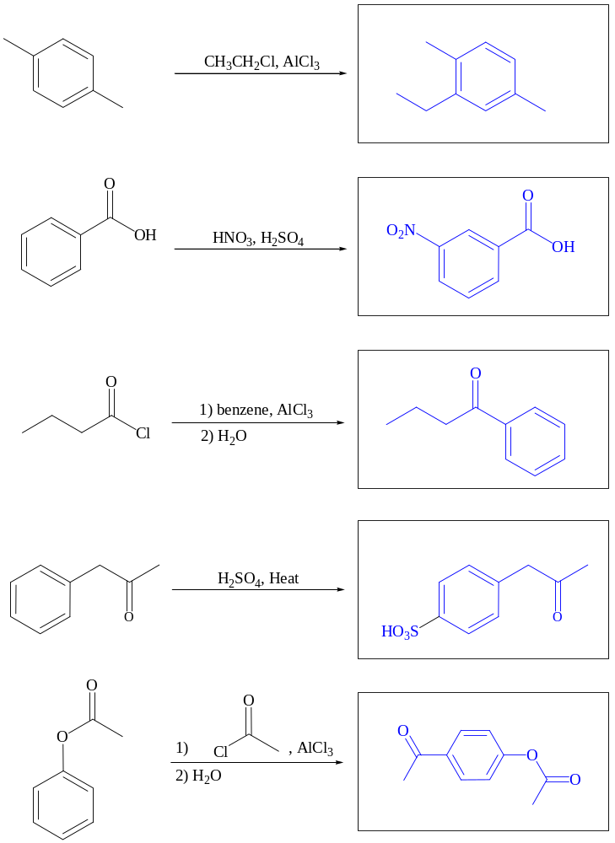

5. Mechanisms
Draw a complete arrow pushing mechanism for the following reaction. Include all resonance forms for your intermediates.
a.
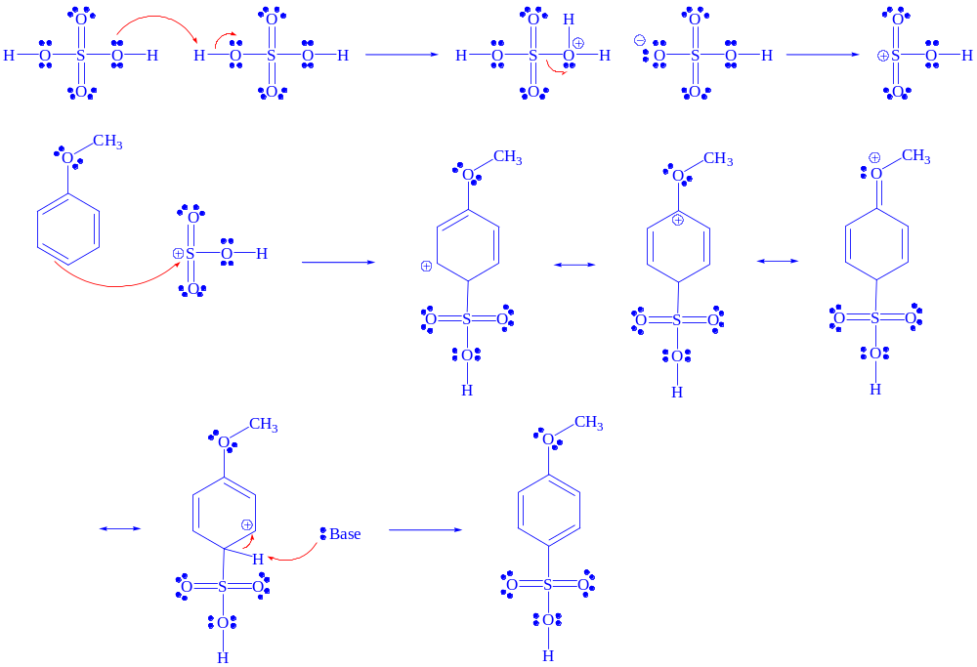

b.
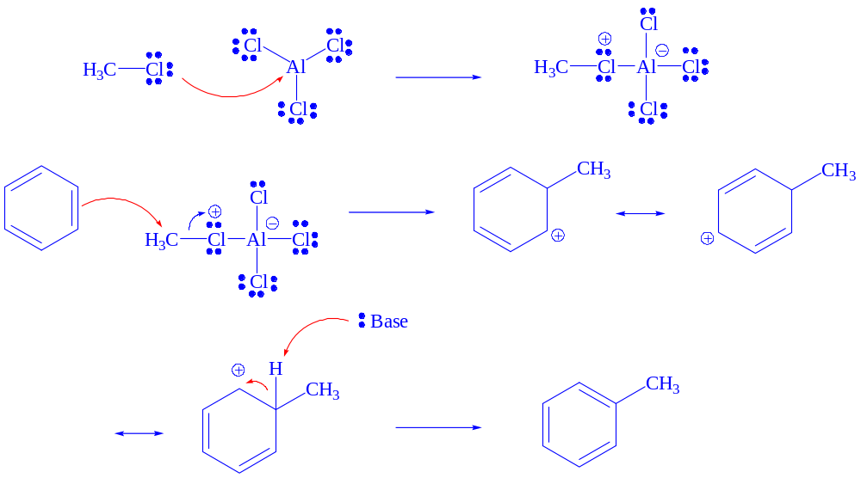
6. Tandem Reactions
Show the sequence of reactions that would be used to prepare the target molecule starting from benzene. Show the necessary reagents and products for each step.
a.
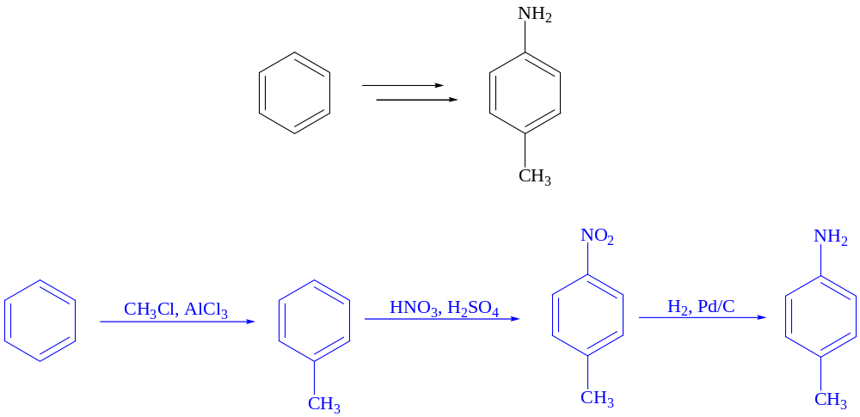

b.
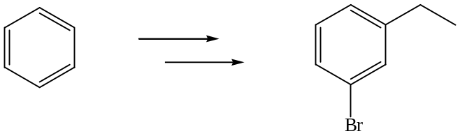
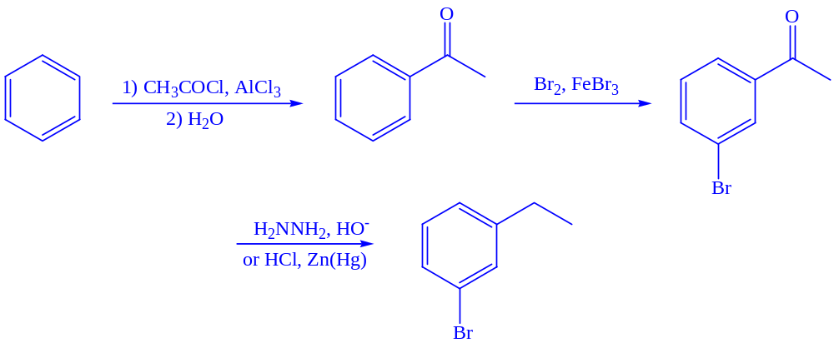

7. Application of Concepts
The following hydrocarbon is actually a polar compound. Why is it polar, and which direction is the dipole oriented? Thoroughly explain your rationale (structures will be helpful).

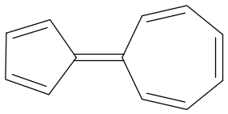

When other resonance structures are drawn, one can see that there is a major contribution from the contributor in green. In this drawing, both rings are now aromatic, meaning this is a MAJOR contributor to the structure overall. Thus the left side is partially negative and the right side partially positive.
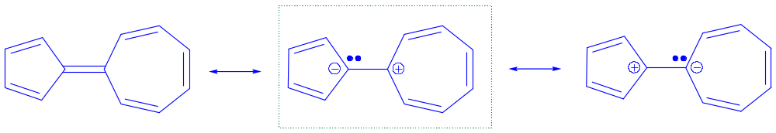

b. Two alcohols are shown below. Cyclohexanol (pk_{a} = 16) is produced as a precursor in nylon synthesis. Phenol (pk_{a} = 10) was used as an antiseptic and is still used in embalming cadavers for use in “gross anatomy” labs in medicals schools. Explain the large difference in the acidities of these two compounds.

Acidity is related to conjugate base stability. Phenol, the stronger acid, must have a more stable conjugate base. This can be seen when the conjugate bases are drawn. One would expect the conjugate base of phenol (“phenoxide”) to have resonance. This in-and-of itself means little, as phenol itself also has resonance. However, the charge in phenoxide ion is stabilized by spreading out the charge across four atoms, as can be seen in the four additional resonance structures. Cyclohexanol’s conjugate base has no resonance stabilization, and thus the charge is essentially isolated on the one atom (oxygen). Phenol’s conjugate base is more stable, due to resonance spreading out the charge, than cyclohexanol’s conjugate base. This makes phenol more acidic.


