1. Kinetics and Thermodynamics
a. Answer the following five questions using the reaction diagrams below (1-4).

i) Which is the fastest exergonic reaction? ________

ii) Which is the slowest endergonic reaction? ________

iii) Which reaction will form the most product (B) at equilibrium? ________

iv) Which reaction(s) has/have an intermediate? ________

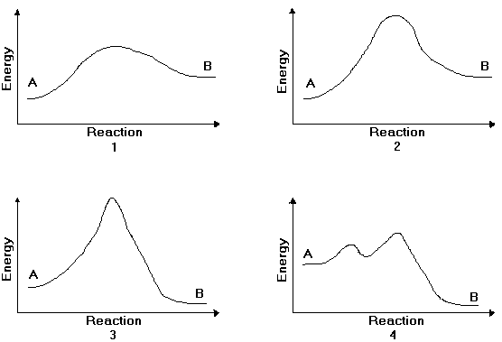v) Which reaction accurately depicts a carbocation reacting with Br⁻? ________

b. Draw a free energy diagram for the acid-catalyzed hydration of 2-butene (the last step is very fast.) Label all reactants, products and intermediates using structures.

2. Reactions
a. Draw the major product or products of each of reaction in the boxes provided. If multiple organic products are equally likely, show each.

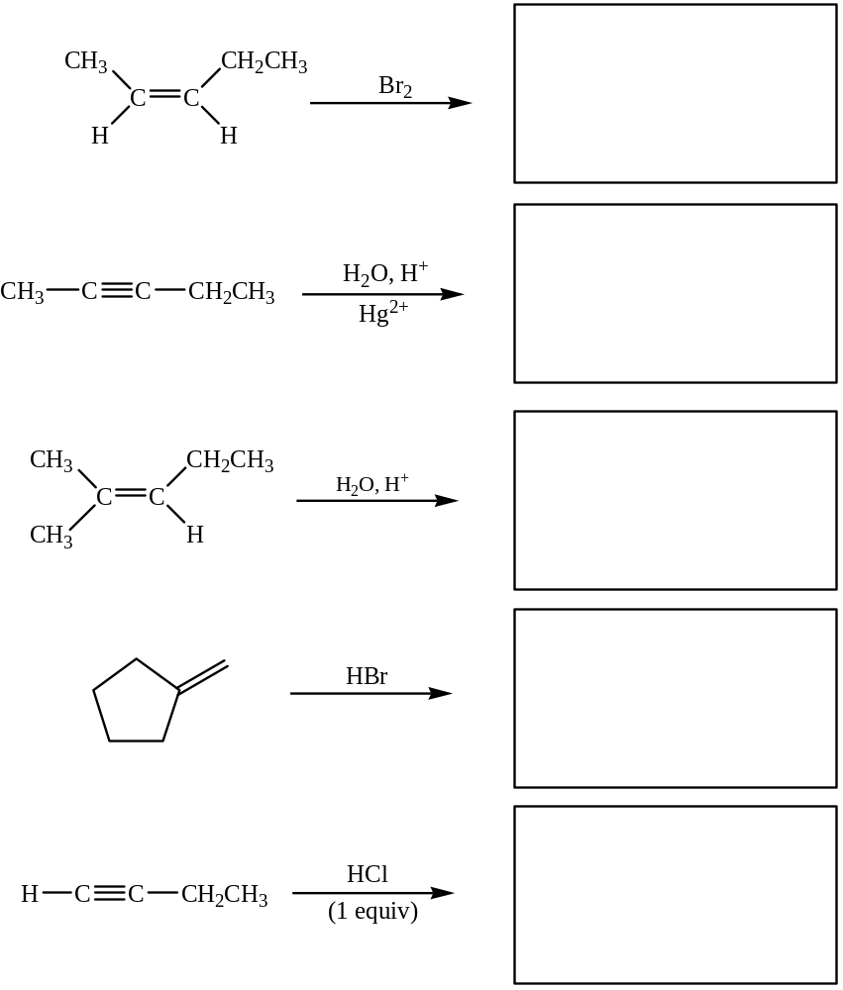

b. Provide the reagents necessary to perform the following reactions in the boxes provided. Be explicit when showing multi-step reactions.

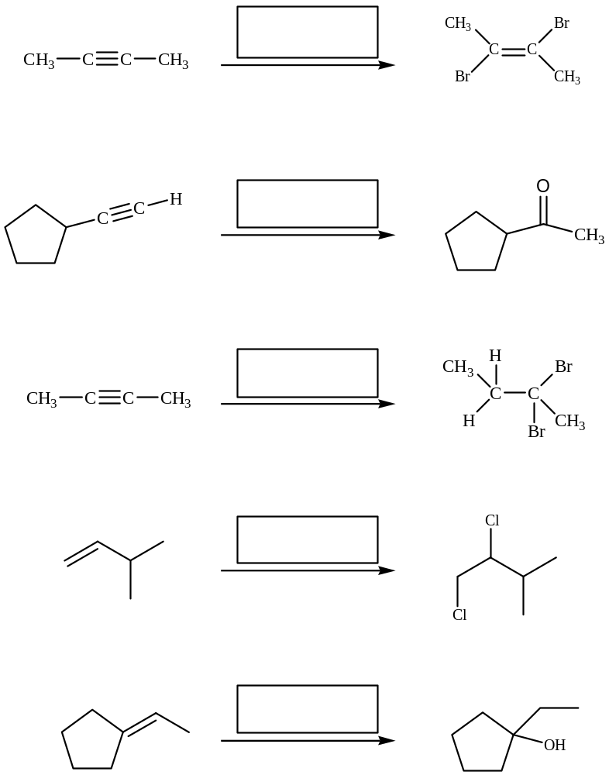

3. Mechanisms
Draw complete arrow pushing mechanisms for the following reactions.
a.
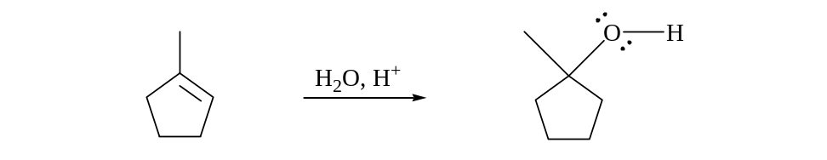

b.
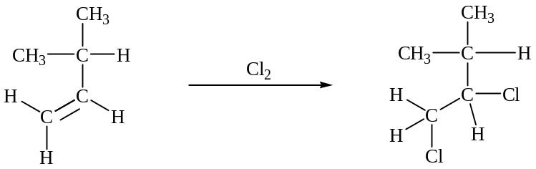

c.
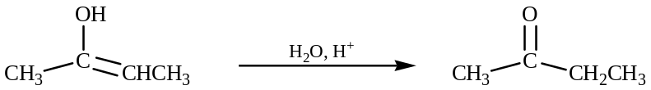

4. Application of Concepts
Follow the instructions below to propose a two-step mechanism for the given reaction:

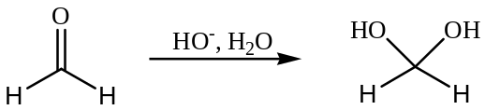

- For the first step, identify the most nucleophilic and most electrophilic reactants and draw each in the appropriate boxes
- Use curved arrows to show how the electrons flow between the two reactants
- Draw the intermediate formed in the appropriate box
- For the second step, identify the role (nucleophile or electrophile) of the intermediate on the line below the box
- Draw the other reactant of the second step in the remaining box and identify its role (nucleophile or electrophile) on the line below the box
- Use curved arrows to show how the electrons flow between the intermediate and the reactant



