1. Aromaticity
Determine if the following species are aromatic or non-aromatic.

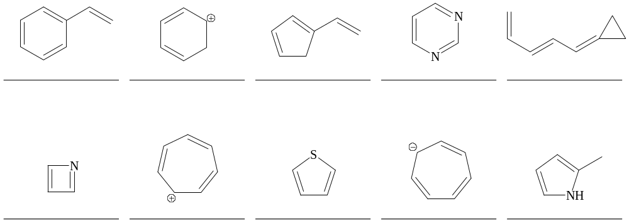

2. Nomenclature
a. Give the common names for the following compounds.
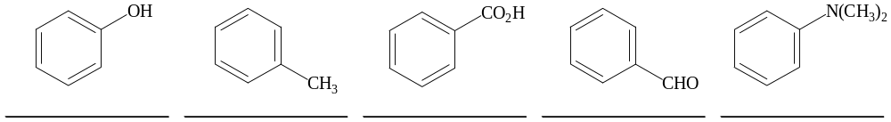

b. Give the proper systematic IUPAC names for the following compounds.
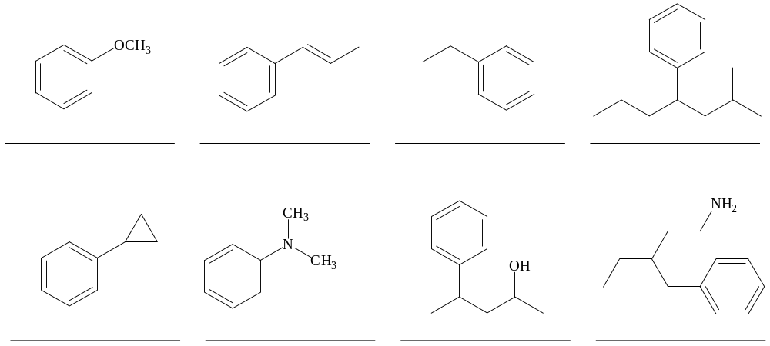
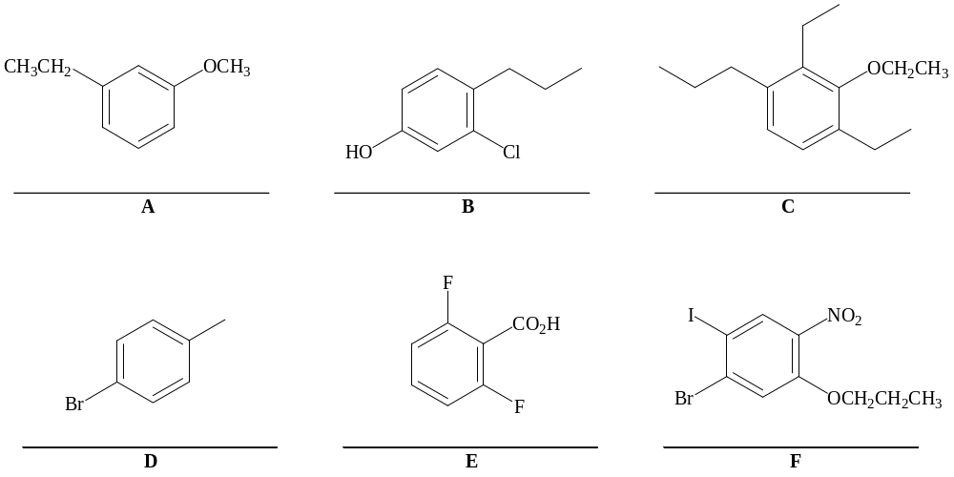

c. Using the structures (A-F) above, answer the following questions.
What is the positional relationship between the two substituents in compound A? ___________
What is the positional relationship between the two substituents in compound D? ___________
What is the positional relationship between the bromine and iodine in compound F? _________

3. Reactions of Benzene
Draw the major product or products of each reaction.

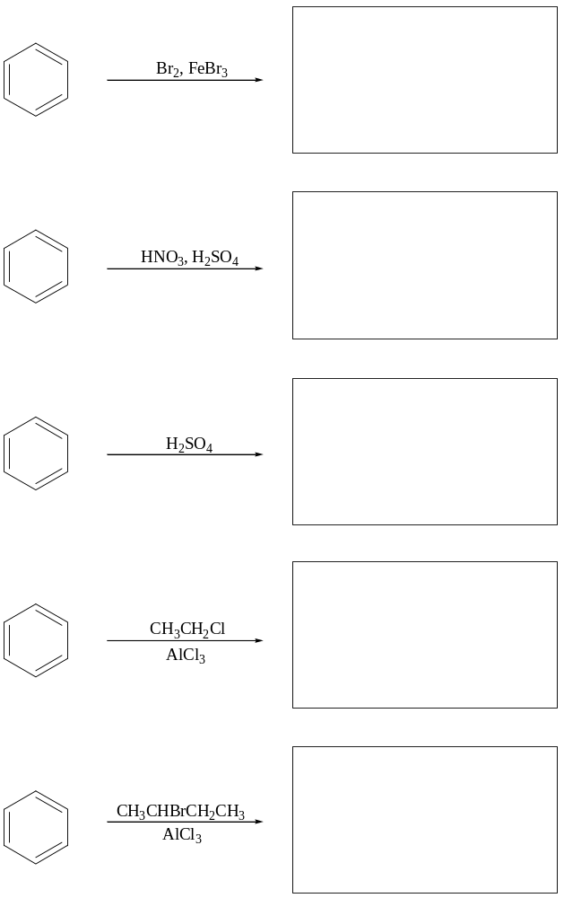

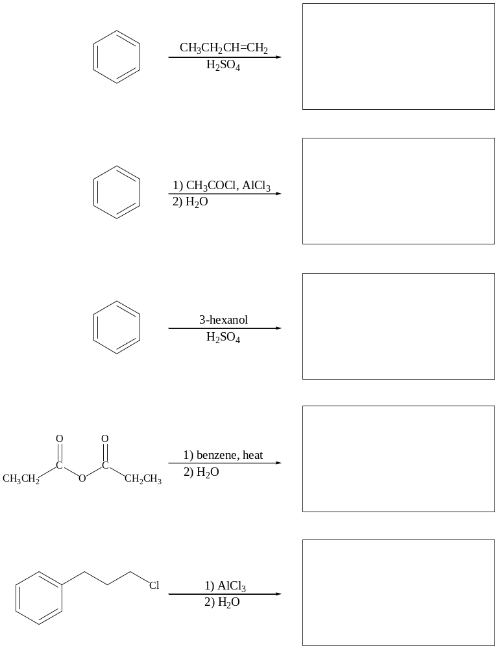

4. Mechanisms
Provide complete arrow-pushing mechanisms for the following reactions.
a.
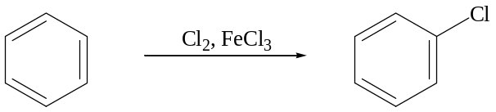

b.
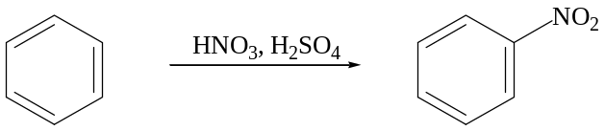

5. Substituent Effects on EAS Reactions
a. Determine if the following substituents would activate or deactivate benzene in an EAS reaction. Then determine if the substituent would be an ortho/para or meta director.

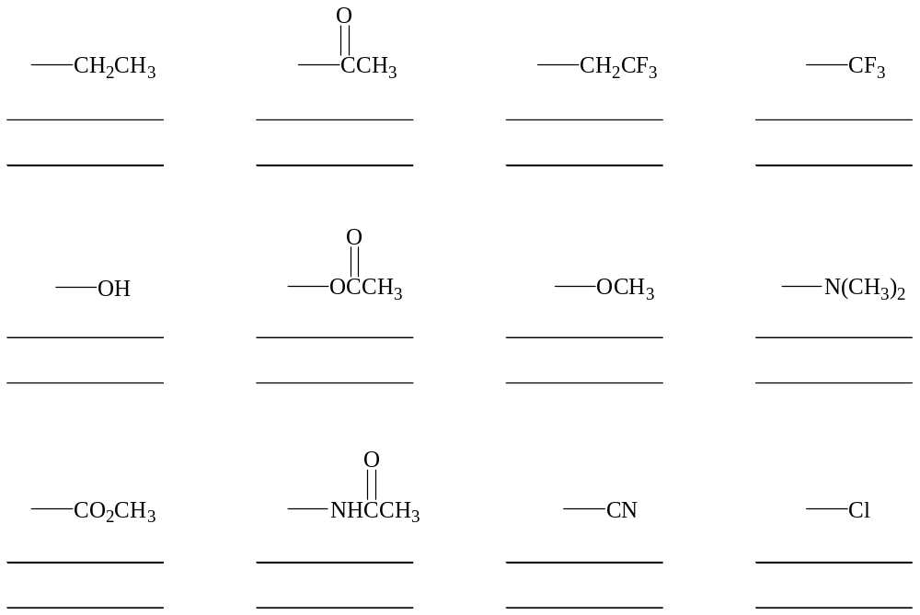

b. For each set, rank the substituents in order of their effect on the rate of an EAS reaction of benzene (1 strongest activating to 4 strongest deactivating.

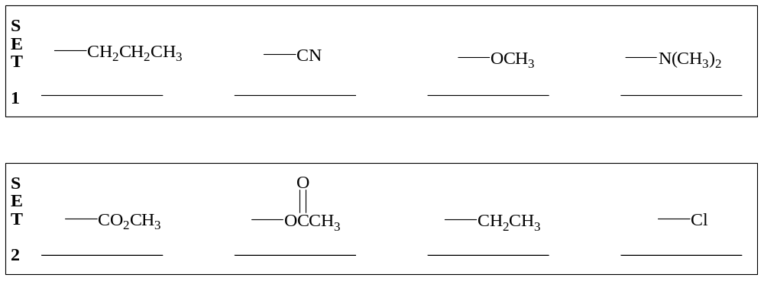

6. EAS Reactions of Substituted Benzenes
Draw the major product or products of each reaction.

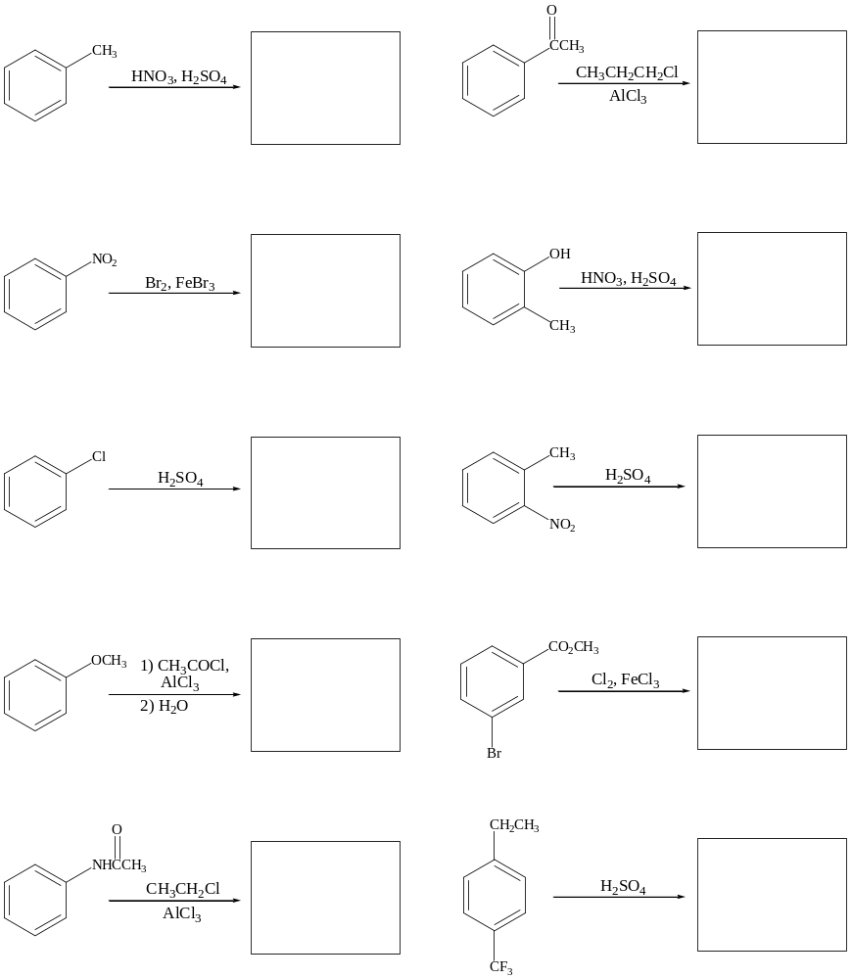
7. Tandem Reactions
Show the sequence of reactions that would be used to form the target compound from benzene.
a.
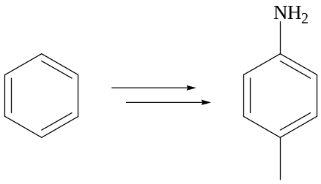

b.


