Straight-Chain Alkanes

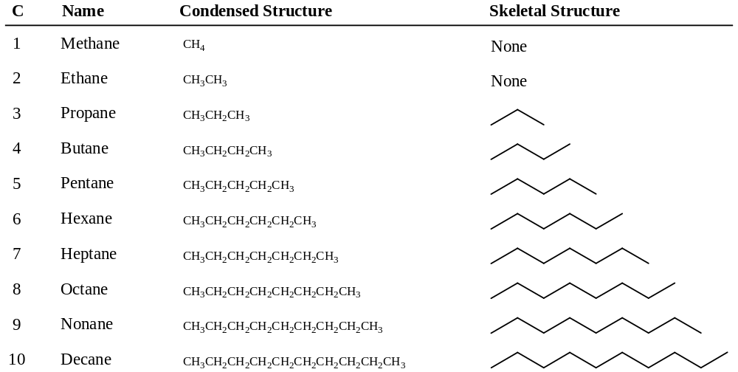

Boiling Points

van der Waals Interactions (weakest)

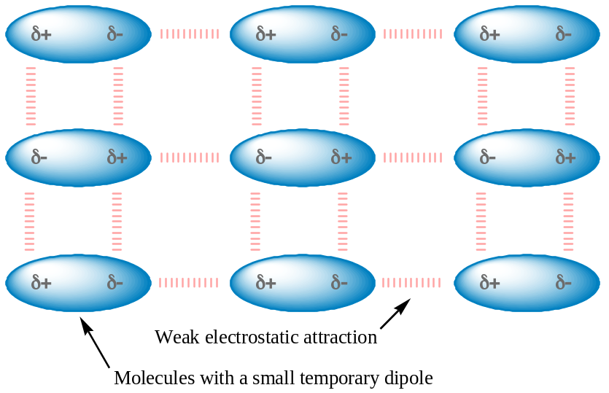

Dipole-Dipole Interactions (moderate)

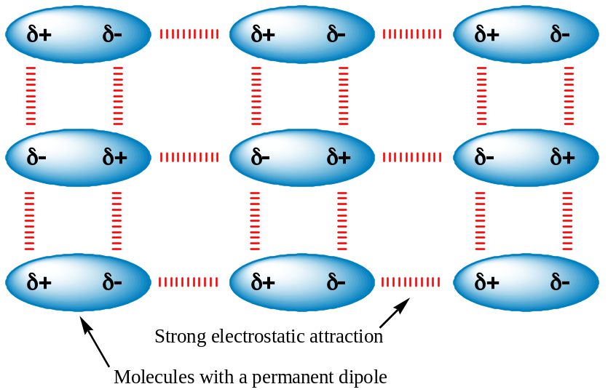

Hydrogen Bonding (strongest)


