Free Rotation

Energy Diagram of Ethane Rotation

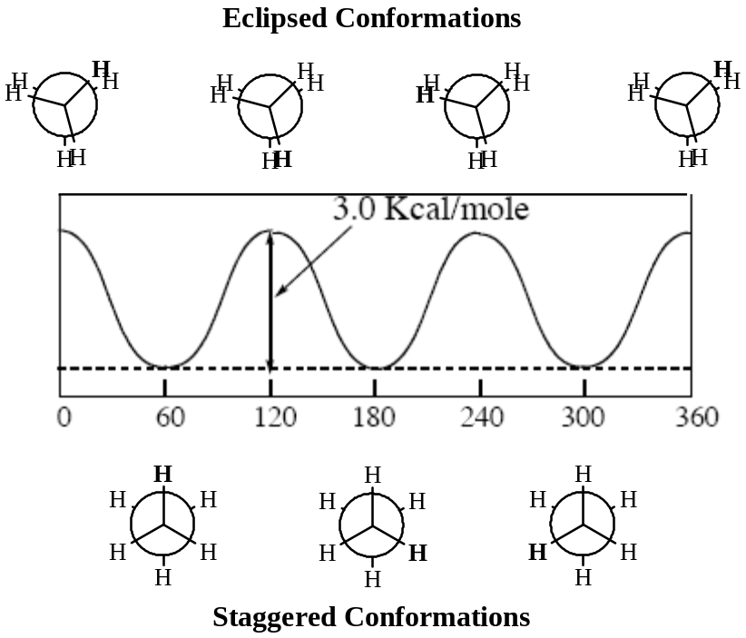

Energy Diagram of Butane Rotation (C2 –C3)

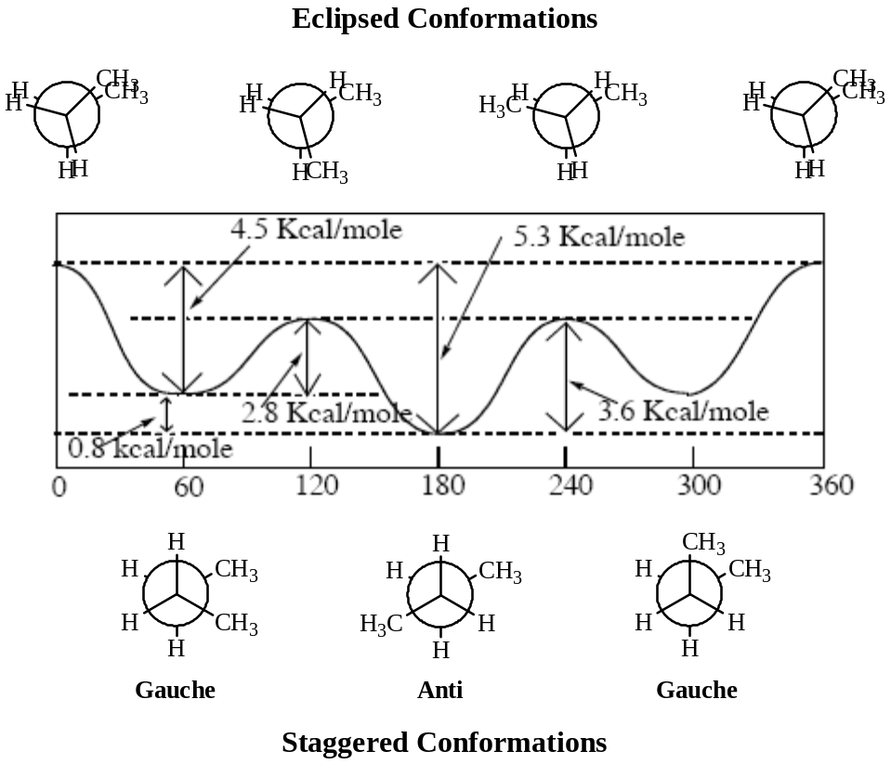

Angle Strain (Ring Strain)

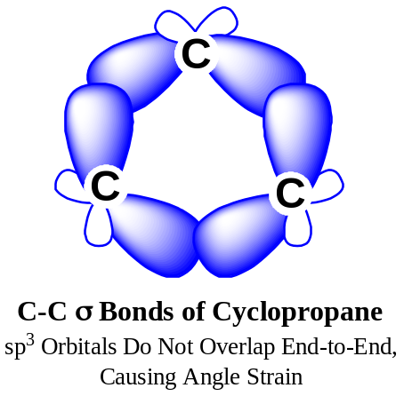

Cyclohexane Chair Conformations

Energy Diagram of Conformational Inversion of Cyclohexane

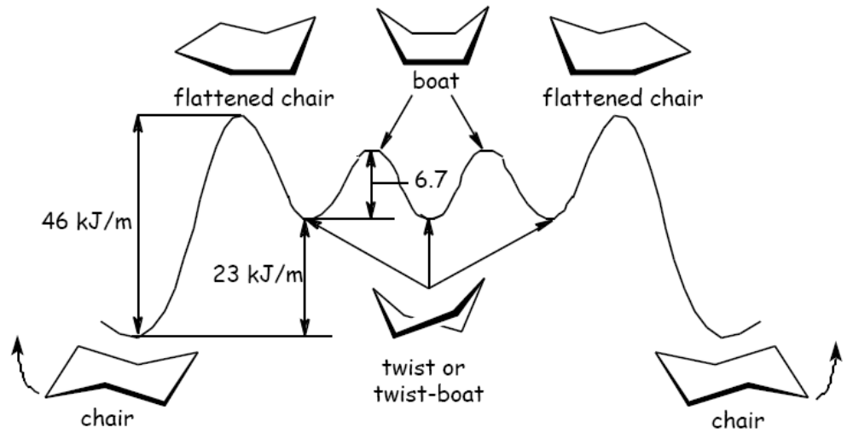

Stereochemistry

Enantiomers
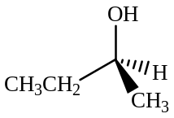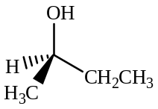

S and R 2-Butanol are Non-identical Mirror Images

Optical Activity
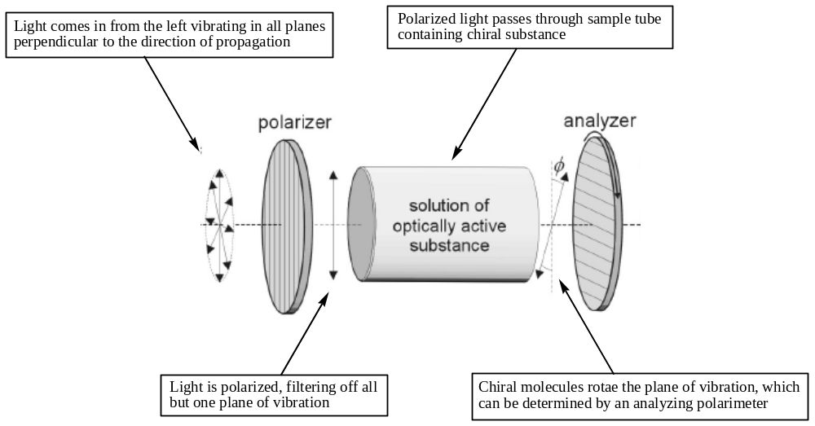
A Polarimeter – used to measure specific optical rotation

Importance of Chirality


