Extraction and Transfer Hydrogenation of Fat from Snack Foods

Fats are macronutrients found in nearly all foods. Structurally, fats are comprised of a glycerol unit which has been esterified with three long-chain carboxylic acids known as fatty acids. Fats and fatty acids are characterized as ‘unsaturated’ or ‘saturated’ based on the presence or absence of alkenes (unsaturation) on the carbon chains. Unsaturated fats and fatty acids can further be classified as monounsaturated (having one alkene) or polyunsaturated (having multiple alkenes).

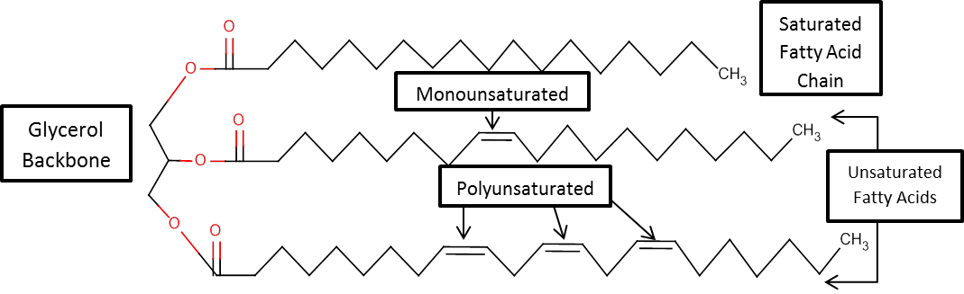

Industrially, the alkenes of unsaturated fats can be ‘saturated’ via the hydrogenation reaction (H₂, Pd/C). A safer alternative to using explosive hydrogen gas is to perform a catalytic transfer hydrogenation (CTH). In place of hydrogen gas, these reactions use safer compounds that can "transfer" one or more equivalents of hydrogen to other molecules.

This experiment has two parts. In the first part, you will extract the fat content from a sample of a pre-packaged snack food (cookies, crackers, chips, etc.). You will then determine the amount of total fat in the sample, and use ¹H-NMR to calculate the amount of saturated, unsaturated, monounsaturated, and polyunsaturated fat in the food. In the second part, you will perform a catalytic transfer hydrogenation on the extracted fat to produce a saturated fat (shortening). You will then use ¹H-NMR to calculate the amount of saturated, unsaturated, monounsaturated, and polyunsaturated fat in the hydrogenated sample.
Required Reading (Padias):
Topic | 2nd Edition | 3rd Edition
Reflux | pp. 31 – 32 | pp. 31 – 32
Extraction | pp. 128 – 137 | pp. 130 – 139
Filtration | pp. 26 – 30 | pp. 26 – 30

Special Safety Notes:
The palladium catalyst is very reactive and can cause fires on contact with certain organic liquids. Palladium is also toxic.

Procedure (Done in pairs)

A. Fat Extraction
Select your food sample from the provided options. Crush the sample in a mortar and pestle until completely homogenized. Place 1.0 gram of the crushed sample in a plastic centrifuge tube. Add 2 mL of hexanes, place the lid on the tube and shake vigorously for at least one minute. Prepare a vacuum filtration setup using a Hirsch funnel and filter flask. Place a small pad of Celite onto the filter paper, turn on the vacuum and tamp the pad down gently. Filter the contents of the centrifuge tube to remove the undissolved solids from the mixture. Rinse the tube with an additional 2 mL of hexanes to fully transfer the sample to the filter. Dry the filtrate by adding a small amount of anhydrous sodium sulfate and then decant the solution into a small pre-weighed beaker. Evaporate the hexanes by gentle heating on a hotplate. Once the volume appears to not change and the sample has an oil-like appearance, reweigh the beaker to determine the mass of the extracted fat. Acquire a ¹H-NMR spectrum of your fat by placing a small amount in an NMR tube and dissolving in about 0.5 mL of chloroform-d.

B. Hydrogenation
Dissolve the remaining fat in 1 mL of hexane and transfer to a pre-weighed 5 mL conical vial. Evaporate the hexanes by gentle heating on a hotplate. Add 1 mL of ethanol, 25 mg of 10% Pd/C, and 125 mg of ammonium formate to the vial containing the fat. Attach a condenser to the top of the conical vial and reflux the reaction for 15 minutes on a hot plate with stirring. Let the reaction cool slightly and add 3mL of dichloromethane. Prepare a vacuum filtration setup with a small pad of Celite as in Part A and filter the contents of the reaction vial. Rinse the conical vial with an additional 2 mL of dichloromethane to fully transfer the sample to the filter. Transfer the filtrate to a small pre-weighed beaker and evaporate the solvents by gentle heating on a hotplate. Once the volume appears to not change and the sample has an oil-like appearance, reweigh the beaker to determine the mass of the saturated fat. Acquire a ¹H-NMR spectrum of your fat by placing a small amount in an NMR tube and dissolving in about 0.5 mL of chloroform-d.

Be sure to record the following information from the package label of the food you chose:
- Serving size - Unsaturated fat per serving (if provided)
- Total fat per serving - Polyunsaturated fat per serving (if provided)
- Saturated fat per serving - Monounsaturated fat per serving (if provided)

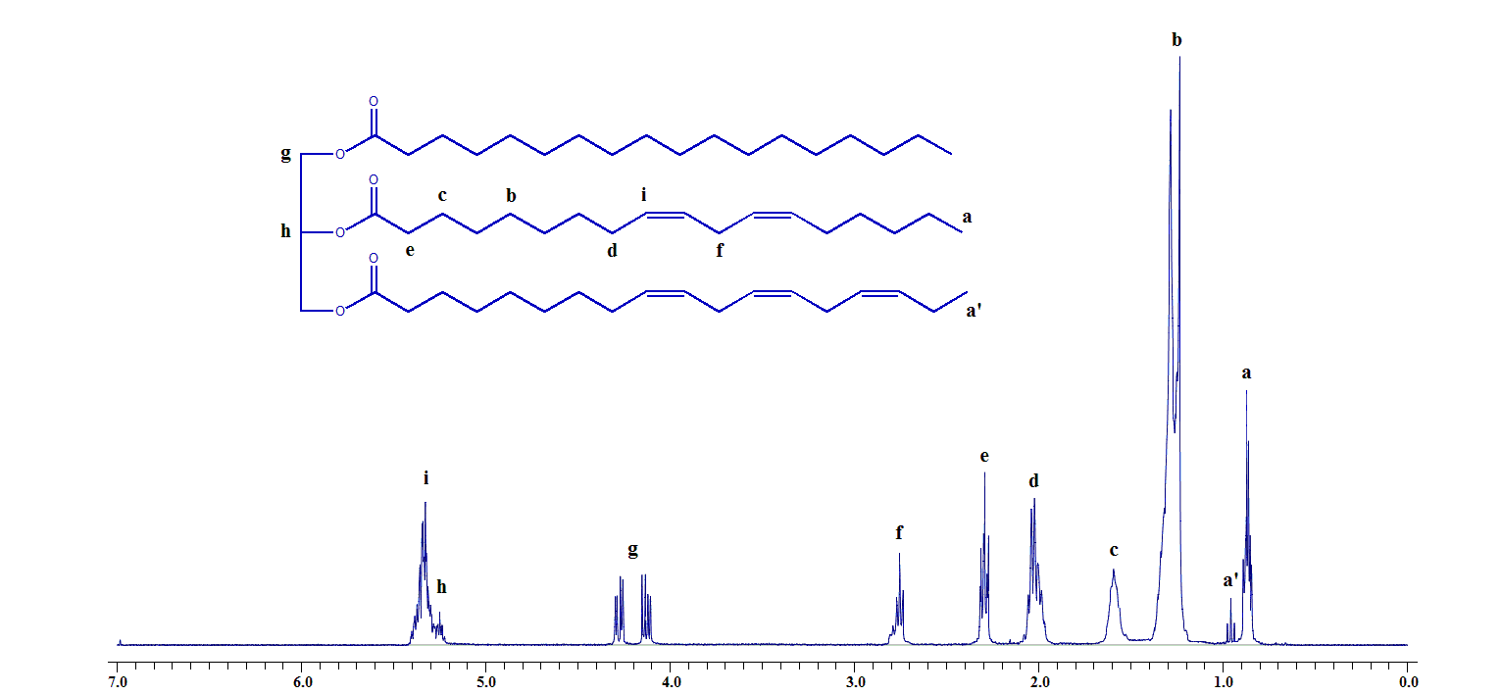
Lab Report Guidance
Be sure to review the “Report Guidelines” and “Example Reaction Lab Report” documents on the course webpage.

- Determine the amount of fat isolated in Part A. Use this value to calculate:
  - The amount of fat per serving of your food. Compare this value to the fat per serving on the food package label.
  - The percent recovery of fat based on the amount of fat per serving on the package.
- Using the NMR spectrum of your extracted fat, use the integral data to calculate:
  - Percent Saturated Fat
  - Percent Unsaturated Fat
  - Percent Monounsaturated Fat
  - Percent Polyunsaturated Fat
Use these values to calculate the grams of each type of fat per serving of your food. Compare these to the values provide on the food package label.
- Calculate a percent yield for the hydrogenation reaction.
- Using the NMR spectrum of your hydrogenated fat, use the integral data to calculate:
  - Percent Saturated Fat
  - Percent Unsaturated Fat
  - Percent Monounsaturated Fat
  - Percent Polyunsaturated Fat
Comment on the effectiveness of the hydrogenation reaction.

Derived Equations:
% Unsaturated Fat $=\frac{2}{4}(\frac{H_{allylic peak}}{H_{alpha peak}})×100$ (Equation 1)

$\% Polyunsaturated Fat =\frac{[H_{bis-allylic}-2\left(\frac{H_{Homo-allylic}}{3}\right)}{H_{alpha}} ×$100 (Equation 2)

Questions
(Fully explain how you arrived at each answer, including all calculations.)

- Cyclohexene can also be used as a hydrogen source in a transfer hydrogenation, releasing two equivalence of molecular hydrogen. Write a balanced equation showing the hydrogenation of 1-butene with cyclohexene in the presence of a Pd/C catalyst.

- An unsaturated fat that is liquid at room temperature, such as olive oil can react in the presence of Pd/C without a hydrogen source to form a solid fat of the same formula. Explain what process besides hydrogenation could be taking place.

- Explain why the effectiveness of the fat extraction in Part A is reported as a “percent recovery” but the effectiveness of the fat hydrogenation in Part B is reported as a “percent yield.”

