*NOTE: For this laboratory, the student only needs to turn in the worksheet, the discussion of results, and the answers to the questions. No formal pre-lab or in-lab is necessary. However, the report must be typed and include the (typed) table of results.*

**Introduction to Molecular Modeling**

Molecular modeling is a computational technique whereby the structure of a molecule is represented numerically and its behavior and properties are calculated using the equations of classical and quantum physics. These calculations are very complex, and in the past required the most powerful computers and significant amounts of computer time to carry out. Today, though, the typical PC is powerful enough to perform these calculations, and many software programs are available to carry out a variety of molecular modeling tasks. In these programs, the user draws a molecule of interest using a graphical interface, and he or she then uses the software to perform molecular mechanics calculations using classical physics, and to perform quantum mechanical calculations using either *ab initio* or semi-empirical methods. The results of these calculations are properties such as energy minima, heats of formation, interatomic distances, charge density maps, HOMO/LUMO maps, etc. for various conformations of the molecule of interest.

In this experiment, you will use Spartan – computer software which performs molecular modeling calculations – to construct molecular models and carry out calculations on four different compounds. Specifically, you will use molecular mechanics methods to calculate the strain energy (Estrain) for two conformations each of ethane, butane, cyclohexane, and *trans*-1,4-dimethylcyclohexane. In addition, you will use Spartan to determine certain other properties for the two conformations of the two cyclic molecules. You will then use this data to determine which conformation in each pair is the more energetically stable, and using what you have learned in class about conformational stabilities, you will provide a reasonable explanation for the results.

Using Spartan 08 (Molecular Modeling Lab, Room 312)

Log on to the computer using the following information:

**Username: organic**

**Password: (available from instructor)**

To open Spartan, click on the **Spartan Icon in the menu bar** (it looks like a greenish blob).

From the **Main Window**, select **New** from the **File Menu** (or click the **New** icon in the toolbar) – this opens the *Build* window.



----Molecules are created in the build window using the tools on the right----

Select the **Tetrahedral Carbon** tool ( ).



Click in the build area to create a carbon (Methane).

----Atoms automatically have hydrogens (yellow) to complete the atom’s valence----

Practice manipulating Methane.

To *move* a molecule, **Right-Click** and **Drag.**

To *rotate* a molecule, **Left-Click** and **Drag.**

You can *move* or *rotate* the molecule at any time while using Spartan.

When you are done practicing, select **Close** from the **File Menu** and Click **“No”** if the program asks if you want to save the file.

***NOTE: Anytime you draw a molecule, look at it before you perform any calculations to make sure it is the molecule (and the conformation) you intended to draw. If it is not the correct molecule or conformation, your calculations will be misleading.***

EXPERIMENT WORKSHEET

Energy Data from Experiments kJ/mol kcal/mol

Estrain of Eclipsed Ethane ___________ ___________

Estrain of Staggered Ethane ___________ ___________

Estrain of Gauche Butane ___________ ___________

Estrain of Anti Butane ___________ ___________

Estrain of Chair Cyclohexane ___________ ___________

Estrain of Boat Cyclohexane ___________ ___________

Estrain of Diaxial *trans*-1,4-dimethylcyclohexane ___________ ___________

Estrain of Diequatorial *trans*-1,4-dimethylcyclohexane ___________ ___________

Distance Data from Experiments Angstroms

H1-H4 Distance in Chair Cyclohexane ___________

H1-H4 Distance in Boat Cyclohexane ___________

Observational Data from Experiments

# of Eclipsing H-H interactions in Chair Cyclohexane ___________

# of Eclipsing H-H interactions in Boat Cyclohexane ___________

**Lab Report**

This report must be typed. Convert the strain energies to kcal/mol and record these values in the worksheet and in your report. Include a typed table of results, a discussion of your results, and the answers to the questions. Address the following items in the discussion of your results:

1. What does it mean for a conformation to be “more stable” than another conformation in terms of the strain energy?
2. For **each of the four molecules** investigated:

* Calculate the difference in strain energy between the two conformations.
* Discuss which conformation was more stable and why (be very detailed; consider eclipsing interactions, gauche interactions and interatomic distances). *Include drawings of the appropriate conformations of all molecules to assist in your discussion.*
* Did your modeling results confirm or contradict what you learned in class about conformational stabilities? How so?
  1. What can you conclude about the usefulness of applying molecular mechanics modeling to conformational analysis problems?
  2. Answer the questions on the following page.

**Questions**

**(Fully explain how you arrived at each answer, including all calculations.)**

***(Instructions for building models, setting dihedral angles, and minimizing energies are found in the paragraphs following the questions).***

1. How many eclipsing H-H interactions are in eclipsed ethane? Based on the results of your calculations with ethane, determine the energy of 1 eclipsing H-H interaction.

2. Using your calculated energy value from above, calculate the total energy of the H-H eclipsing interactions in boat cyclohexane relative to chair cyclohexane. Do the eclipsing H-H interactions in boat cyclohexane account for the entire energy difference between chair and boat cyclohexane? If not, what other factors may account for the rest of the energy difference? (NOTE: Examining models will help you answer this question.)

3. Using the relationship between equilibrium constant (K) and standard free energy difference (Go) you learned in general chemistry, calculate the ratio of equatorial to axial conformations for methylcyclohexane at equilibrium at 25 oC, given the following:



***1. Determining the Strain Energies for Staggered and Eclipsed Ethane***

**Building Ethane**

From the **Main Window**, select **New** from the **File Menu** (or click on the toolbar)



Select the **Tetrahedral Carbon** tool ( ).



Click in the build area to create a carbon.

To attach a second carbon, click one of the yellow hydrogens on the first carbon.

**Forcing the Eclipsed Conformation of Ethane**

----Molecules can be forced into a conformation by defining a dihedral angle----

Select **Measure Dihedral** from the **Geometry Menu** (or click on).



Click on a hydrogen, then the carbon bonded to it, then the next carbon and then a hydrogen bonded to the second carbon.

Enter “0.001” for the angle in the text box at the bottom right of the screen (next to   
“Dihedral (…) =” ) and press **Enter.**

Select **Constrain Dihedral** from the **Geometry Menu**.Click again on the *same four atoms you used to define the dihedral angle*, then click on the **Lock** icon () at the bottom right of the screen. The Lock icon will change to indicating that a dihedral constraint is to be applied.



Select **Save** from the **File Menu,** left click and highlight the **Home** directory.

Enter “ethane” as the filename and click **Save.** Click “Yes” ifthe program asks if you want to replace an already existing file.

Select **View** () from the toolbar (or select **View** from the **Build Menu**).



The structure should now appear in the main window.

**Determining the Strain Energy**

Select **Setup 🡪 Calculations** from the **Main Menu.** This brings up the Calculations dialog box. To the right of “Calculate,” select **Equilibrium Geometry** at **Ground** state with **Molecular Mechanics MMFF**. To the right of “Subject to,” check the **Constraints** box. The Calculations dialog box should look like this:

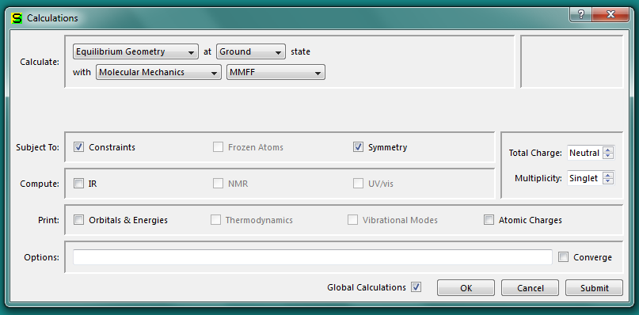

Click “**Submit**”.

When the calculations are complete, select **Display 🡪 Properties** from the Main Menu. Record the energy (in kJ/mol) to 2 decimal places in the worksheet (Use the quantity labeled “Energy,” not the quantity labeled “Energy(aq).”) Close the Molecule Properties dialog box.

Select **File 🡪 Close** from the Main Menu and select “No” if the program asks if you want to save the file.

**Forcing the Staggered Conformation of Ethane**

Select **File 🡪 New** from the **Main Menu** (or click on the toolbar) and build ethane as described above.



Select **Measure Dihedral** from the **Geometry Menu** (or click on).



Click on a hydrogen, then the carbon bonded to it, then the next carbon and then a hydrogen bonded to the second carbon.

Enter “60” for the angle in the text box at the bottom right of the screen (next to   
“Dihedral … ) and press **Enter.**

Select **Constrain Dihedral** from the **Geometry Menu**.Click again on the *same four atoms you used to define the dihedral angle*, then click on the **Lock** icon () at the bottom right of the screen. The Lock icon will change to indicating that a dihedral constraint is to be applied.



Select **Save** from the **File Menu.**

Enter “ethane” as the filename and click **Save.** Click “Yes” ifthe program asks if you want to replace an already existing file.

Select **View** () from the toolbar (or select **View** from the **Build Menu**).



The structure should now appear in the main window.

**REPEAT** the “Determining the Strain Energy” procedure (from part 1) to obtain Estrain for the staggered conformation of ethane.

Select **Close** from the **File Menu** and click “No” if the program asks if you want to save the file.

***2. Determining the Strain Energies for Gauche and Anti Butane***

**Building Butane**

From the **Main Window**, select **New** from the **File Menu** (or click on the toolbar).



Select the **Tetrahedral Carbon** tool ( ).



Click in the build area to create a carbon.

To attach a second carbon, click one of the yellow hydrogens of the first carbon.

Attach two new carbons, one at a time, by clicking on the appropriate yellow hydrogens. NOTE: make sure you have built butane (linear), and not 2-methylpropane (branched).

**Forcing the Gauche Conformation of Butane**

Select **Measure Dihedral** from the **Geometry Menu** (or click on).



Click on each carbon in the order C1, C2, C3, C4.

Enter “60” for the angle in the text box at the bottom right of the screen (next to   
“Dihedral (…) =”) and press **Enter.**

Select **Constrain Dihedral** from the **Geometry Menu**.Click again on the *same four carbons you used to define the dihedral angle*, then click on the **Lock** icon () at the bottom right of the screen. The Lock icon will change to indicating that a dihedral constraint is to be applied.



Select **Save** from the **File Menu.**

Enter “butane” as the filename and click **Save.** Click “Yes” ifthe program asks if you want to replace an already existing file.

Select **View** () from the toolbar (or select **View** from the **Build Menu**).



The structure should now appear in the main window.

**REPEAT** the “Determining the Strain Energy” procedure (from part 1) to obtain Estrain for the gauche conformation of butane.

Select **Close** from the **File Menu** and click “No” if the program asks if you want to save the file.

**Forcing the Anti Conformation of Butane**

Select **File 🡪 New** from the **Main Menu** (or click on the toolbar) and build   
*n*-butane as described above.



Select **Measure Dihedral** from the **Geometry Menu** (or click on).



Click on each carbon in the order C1, C2, C3, C4.

Enter “180” for the angle in the text box at the bottom right of the screen (next to   
“Dihedral (…) =”) and press **Enter.**

Select **Constrain Dihedral** from the **Geometry Menu**.Click again on the *same four carbons you used to define the dihedral angle*, then click on the **Lock** icon () at the bottom right of the screen. The Lock icon will change to indicating that a dihedral constraint is to be applied.



Select **Save** from the **File Menu.**

Enter “butane” as the filename and click **Save.** Click “Yes” ifthe program asks if you want to replace an already existing file.

Select **View** () from the toolbar (or select **View** from the **Build Menu**).



The structure should now appear in the main window.

**REPEAT** the “Determining the Strain Energy” procedure (from part 1) to obtain Estrain for the anti conformation of butane.

Select **Close** from the **File Menu** and click “No” if the program asks if you want to save the file.

***3. Determining Strain Energies, H1-H4 Distances, and Number of Eclipsing H-H Interactions for Chair and Boat Cyclohexane***

**Building the Chair Conformation of Cyclohexane**

Select **File 🡪 New** from the **Main Menu** (or click on the toolbar).



Select “Cyclohexane” from the dropdown menu next to the “Rings” option near the bottom of the tools.

Click in the build area to create a Cyclohexane.

Select **Save** from the **File Menu**

Enter “cyclohexane” as the filename and click **Save.** Click “Yes” ifthe program asks if you want to replace an already existing file.

Select **View** () from the toolbar (or select **View** from the **Build Menu**).



The structure should now appear in the main window.

**REPEAT** the “Determining the Strain Energy” procedure (from part 1) to obtain Estrain for the chair conformation of cyclohexane.

**Determining H1-H4 Distance in Chair Cyclohexane**

Select **Measure Distance** from the **Geometry Menu.**

Click on an axial up hydrogen (H1).

Click on the equatorial up hydrogen 3 carbons away (H4) (See figure below).



The H1-H4 distance (in Angstroms) will appear in the text box at the lower right of the screen (next to “Distance(…) = ”).

Record this value as the H1-H4 distance for chair cyclohexane.

**Determining the Number of Eclipsing H-H Interactions in Chair Cyclohexane**

**ROTATE** (**Left-Click** and **Drag**) the model and orient it so as to site down the C1-C2 bond of the cyclohexane ring:

C1

C1-C2 bond

C5

C6

C3

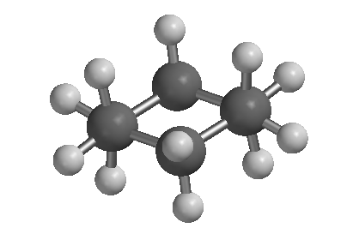

**Considering only the atoms attached to C1 and C2 (those within the circle), COUNT** the number of eclipsing H-H interactions you see (if needed, refer to the discussion of ethane conformations in your lecture notes or textbook to find the definition of an eclipsing H-H interaction).

**SITE** down the C2-C3 bond and count the number of eclipsing H-H interactions. Repeat for the C3-C4, the C4-C5, the C5-C6 and the C6-C1 bonds in the cyclohexane ring.

**RECORD** the total number of eclipsing H-H interactions on the worksheet.

Select **Close** from the **File Menu** and click “No” if the program asks if you want to save the file.

**Forcing the Boat Conformation of Cyclohexane**

Select **File 🡪 New** from the **Main Menu** (or click on the toolbar).



Select “Cyclohexane” from the dropdown menu next to the “Rings” option near the bottom of the tools.

Click in the build area to create a Cyclohexane. Orient your cyclohexane so you are looking down the C2-C3 and C6-C5 bonds as shown in the figure below.

C5

C6

C1

C4

C2

C3

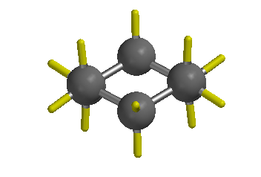

Select the **Break Bond** tool () (or Select **Build 🡪 Break Bond** from the **Main Menu**) and click on the indicated (C1-C6) bond in the diagram below:



Break this bond



Select **Measure Dihedral** from the **Geometry Menu** (or click on).



Click on each carbon in the order C1, C2, C3, C4.

Enter “0.001” for the angle in the text box at the bottom right of the screen (next to   
“Dihedral … ) and press **Enter.**

Select **Constrain Dihedral** from the **Geometry Menu**.Click again on the *same four carbons you used to define the dihedral angle*, then click on the **Lock** icon () at the bottom right of the screen. The Lock icon will change to indicating that a dihedral constraint is to be applied.



Select the **Bond** tool () (or Select **Build 🡪 Make Bond** from the **Main Menu**) and re-form the bond between C1 and C6 by clicking on a yellow hydrogen on each carbon.



Make sure the carbons in your molecule are arranged in the boat conformation of cyclohexane before proceeding:

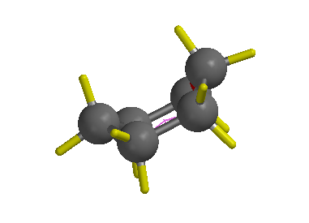

Select **Save** from the **File Menu.**

Enter “cyclohexane” as the filename and click **Save.** Click “Yes” ifthe program asks if you want to replace an already existing file.

Select **View** () from the toolbar (or select **View** from the **Build Menu**).



The structure should now appear in the main window.

**REPEAT** the “Determining the Strain Energy” procedure (from part 1) to obtain Estrain for the boat conformation of cyclohexane.

**Determining H1-H4 Distance in Boat Cyclohexane**

Select **Measure Distance** from the **Geometry Menu.**

Click on a “flagpole” hydrogen (H1).

Click on the other “flagpole” hydrogen (H4) (See figure below).



The H1-H4 distance (in Angstroms) will appear in the text box at the lower right of the screen (next to “Distance(…) = ”).

Record this value as the H1-H4 distance for boat cyclohexane.

**REPEAT** the “Determining the Number of Eclipsing H-H Interactions…” procedure to determine the number of eclipsing H-H interactions in boat cyclohexane.

Select **Close** from the **File Menu** and click “No” if the program asks if you want to save the file.

***4. Determining Strain Energies for trans-1,4-Dimethylcyclohexane***

**Building Diaxial *trans*-1,4-Dimethylcyclohexane**

Select **File 🡪 New** from the **Main Menu** (or click on the toolbar).



Select “Cyclohexane” from the dropdown menu next to the “Rings” option near the bottom of the tools.

Click in the build area to create a Cyclohexane.

Select the **Tetrahedral Carbon** tool ( )



Click on the axial yellow hydrogens on both C1 and C4 to replace them with methyl groups.

Select **Save** from the **File Menu.**

Enter “dimethylcyclohexane” as the filename and click **Save.** Click “Yes” ifthe program asks if you want to replace an already existing file.

Select **View** () from the toolbar (or select **View** from the **Build Menu**).



The structure should now appear in the main window.

**REPEAT** the “Determining the Strain Energy” procedure (from part 1) to obtain Estrain for the diaxial conformation of *trans*-1,4-dimethylcyclohexane.

Select **Close** from the **File Menu** and click “No” if the program asks if you want to save the file.

**Building Diequatorial *trans*-1,4-Dimethylcyclohexane**

Select **File 🡪 New** from the **Main Menu** (or click on the toolbar).



Select “Cyclohexane” from the dropdown menu next to the “Rings” option near the bottom of the tools.

Click in the build area to create a Cyclohexane.

Select the **Tetrahedral Carbon** tool ( ).



Click on the equatorial yellow hydrogens on both C1 and C4 to replace them with methyl groups.

Select **Save** from the **File Menu.**

Enter “dimethylcyclohexane” as the filename and click **Save.** Click “Yes” ifthe program asks if you want to replace an already existing file.

Select **View** () from the toolbar (or select **View** from the **Build Menu**).



The structure should now appear in the main window.

**REPEAT** the “Determining the Strain Energy” procedure (from part 1) to obtain Estrain for the diequatorial conformation of *trans*-1,4-dimethylcyclohexane.

Select **Close** from the **File Menu** and click “No” if the program asks if you want to save the file.

Exit Spartan and log out (under the “System” menu) of the computer.