Name: ______Justin Arthur Student__________ Date: ___08/27/2014___ Exp. #: JAS-11

Title: _______Isolation of Eugenol from the Steam Distillation of Cloves ____________________________

Purpose: _____ To isolate eugenol from cloves by steam distillation and analyze it using IR _________________and ¹H-NMrspectroscopy___________________________________________________________

Chemical & Safety Data:
Substance | Structure | MW (g/mol) | m.p. (ºC) | b.p. (ºC) | Density (g/mL) | Role
Name: Dichloromethane | N/A | 84.93 | -97 | 39 to 40 | 1.32 | Solvent
Formula: CH₂Cl₂ |  | Safety: Irritant, possible cancer hazard, inhalation may cause CNS effects
Name: Sodium sulfate | N/A | 142.04 | 884 | N/A | N/A | Drying Agent
Formula: Na₂SO₄ |  | Safety: Possible irritant
Name: Eugenol |  | 164.20 | -12 to -10 | 254 | 1.06 | Analyte
Formula: C₁₀H₁₂O₂ |  | Safety: Irritant, potential allergen
Name: Chloroform-d | N/A | 120.38 | -64 | 61 | 1.5 | Solvent
Formula: CDCl₃ |  | Safety: Irritant, possible cancer hazard, inhalation may cause CNS effects

1. The apparatus sketched below was assembled and charged with 1.032 g of ground cloves and 17 mL distilled water. The cloves were soaked for about 15 min until thoroughly wetted.
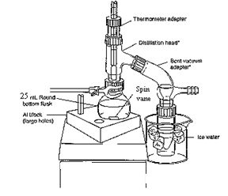
2. The mixture was heated to boiling. Initial hot plate setting = 3. After 20 min, mixture still not boiling so setting increased
to 7. Distillate collected at rate of about 1 drop/2-3 sec. ~10 mL 6.5 mL of distillate collected, then distillation was discontinued.
3. The distillate was transferred to a separatory funnel, extracted with 2 mL dichloromethane, then again with (2 x 1 mL) dichloromethane
4. The combined organic extracts were dried over sodium sulfate, and transferred to a tared beaker conical vial
(Tare wt = 18.643 g).
5. The dichloromethane was evaporated by heating on a hot plate (UNDER HOOD!) to yield a pale yellow oil.
Vial + eugenol = 18.720 g
Wt eugenol = 0.077 g (% Recovery = (0.077 g/1.032 g) x 100 = 7.46%)

6. An IR spectrum was obtained by the thin film method.

Isolation of Eugenol from Cloves by Steam Distillation and its Identification by Infrared Spectroscopy
Justin Arthur Student
CHEM 304
September 8, 2014
INTRODUCTION
“Essential oils” are the volatile components associated with the aromas of many plants.¹ In this experiment, the essential oil eugenol (the main component of oil of cloves) will be isolated from ground cloves by steam distillation and identified by infrared spectroscopy.
The principle of steam distillation is based on the fact that two immiscible liquids will boil at a lower temperature than the boiling points of either pure component, because the total vapor pressure of the heterogeneous mixture is simply the sum of the vapor pressures of the individual components (i. e. P_{T} = Pº_{A} + Pº_{B}, where Pº is the vapor pressure of the pure liquids). This leads to a higher vapor pressure for the mixture than would be predicted for a solution using Raoult’s Law (that is P_{T} = Pº_{A}N_{A} + Pº_{B}N_{B}, where N is the mole fraction of the component in the mixture). The higher total vapor pressure leads to a lower boiling point for the mixture than for either single component.² During the isolation of a liquid natural product by steam distillation, water is one of the components, and the liquid natural product being isolated (which is immiscible with water) is the other component. The product can be steam distilled from the natural source at a relatively low temperature (always less than 100 ºC), thus avoiding decomposition of the product.²
Steam distillation can be carried out in two ways: the direct method and the live steam method.³ In the direct method, steam is generated by boiling a mixture of the source of the compound of interest and water. The live steam method is carried out by passing steam from an external source into the distillation flask. The direct method of steam distillation will be used in this experiment.

EXPERIMENTAL
The apparatus shown in Figure 1 below was assembled and the 25-mL round bottom flask was charged with 1.032 g of ground cloves and 15 mL of distilled water. The cloves were allowed to soak in the water until thoroughly wetted (about 15 min), then the mixture was distilled, the distillate being collected at the rate of about one drop every 2 – 3 seconds. After about 6 mL of distillate were collected, the distillate was extracted with 2.0 mL of CH₂Cl₂ (aka DCM), then again with (2 x 1.0 mL) of DCM. The DCM extracts were combined, dried over Na₂SO₄, and evaporated to give the product eugenol as a pale yellow oil.

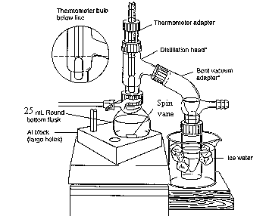
Figure 1⁴

Product mass: 0.077 g (7.46% recovery)
FTIR (film, NaCl plates): 3560 (OH), 3080 – 3000 (sp² CH), 2980 – 2940 (sp³ CH), 1640 (alkene C=C), 1600, 1514 (aromatic C=C) cm⁻¹.

DISCUSSION
Steam distillation of cloves produced 0.0770 g of an oil which contained in its IR spectrum the functional groups O-H (at 3560 cm⁻¹), sp² C-H (3080 – 3000 cm⁻¹), aliphatic C-H (2980 – 2940 cm⁻¹), and both alkene C=C (at 1640 cm⁻¹) and aromatic C=C (at 1600 and 1514 cm⁻¹). The IR spectrum is attached to this report. These data are consistent with the structure of eugenol, shown in Figure 2 below:
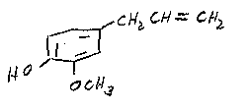
Figure 2: Eugenol
In addition, the IR of the product from the steam distillation of cloves closely corresponds with that of an authentic sample of eugenol shown in the Spectral Database for Organic Compounds.⁵ Therefore, it can be concluded that the oil which was isolated from cloves is in fact, eugenol.

0.0770 g of eugenol was recovered from 1.032 g of cloves. This corresponds to a percent recovery of 7.46%:

Amt. Eugenol isolated 0.0770 g
% Recovery = ------------------------------ = -------------- x 100 = 7.46%
Amt. Cloves used 1.032 g

Although the % recovery (7.46%) seems slightly low relative to the expected 10%⁵, the experiment proceeded as planned. There were no spills or other abnormal physical losses. It is possible that the ratio of the size of the glassware to the theoretical amount of eugenol which can be obtained from cloves in this experiment is large, leading to adherence of a large percentage of the product on the sides of the glass apparatus. If this is so, then steam distillation of a larger sample of cloves should give an improved recovery. Otherwise, it can be concluded that the specific sample of cloves used contains approximately 7.5% eugenol.

CONCLUSION
In this experiment, it was shown that about 7.5% of an oil could be recovered from cloves by steam distillation. This oil was identified as eugenol by comparison of its infrared spectrum with an authentic sample.

REFERENCES
1. Pavia, D. L.; Lampman, G. M.; Kriz, G. S.; Engel, R. G. Introduction to Organic Laboratory Techniques, A Microscale Approach; 3rd ed.; Brooks/Cole: Pacific Grove, CA, 1999; p. 139.
2. Pavia, D. L.; Lampman, G. M.; Kriz, G. S.; Engel, R. G. Introduction to Organic Laboratory Techniques, A Microscale Approach; 3rd ed.; Brooks/Cole: Pacific Grove, CA, 1999; p. 663.
3. Pavia, D. L.; Lampman, G. M.; Kriz, G. S.; Engel, R. G. Introduction to Organic Laboratory Techniques, A Microscale Approach; 3rd ed.; Brooks/Cole: Pacific Grove, CA, 1999; p. 665.
4. Wenqiang, G.; Shufen, L.; Ruixiang, Y.; Shaokun, T.; Can, Q. Food Chemistry, 2007, 101, 1558.
5. Spectral Database for Organic Compounds (SDBS). http://riodb01.ibase.aist.go.jp/sdbs/cgi-bin/cre_index.cgi?lang=eng (accessed January, 2012)
ANSWERS TO QUESTIONS
1. Why is eugenol steam-distilled rather than purified by simple distillation?

Eugenol has a high boiling point (254 ºC), and many organic compounds decompose at such high temperatures. Steam distillation allows eugenol to be distilled at a much lower boiling point (< 100 ºC), thus minimizing the potential for decomposition.

2. In a steam distillation, the amount of water actually distilled is usually greater than the amount calculated, assuming that both water and organic substance exert the same vapor pressure when they are mixed that they exert when each is pure. Why does one recover more water in the steam distillation than was calculated? (Hint: Are the organic compound and water truly immiscible?)

In most cases, organic substances have some solubility in water. If this is true, then the amount of water which is required to steam distill the substance in its entirety is the calculated amount plus an amount needed to distill over the amount of substance dissolved in water.

3. Steam distillation is one way to isolate an essential oil from a plant or fruit. Describe two other methods.

Expression (or cold-pressing) is the process of mechanically squeezing the oils out of the source, and is usually used for isolating citrus fruit essential oils. Solvent extraction is the process of treating the source with an organic solvent, such as hexane or supercritical carbon dioxide. The oils dissolve in the organic solvent, and then are isolated by evaporating the organic solvent.

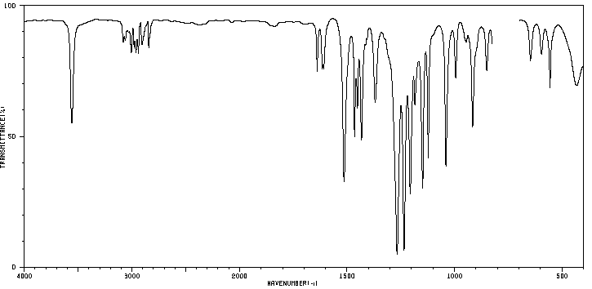
1-EAC-11, 1/9/2012

