Solubility
- Macronutrients and Micronutrients -

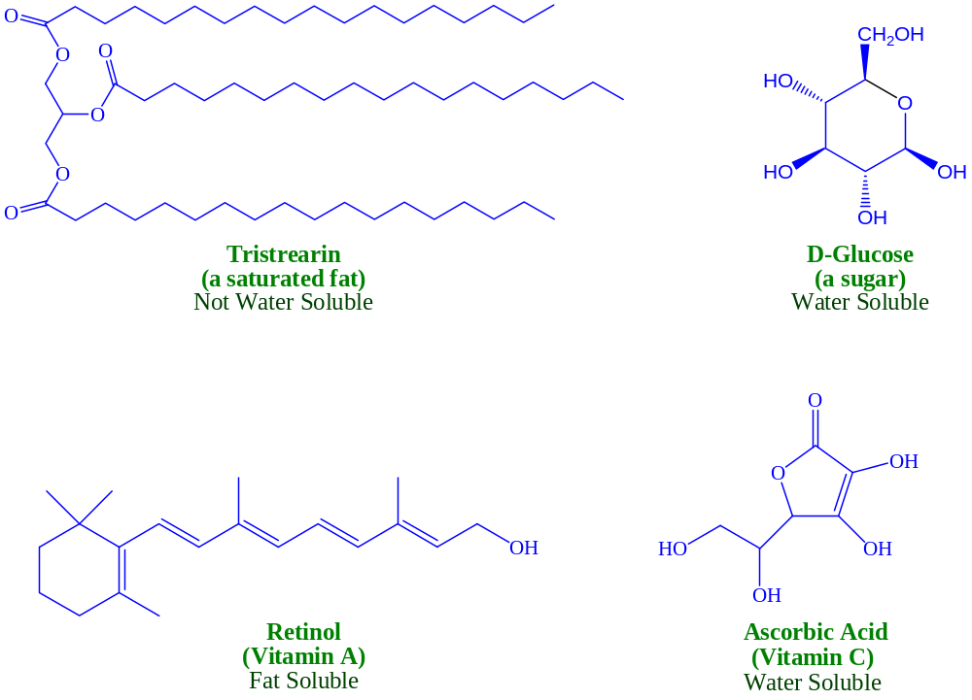

Monosaccharides (Sugars)
- Cyclization and Chair Conformations -

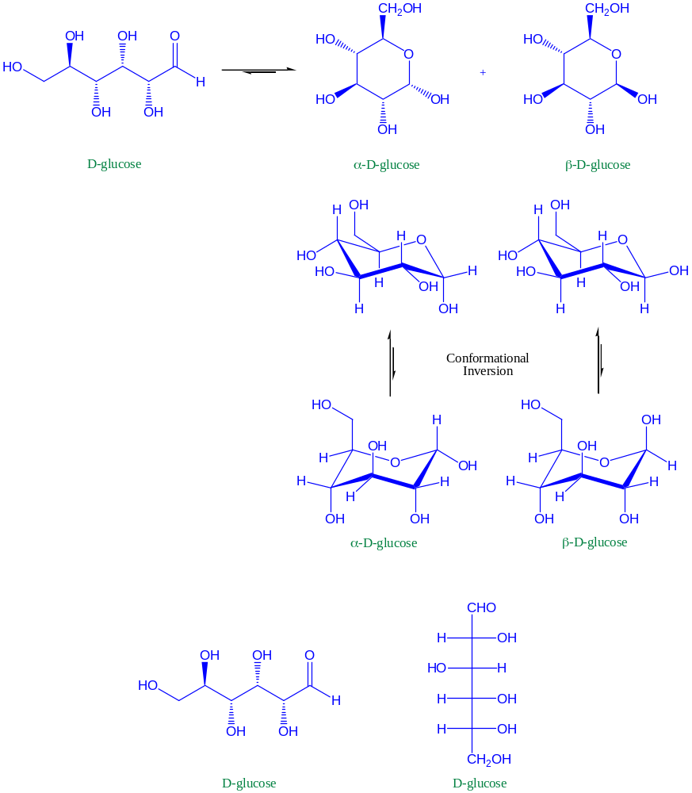

Metabolism of Fats
- Acyl Substitutions -

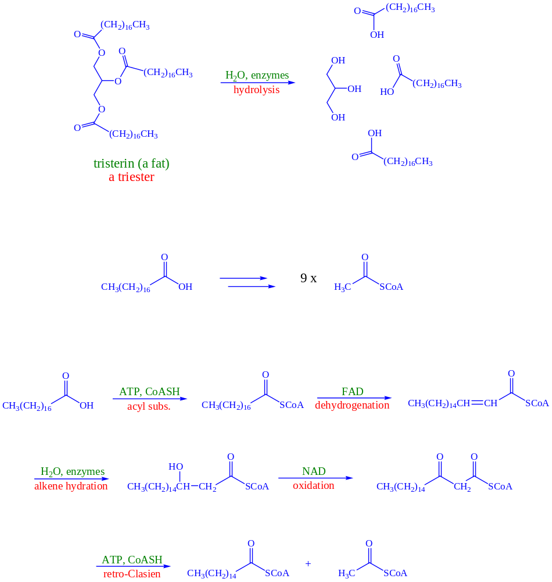

Metabolism of Sugars
- Aldolase -

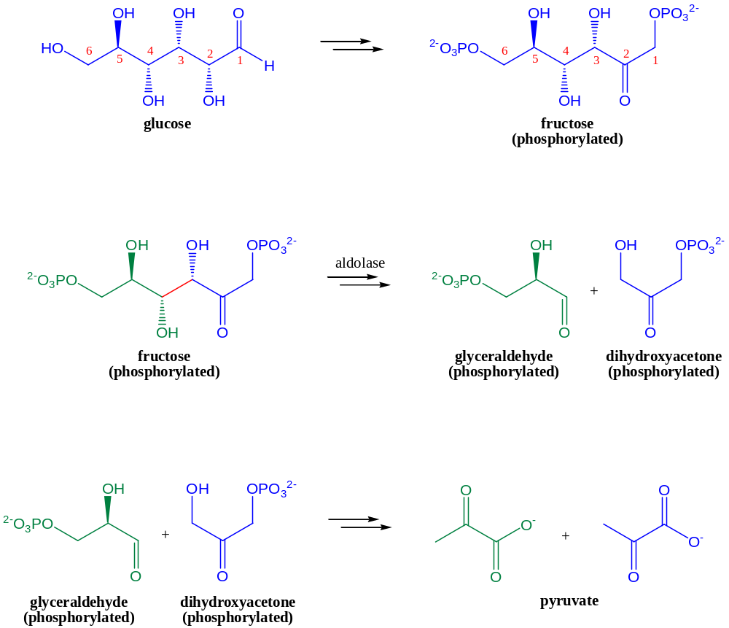

Aldolase (Revisited)
- Imine Intermediates -

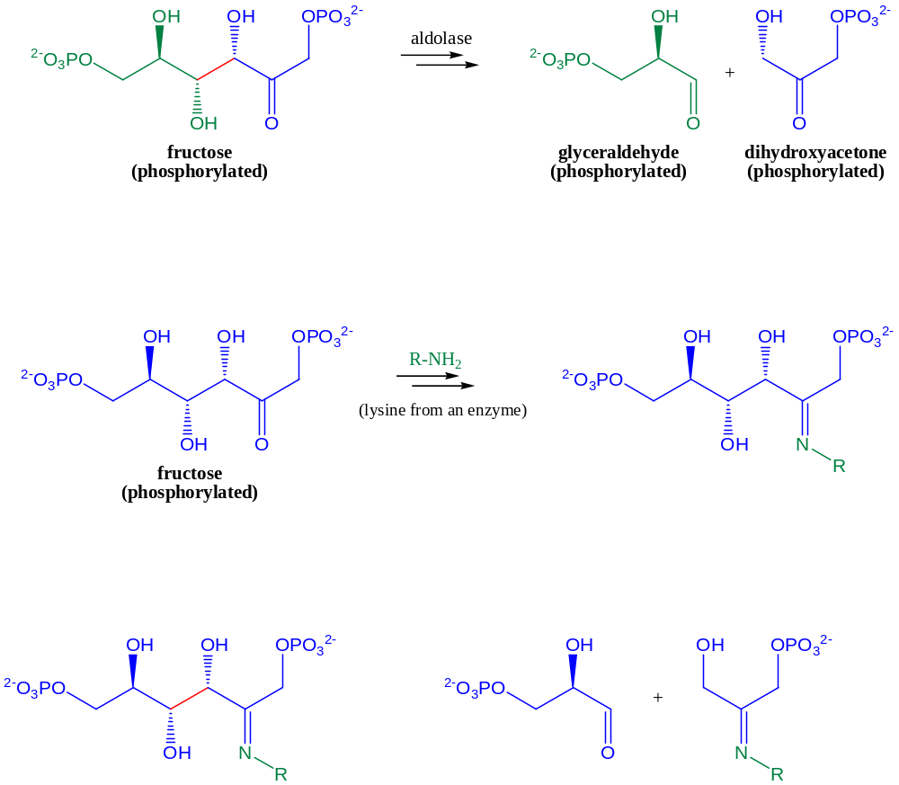

Mono- and Disaccharides
- Acetals and Hemiacetals -

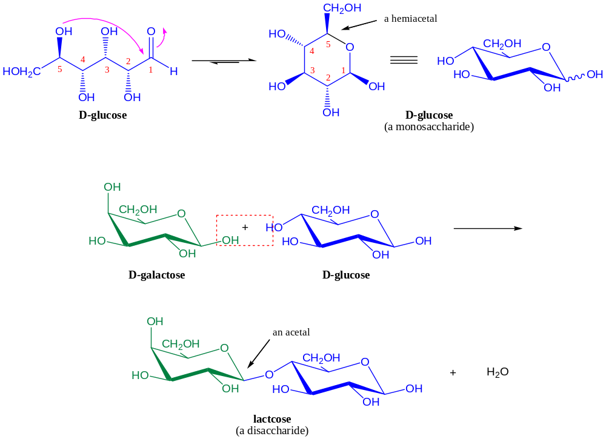

Polysaccharides
- Acetals and Hemiacetals -

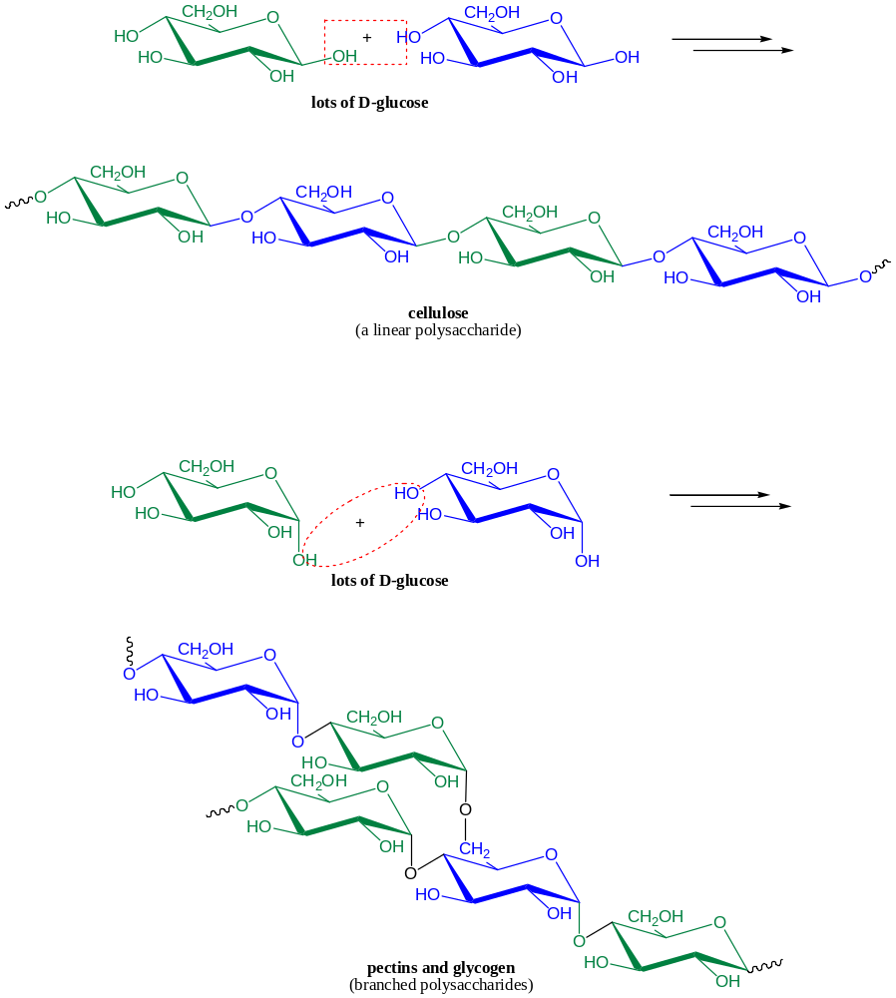
Bicyclic Compounds
- Bioactive Examlpes -

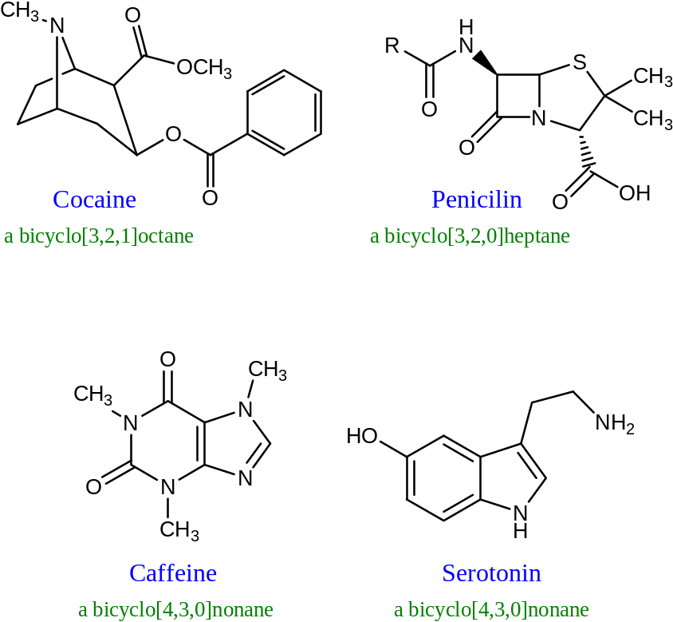
Busulfan
- Targeting Cancer with Nucleophilic Substitution -
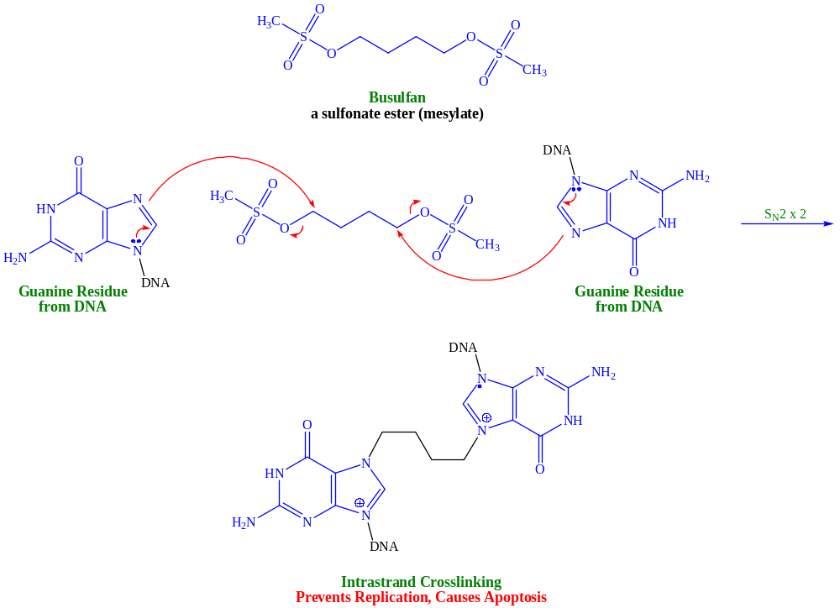
Carrots, Vitamin A and Vision
- Alkene Stereochemistry and Imines -
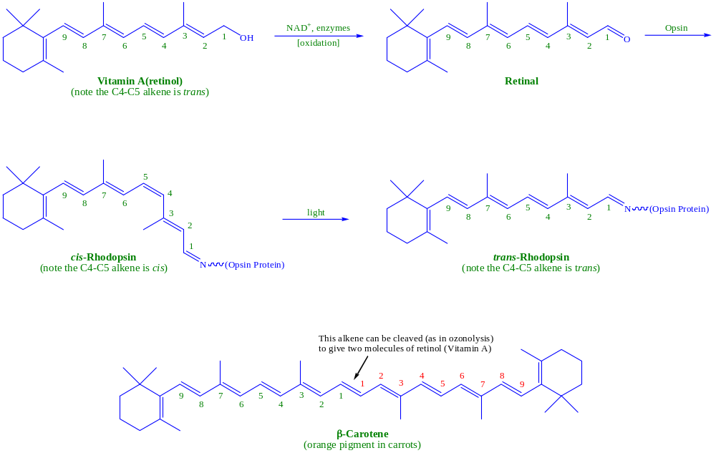
Hydrogenation of Fats
- Unsaturated, Saturated and trans Fats -

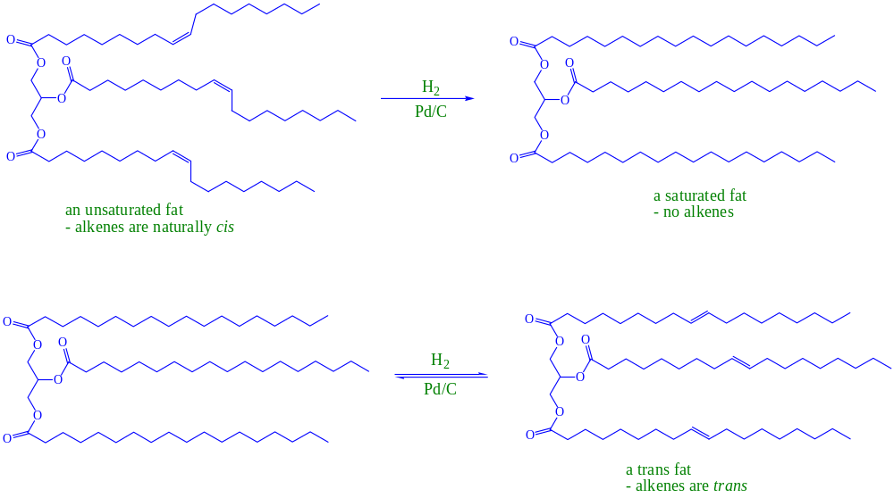
Iodine Number of Fats
- Determining How Unsaturated a Fat Is -



