1. Reactions
Draw the major product or products of each of reaction in the boxes provided. If multiple organic products are equally likely, show each. For stereoselective reactions, be certain that your structures clearly indicate stereochemistry.

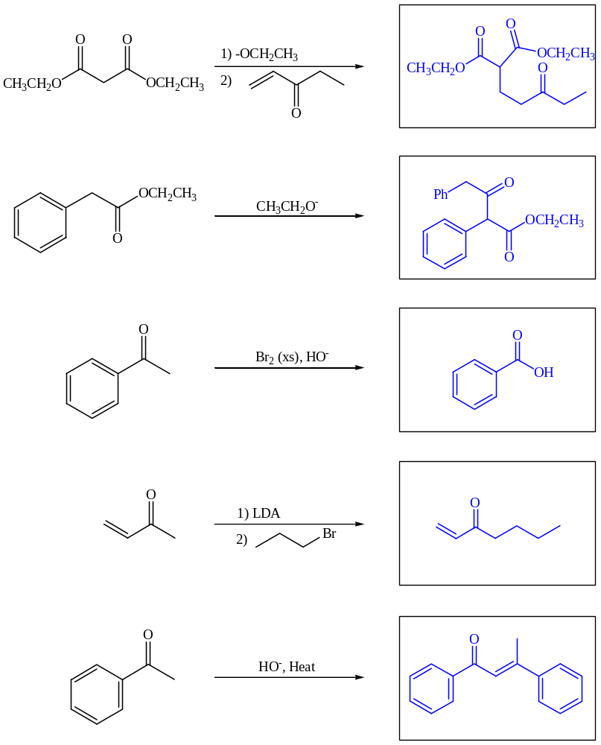

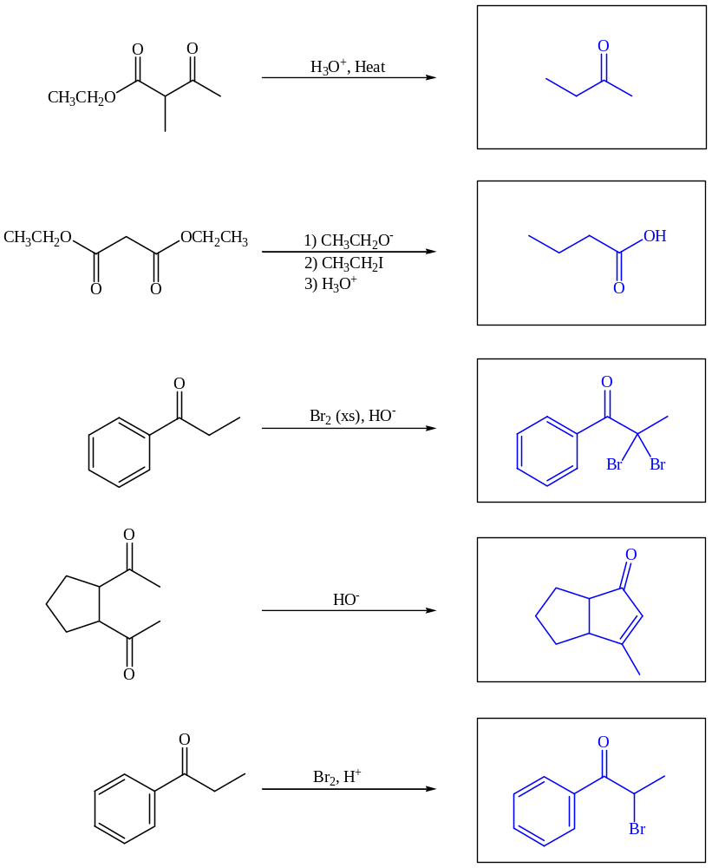

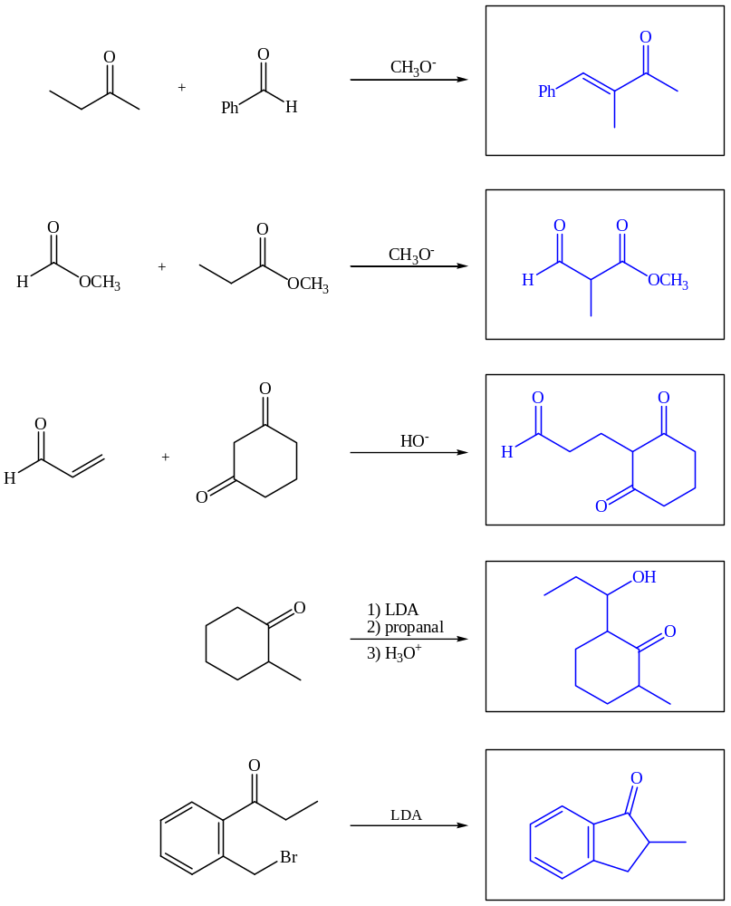

2. Mechanisms
Draw complete arrow-pushing mechanisms for the following reactions.
a.
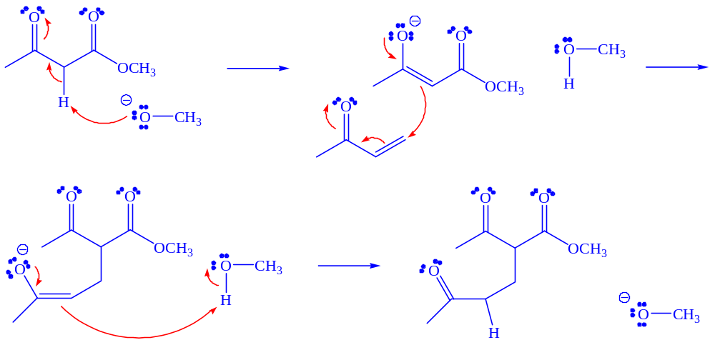

b.

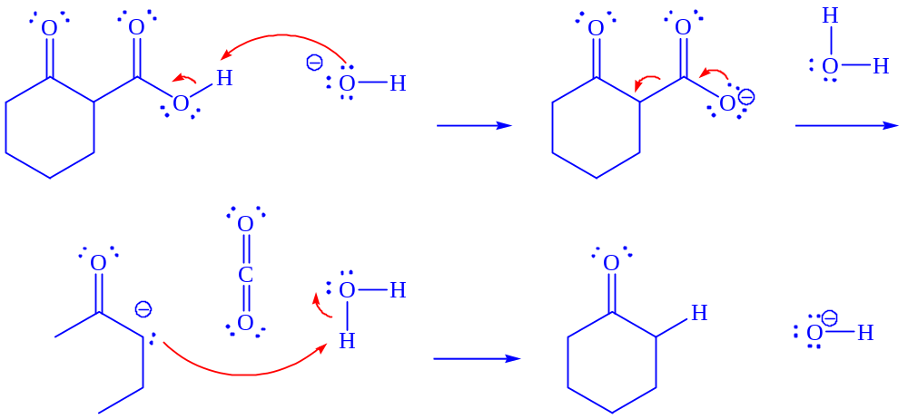

3. Synthesis
Propose a selective multi-step synthesis of each target molecule starting with the compound provided. Show the necessary reagents and products for each step.
a.
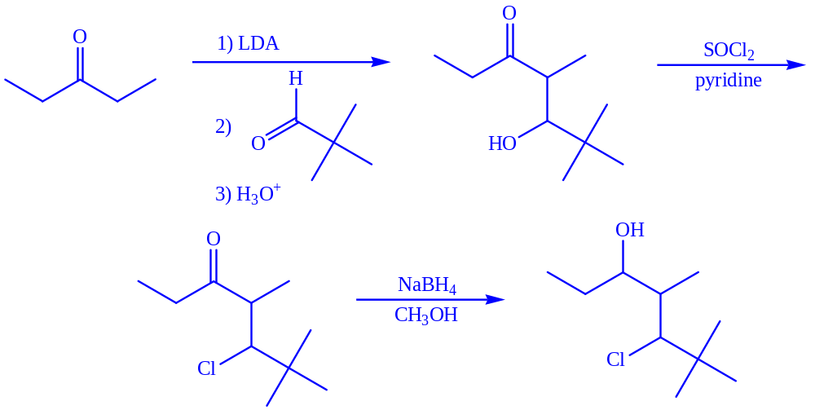

b.
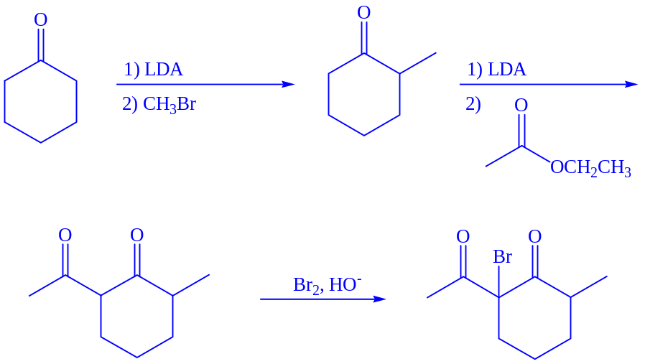

4. Application of Concepts
a. Enamines react very similarly to enols and enolates. Propose a complete arrow-pushing mechanism for the reaction of the following enamine with acetyl chloride.
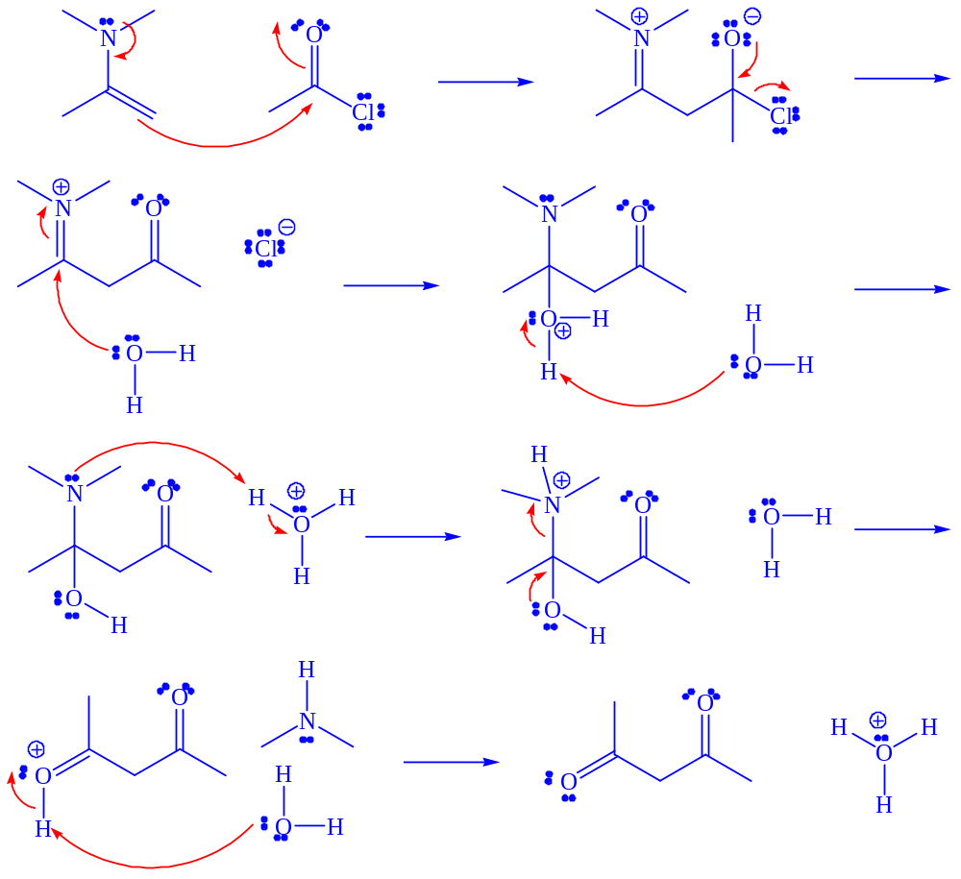

b. The Darzens condensation is a useful way to prepare epoxides. Propose a complete arrow-pushing mechanism for the Darzens condensation below.


