1. Extent of Enolizations
For each reaction, draw the enolate that would form, then indicate whether partial or quantitative enolization will result.
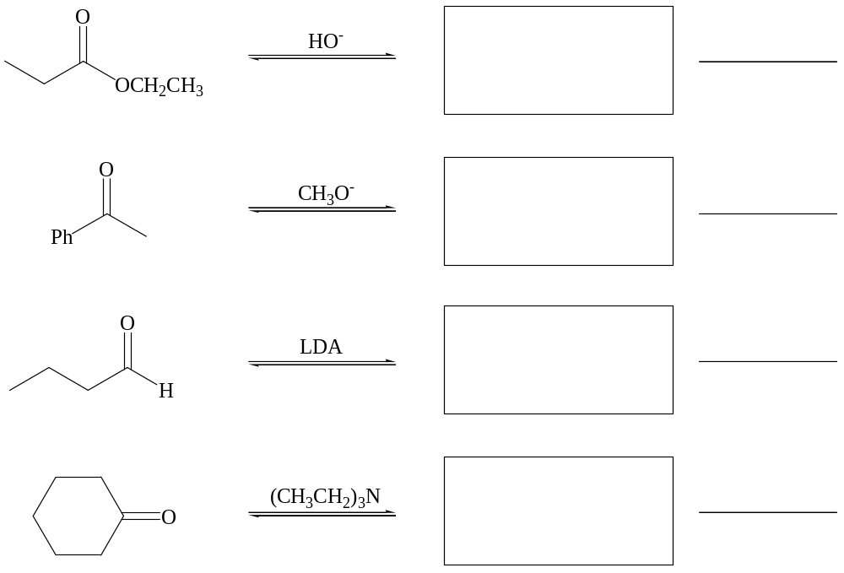

2. Regiochemistry of Enolizations
For each reaction, draw all possible enolate regioisomers, then circle the major isomer formed.
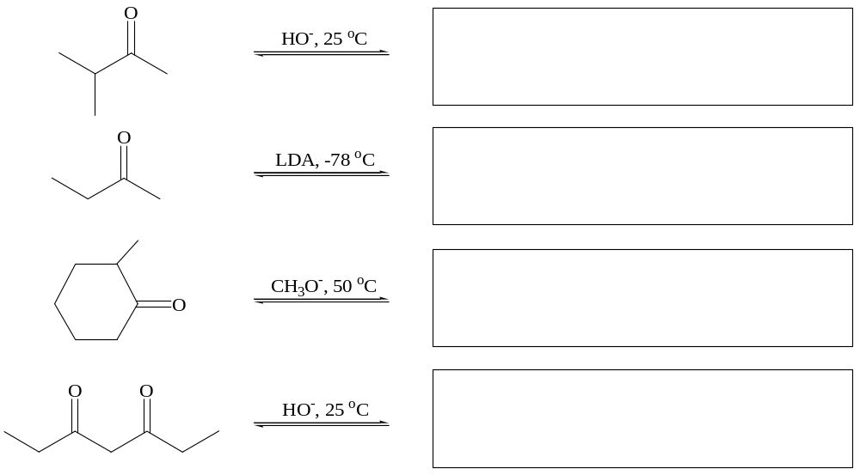
3. Substitution-type Reactions with Halogens and Alkyl Halides.
Draw the major product or products of each reaction.

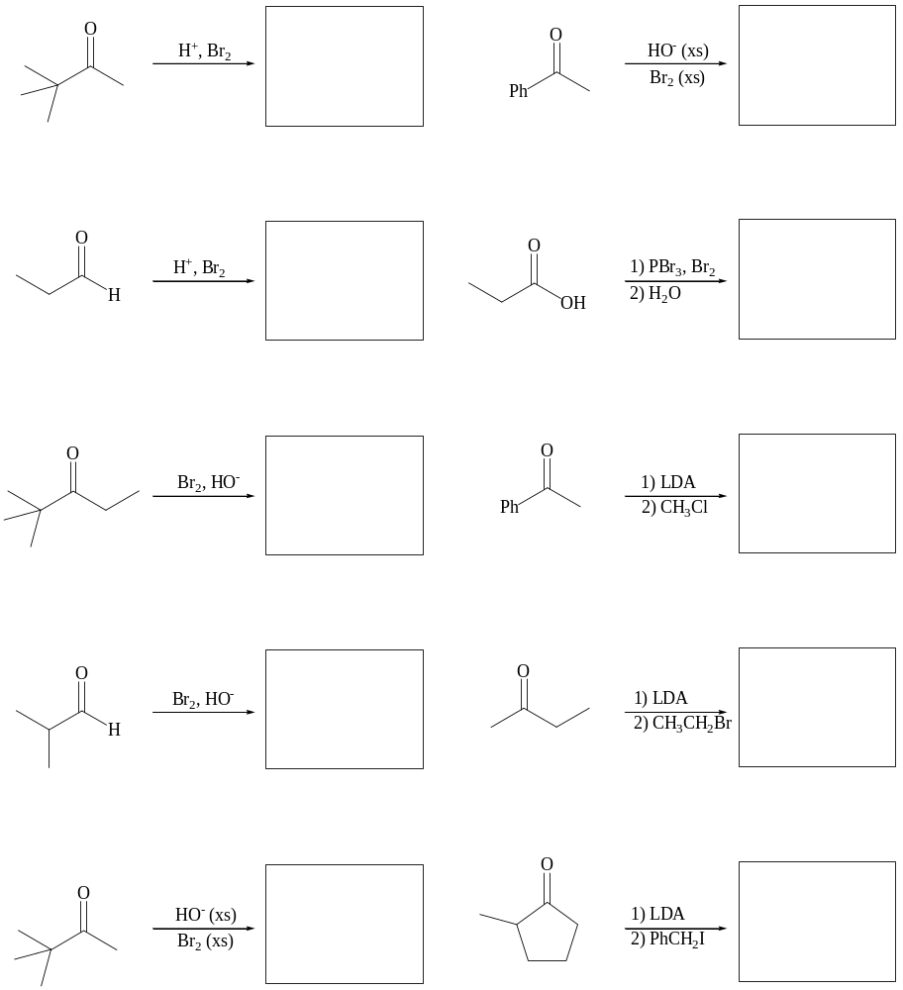

4. Aldol-type Reactions with Aldehydes and Ketones.
Draw the major product or products of each reaction.

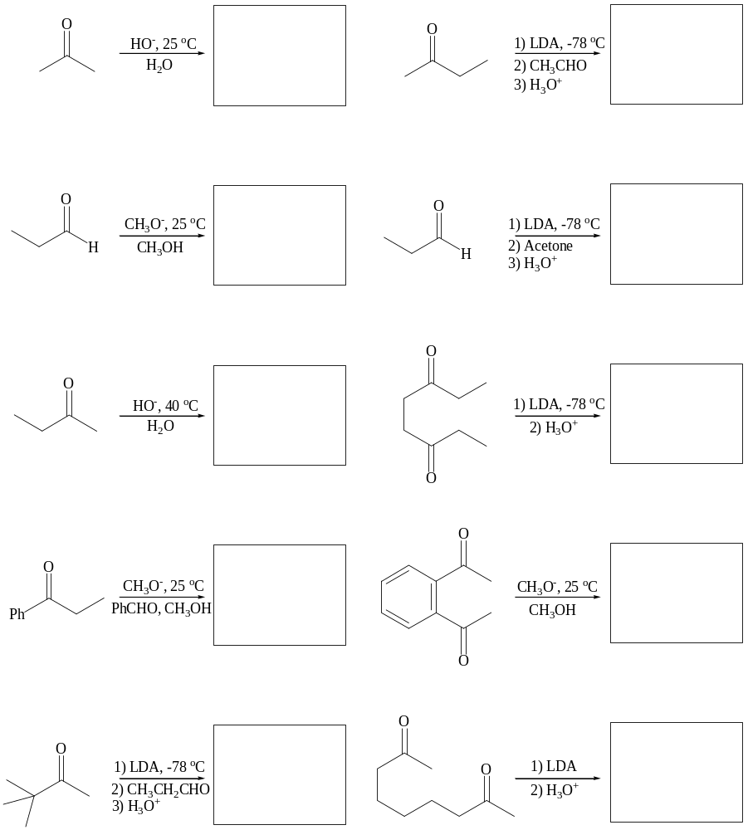

5. Claisen-type Reactions with Carboxylic Acid Derivatives.
Draw the major product or products of each reaction.

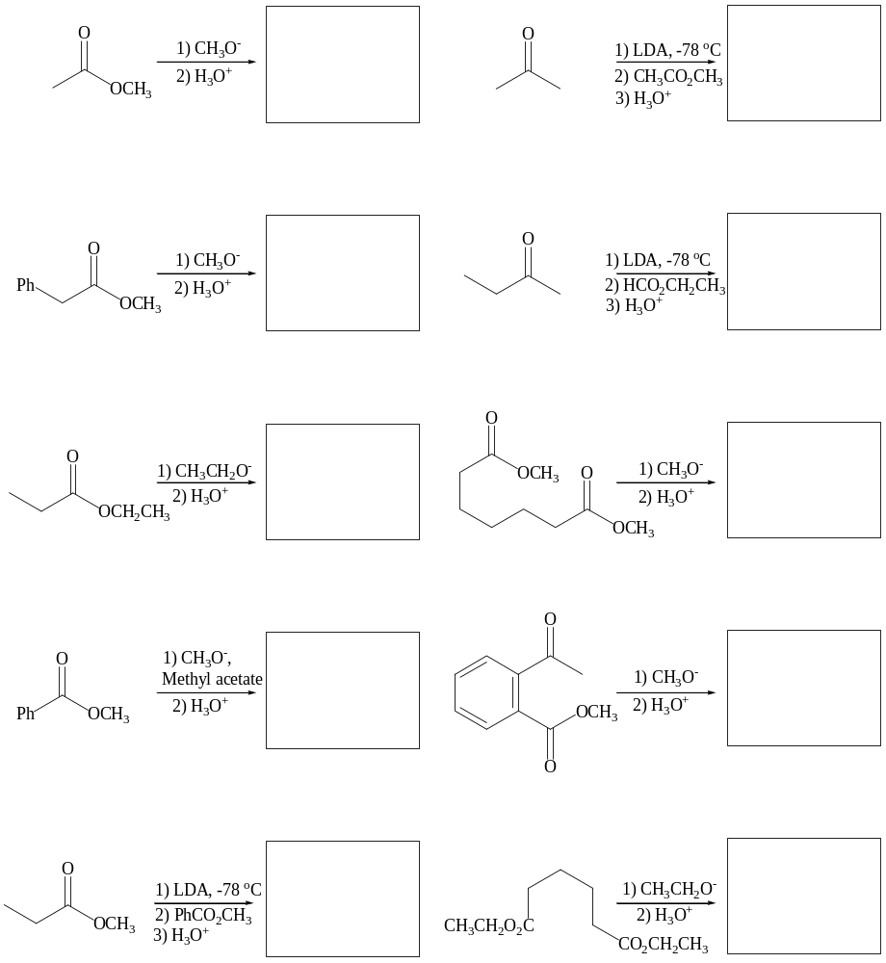

6. Michael-type Reactions with α,β-Unsaturated Carbonyls
Draw the major product or products of each reaction.
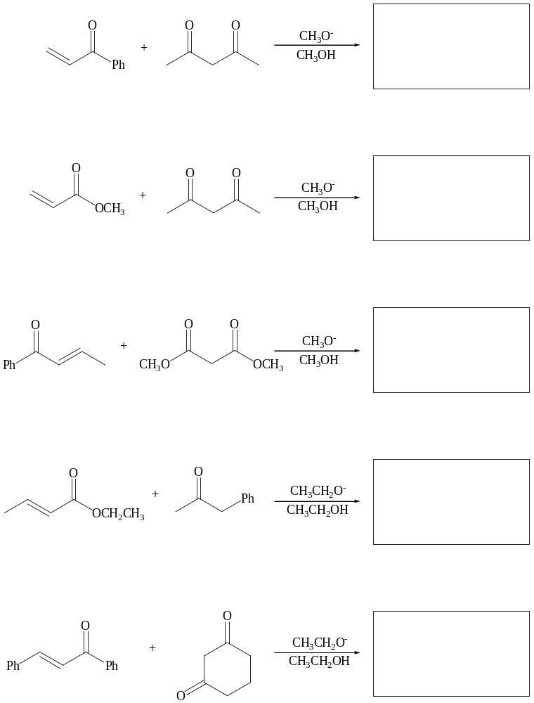
7. Tandem and Related Reactions.
Draw the major product or products of each reaction.

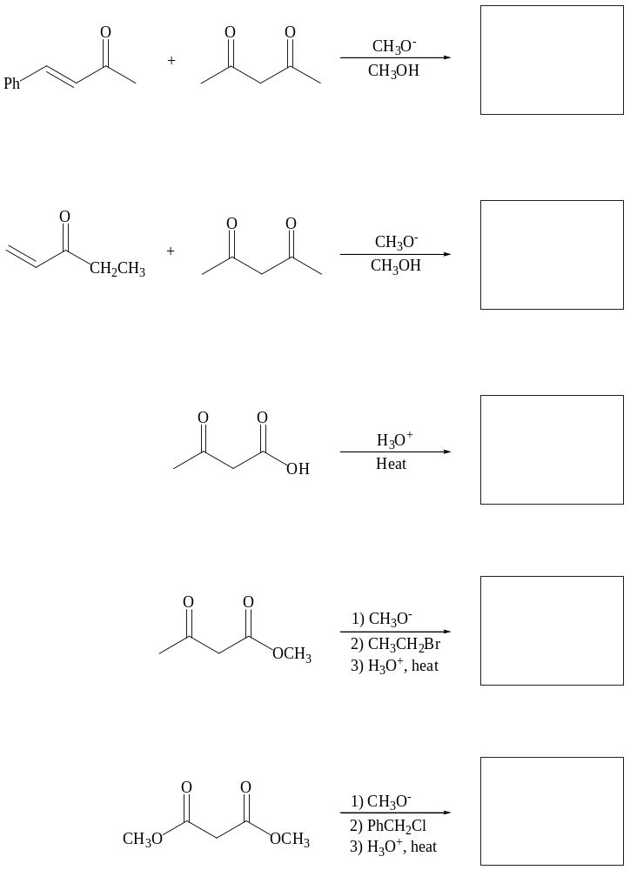
8. Reactions of Enamines.
Draw the major product or products of each reaction.
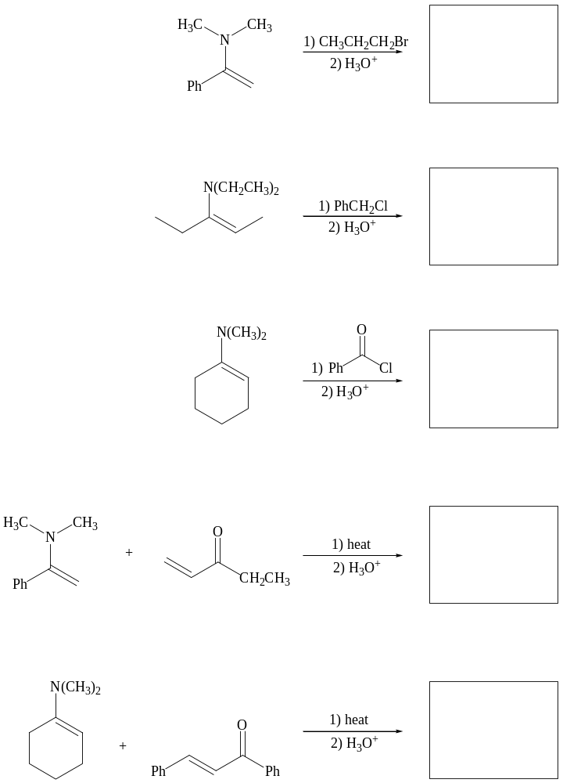

9. Mechanisms
Provide a complete arrow-pushing mechanism for the following reactions.
a.
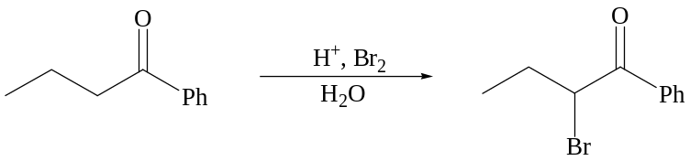

b.
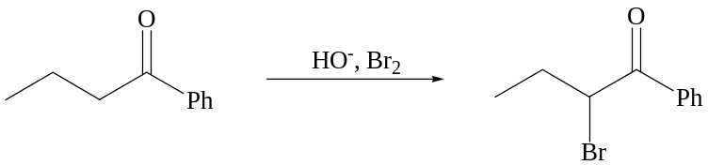

c.
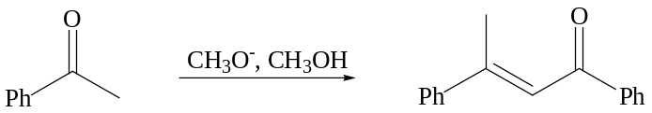

d
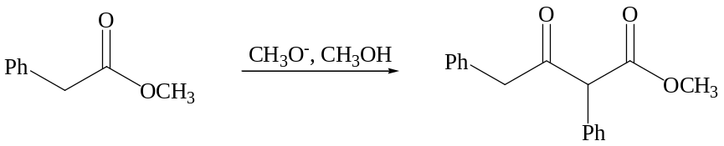

10. Synthesis
Propose a plausible, selective synthesis for each of the following.
a.
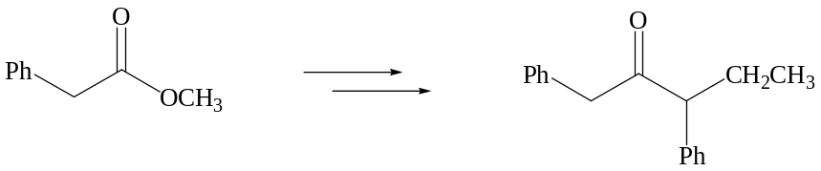

b.


