1. Acids and Bases
a. For each SET of compounds, rank each compound from most acidic (1) to least acidic (4).

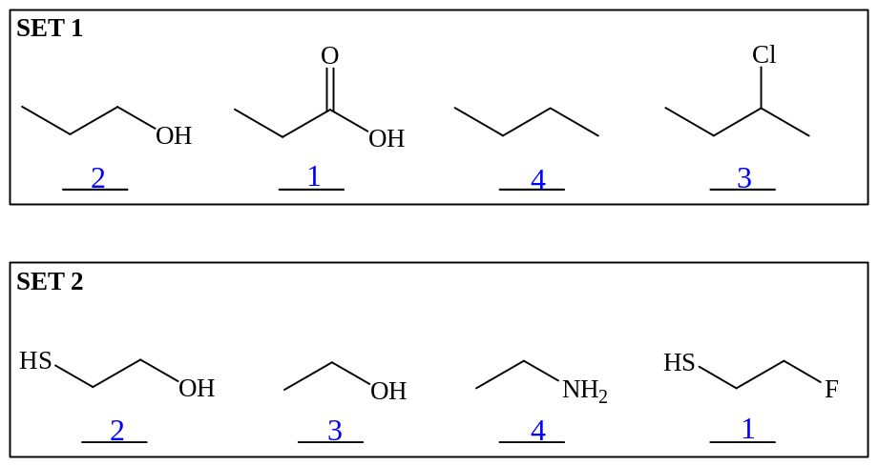

b. For each SET of compounds, rank each from most basic (1) to least basic (3).

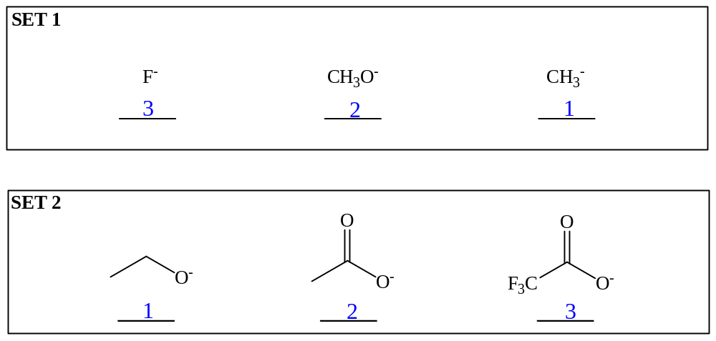

c. Draw LEWIS STRUCTURES for the products of each acid-base reaction in the boxes provided. Indicate which direction is favored by writing “LEFT” or “RIGHT” above the equilibrium arrow for each reaction.

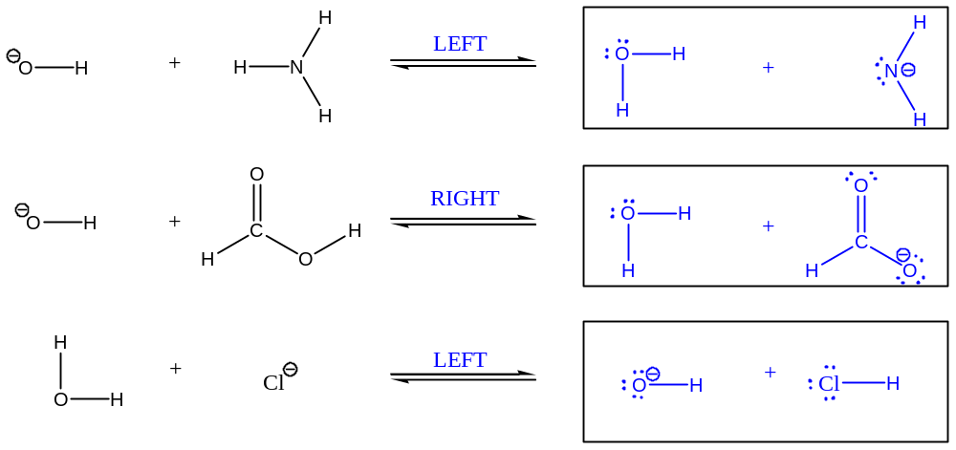

2. Kinetics and Thermodynamics
a. Answer the following five questions using the reaction diagrams below (1-4).

i) Which is the fastest exergonic reaction? ____4___

ii) Which is the slowest endergonic reaction? ____2___

iii) Which reaction will form the most product (B) at equilibrium? ____4___

iv) Which reaction(s) has/have an intermediate? ____4___

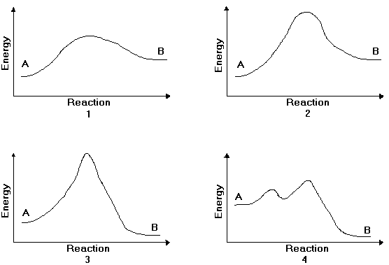v) Which reaction accurately depicts a carbocation reacting with Br⁻? ____3__

b. Draw a free energy diagram for the acid-catalyzed hydration of 2-butene (the last step is very fast.) Label all reactants, products and intermediates using structures.

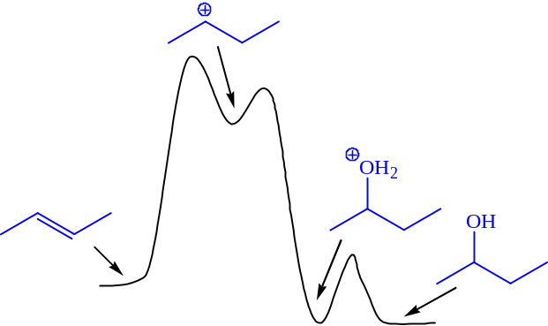
3. Reactions
a. Draw the major product or products of each of reaction in the boxes provided. If multiple organic products are equally likely, show each. For stereoselective reactions, be certain that your structures clearly indicate stereochemistry.

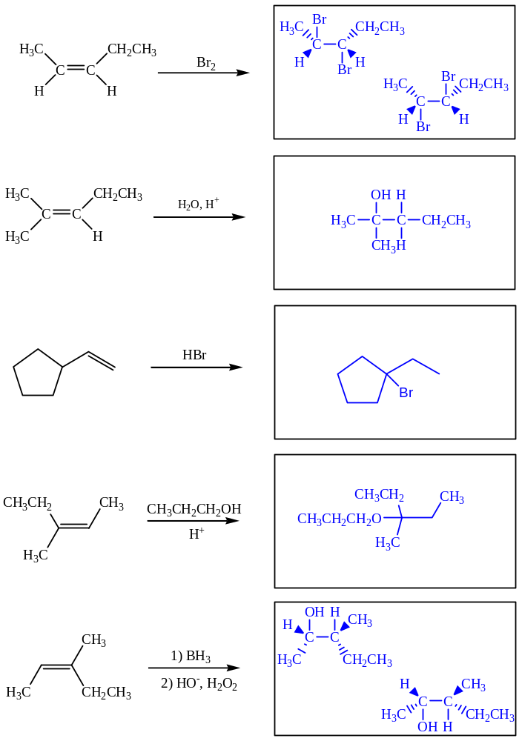

b. Provide the reagents necessary to perform the following reactions in the boxes provided. Be explicit when showing multi-step reactions.

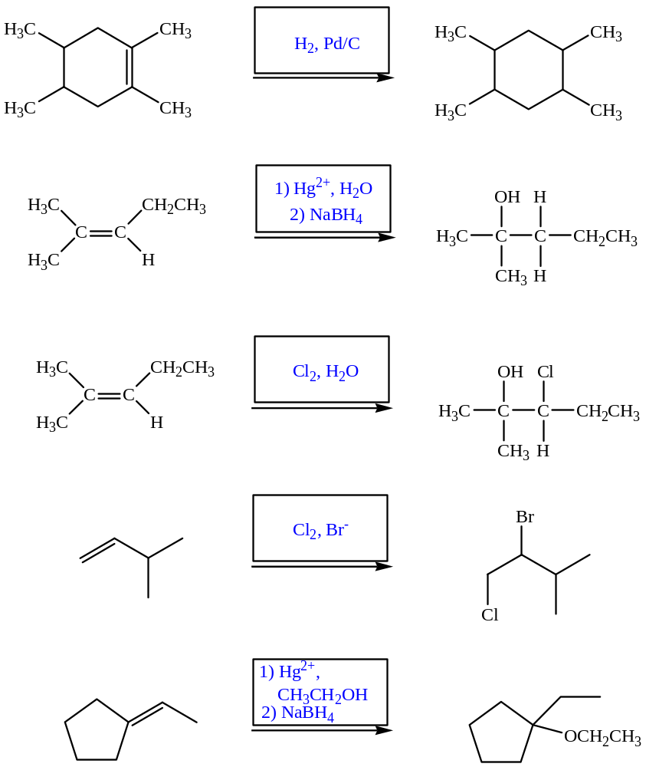

4. Mechanisms
Draw complete arrow pushing mechanisms for the following reactions.

a.
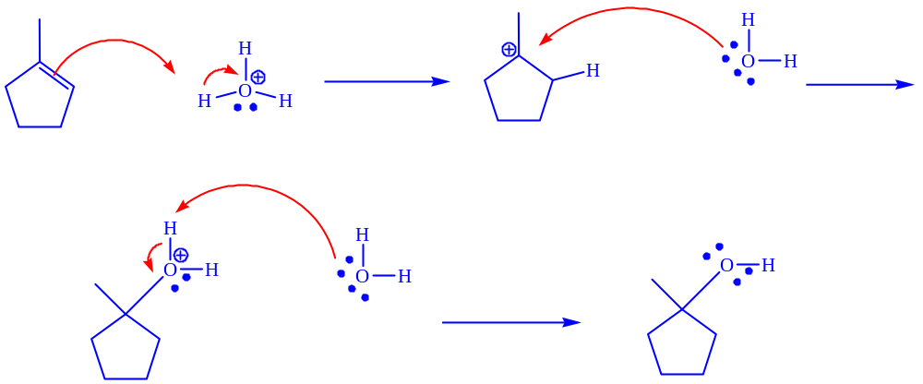

b.
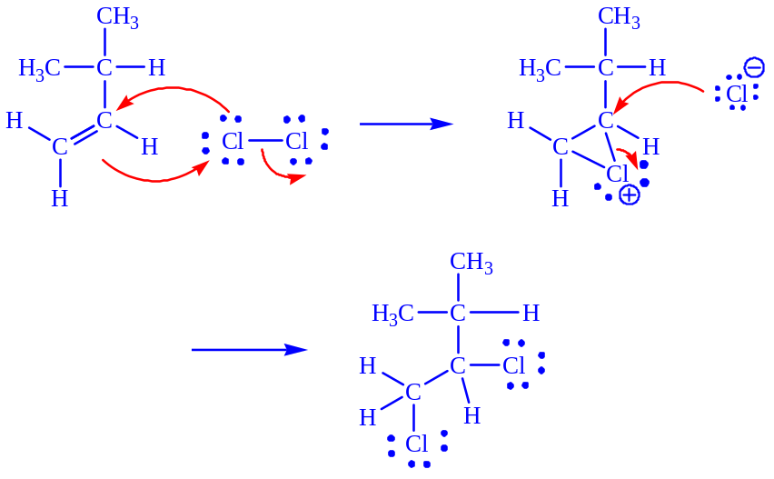

5. Mechanistic Proposal
Follow the instructions below to propose a two-step mechanism for the given reaction:

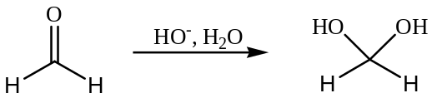

- For the first step, identify the most nucleophilic and most electrophilic reactants and draw each in the appropriate boxes
- Use curved arrows to show how the electrons flow between the two reactants
- Draw the intermediate formed in the appropriate box
- For the second step, identify the role (nucleophile or electrophile) of the intermediate on the line below the box
- Draw the other reactant of the second step in the remaining box and identify its role (nucleophile or electrophile) on the line below the box
- Use curved arrows to show how the electrons flow between the intermediate and the reactant



