1. Nomenclature
For each example, provide the structure appropriate to the name or the name of the given structure.

Alkanes
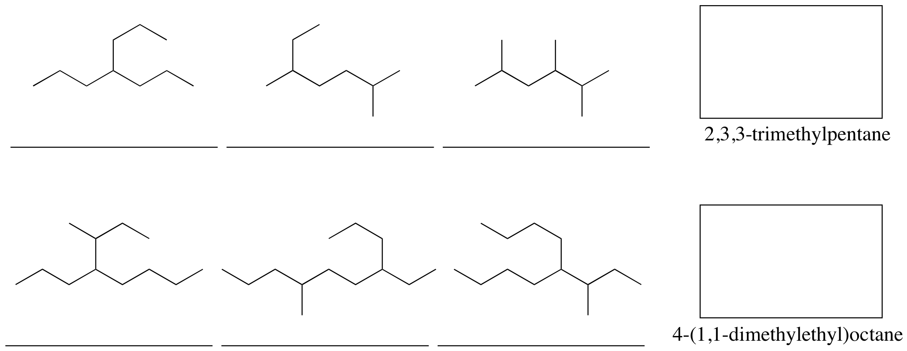

Alkyl halides

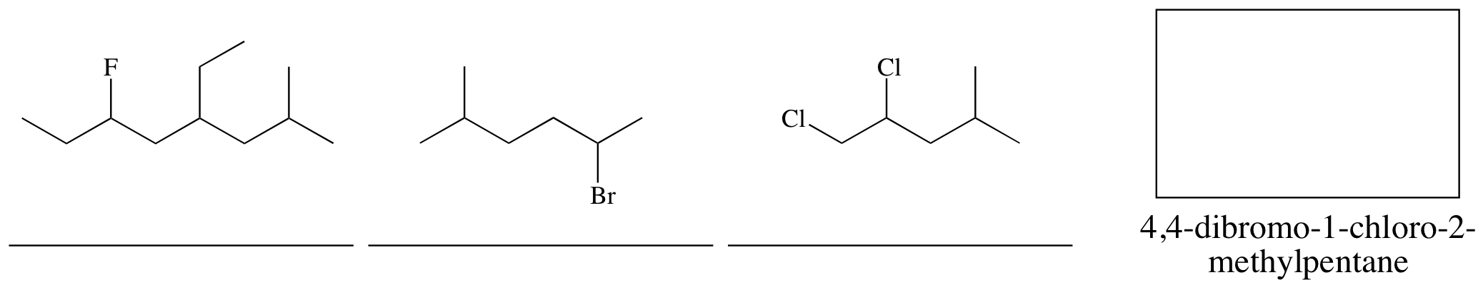

Ethers
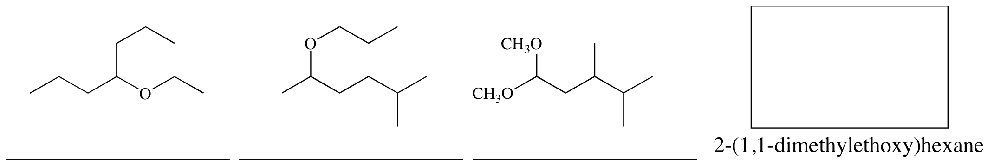

Alkenes
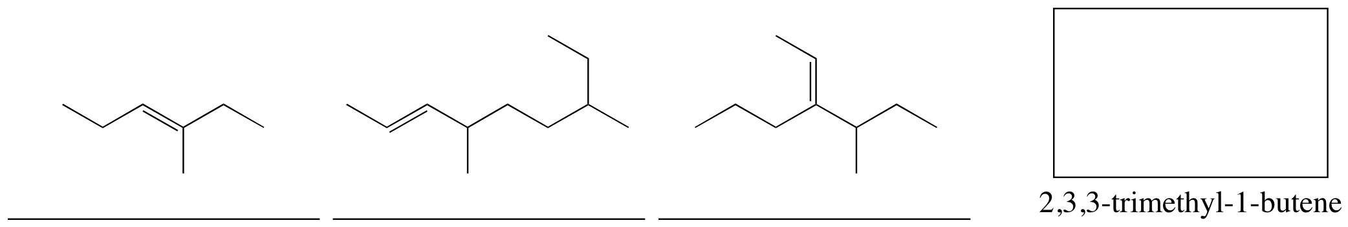

Alkynes
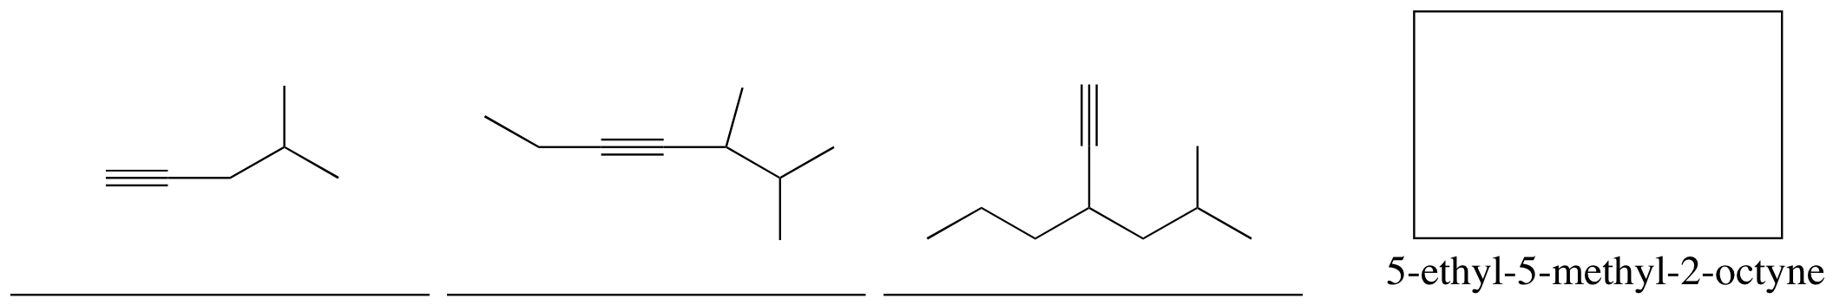

Alcohols
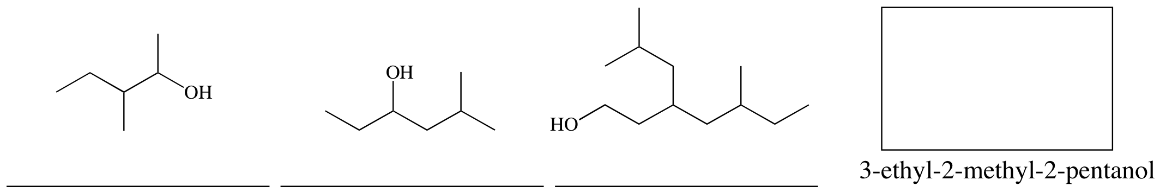

Amines
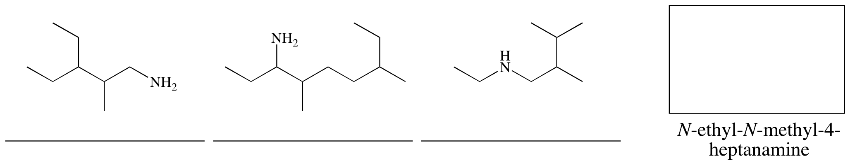

Cyclic Compounds
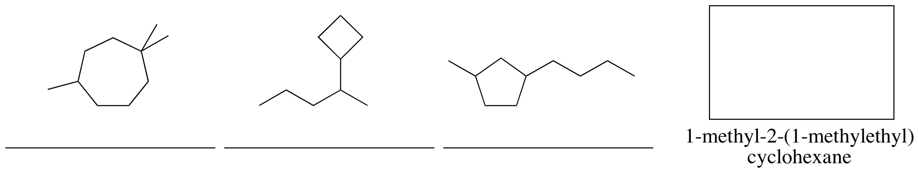

Multifunctional
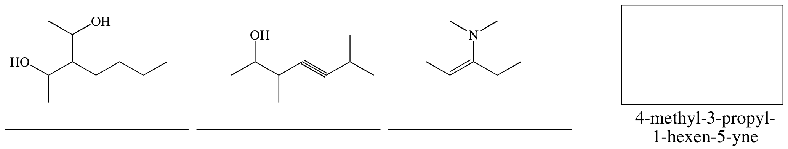

Assorted
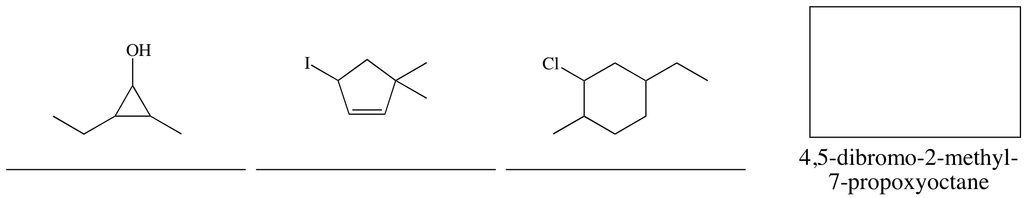

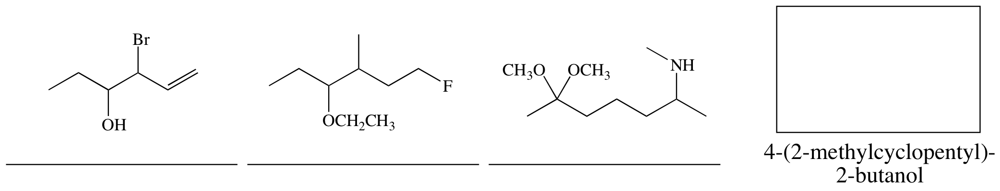

2. Terminology
For each compound below, indicate the degree of substitution at the carbon indicated with an arrow. Identify the class of each compound (alkane, amine, alkyl halide, etc.) and the type as appropriate for the class (primary, internal, disubstituted, etc.).



