Heat Engines, Carnot Engines and Entropy
- Some things happen, some things don’t. A gas expands to fill a container, but an expanded gas does not contract. A hot object cools, but a cool object does not heat. This is the general idea of spontaneity. For any spontaneous process, one which does not require work to proceed, we find that the reverse process has no natural tendency to occur, and does require work.
  - The driving force of a spontaneous process is not the lowering of energy. Ex. When a hot object cools, its energy is spontaneously lowered, but the energy of the surroundings is spontaneously raised.
  - The driving force of spontaneous change is the tendency for energy to disperse and matter to disorganize. The measure of dispersal used in thermodynamics is called ENTROPY.

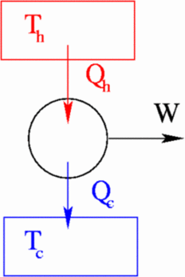
- A heat engine is any device that takes heat energy from a warm source, converts some of it to work, and discards the rest. Some examples include cars, coal/nuclear power plants, air conditioning.

  - It is clear that NO device can convert 100% of heat into work. A significant portion is always dumped into the surroundings. This is a consequence of entropy, S. Entropy will be discussed in much greater detail, but for now, we will define entropy change.

  - The change in the entropy of a system is equal to:
$dS=\frac{dq_{rev}}{T}$ eq. 3.1 (3.12) Infinitesimal change in S along a reversible path at T

- We see that w = Δq. The heat that leaves the “hot source” enters the system, which is comprised of some type of “working fluid” (ex. air). Work is performed and unused heat is dumped into the “cold sink”. It is assumed that the source and sink are so large that their temperatures are constant through a cycle.

- Sadi Carnot was the first to realize and quantify a relationship between the efficiency of a heat engine and the temperature T_{h} and T_{c} involved. He developed the theoretical Carnot cycle to define the steps of the operation, shown in the figure below in terms of PV and TS. A Carnot cycle represents the most perfect thermodynamic heat engine possible, and assumes several unrealistic conditions such as perfect insulation and zero-friction.
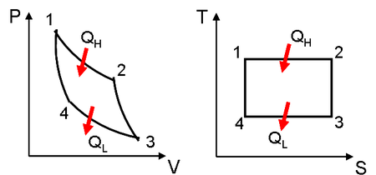

  - In the PV curve and corresponding TS curve, we can see that there are 4 steps to the process of converting heat to work in a heat engine.
    - Step 1 (12): Isothermal, reversible expansion of the system. During this step, the source, at temperature T_{H}, transfers heat q_{H} to the system. The system is isolated against the cold sink. The temperature of the system is only infinitesimally smaller than T_{H} so that the heat transfer is reversible. The system must do work w₁ during expansion so that ΔU=0 (constant T). The entropy of the system increases by ΔS = q_{H}/T_{H}.
    - Step 2 (23): Adiabatic, reversible expansion of the system. During this step, the system continues to expand without additional heat, which requires work w₂ to be done by the system. This process is assumed to be totally insulated. The continued expansion causes the temperature to drop to T_{c}. The entropy is unchanged as q₂ = 0.
    - Step 3 (34): Isothermal, reversible compression of the system. Here, some heat q_{c} leaves and enters the cold sink, which is at T_{c}. This causes work to enter the system (compression) so that ΔU remains 0. Once again, the system and cold sink are at nearly the same temperature to ensure reversibility. The entropy of the system decreases by ΔS = q_{c}/T_{c.} We can see that q_{c}/T_{c} = -q_{H}/T_{H}. The net entropy change of the system is 0 (entropy change in the surroundings is POSITIVE; this is discussed later)
    - Step 4 (41): Adiabatic, reversible compression. Here, q₄=0. The system returns to its original state after having some work w₄ done on it. This compression raises the temperature of the system from T_{c} back to T_{h}.

- Because the system is returned to its original state, ΔU = 0. This means that:
  - $\left|q_{tot}\right|=\left|w_{tot}\right|$
  - The total efficiency, η, is defined as the ratio of the work produced to the heat energy in. Usable work occurs in steps 1 and 3
$η=\frac{\left|w_{tot}\right|}{q_{1}}=\frac{q_{H}-q_{C}}{q_{H}}=1-\frac{q_{c}}{q_{H}}= 1-\frac{T_{c}}{T_{H}}$ eq 3.2 (3.10) Carnot efficiency
  - This result tells us that the efficiency of an ideal heat engine, operating perfectly, depends only on temperature, but yet, not even a perfect system can operate at 100% because T_{c}/T_{H} ≠ 0.
    - We have established that:
$\frac{q_{3}}{q_{1}}=\frac{-T_{c}}{T_{H}}$
$\frac{q_{3}}{T_{c}}+\frac{q_{1}}{T_{H}}=0$
*The expression above tells us that the relationship between q and T is a STATE FUNCTION!
Group work: 3.6

Entropy changes
- Revisiting our initial definition for dS, we can see that for an isothermal, reversible process, integration at constant T yields:
$∆S=\frac{1}{T}\int{dq_{rev}}=\frac{q_{rev}}{T}$ eq. 3.3a (3.14) Entropy change in a reversible, isothermal process

- We can revisit the concept of heat capacity from ch 2, which calculates q based on a change in T:
${\overline{C}}_{i}=\frac{q}{n∆T}$ eq. 2.5 where${\overline{C}}_{i}$ refers to constant P or V molar heat capacity. Plugging into eq. 3.3a:
$∆S= \int_{T_{i}}^{T_{F}}{\left(\frac{n{\overline{C}}_{i} dT}{T}\right)}$ eq. 3.3b (3.20) Finding ΔS from changing T using C
Group ex. 3.20
  - For an ideal gas under isothermal conditions, you can evaluate the entropy change based on changes in volume or pressure:

ΔU = 0 (isotherm)
dq = -dw Plugging into eq 3.3a
$∆S=\frac{1}{T}\int{pdV}=nR\ln\left(\frac{V_{F}}{V_{i}}\right)$ eq. 3.3c. ΔS for reversible, isothermal process for ideal gas

Applying Boyle’s law, eq. 3.2b can be expressed in terms of changing pressures:
$∆S=nR\ln\left(\frac{P_{i}}{P_{F}}\right)$ eq. 3.3d. (3.21) ΔS for reversible, isothermal process in terms of ΔP

- Revisiting eq. 3.2, maximum efficiency is obtained when the cold sink is as cold as possible and the hot sink is as hot as possible. But why? We know for a Carnot cycle, the entropy change of the system is 0, but what about of the universe?
  - ${ΔS}_{univ}=-\frac{\left|q_{1}\right|}{T_{H}}+\frac{\left|q_{3}\right|}{T_{c}}$ The 1st term is the entropy loss in the hot source, the 2nd is the entropy gain in the cold sink. When the temperature difference is extreme, the decrease in entropy in the hot source is minimal, while the increase in the cold sink is large. This is due to the high entropy that already exists in the hot source. This is the significance of the T term in the denominator of eq. 3.1. (Ex. Noise contribution)
    - Thus, for a heat engine to work, it must obey the 2nd law of thermodynamics (recap). This means that ΔS_{univ} > 0. In other words, the universe can never lose entropy from a process. Spontaneous process occur when the resulting entropy change of the universe is positive!
    - So, as the temperature difference increases, smaller values of q₃ can satisfy this requirement, which allots more energy to be used for work!
    - However, any cycle that is irreversible can never be more efficient than a reversible one.
    - Class ex. The schematic of a heat engine shows a device drawing in heat and expending work. What does the schematic of a “heat pump” (ex. refrigerator) look like?

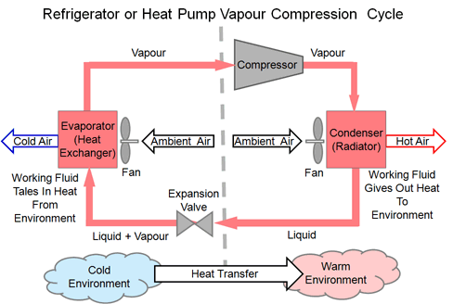
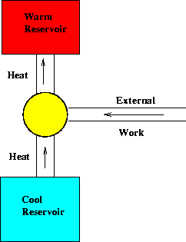

More on Entropy

- Entropy is a state function, so a process can be broken down into multiple steps and evaluated, with the total ΔS equal to the summation of the individual dS values. Again, since the path doesn’t matter, we can evaluate any path that is mathematically convenient.
  - Example problem: Find ΔS for 1 mole of He undergoing the following process: He (298 K, 1.5 atm) He (100K, 15 atm), assuming that He acts as a noble gas
    - We can simply assert that the overall process occurs in two simple steps: He (T₁, P₁) $\underset{→}{dS_{1}}$ He (T₂, P₁) $\underset{→}{dS_{2}}$ He (T₂, P₂)
    - The 1st process is isobaric, changing temperature. The entropy change of such a process is easy to evaluate.
      - ${dS}_{1}=n\overline{C_{p}}\ln\left(\frac{T_{F}}{T_{i}}\right)$ Recall! For a monatomic, ideal gas, $\overline{C_{v}}=\frac{3}{2}R, \overline{C_{p }}=\frac{5}{2}R$
    - The 2nd process is isothermal, changing pressure
      - ${dS}_{2}=nR\ln\left(\frac{P_{i}}{P_{F}}\right)$
- $ΔS_{sys}=dS_{1}+{dS}_{2}=\left(1 mol\right)\left(20.78\frac{J}{mol K}\right)\ln\left(\frac{100}{298}\right)+\left(1 mol\right)\left(8.314\frac{J}{mol K}\right)\ln\left(\frac{1.5}{15}\right)=-41.8\frac{J}{K}$

  - Note: q and w can not be determined since we don’t know the actual path of the process; as these terms are clearly path-dependent. This also means that we cannot find ΔS_{surr}, since ${ΔS}_{surr}=\frac{{-q}_{rev, sys}}{T}$, where q_{rev,sys} is the heat transferred in/out of the system (ex. If heat leaves the system, q_{sys} would be negative, so q_{surr} would be positive). As you see, we are assuming that the surroundings are big enough to treat the heat exchange as reversible and isothermal.

Entropy of mixing
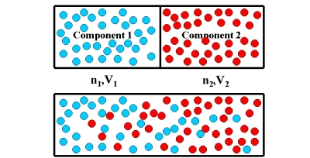

- Consider the image above. A container is divided by a barrier, with two systems of gases having volumes V1 and V2, but having the same P and T. If the barrier is removed, the gases will mix isothermally and isobarically. Thus, ΔU = 0. No heat is transferred so q = 0. Therefore, w = 0. Entropy must cause this process to happen because there is no apparent change in energy.
  - Again, let’s just assume that the mixing takes place in two steps:
    - Expansion of gas 1 from V₁ to V_{tot}
    - Expansion of gas 2 from V₂ to V_{tot}
    - Using eq 3.3c: $∆S_{mix}=\sum{n_{i}R\ln\left(\frac{V_{tot}}{V_{i}}\right)}$ Eq. 3.4a (3.23) Entropy of mixing

Statistical Thermodynamics Applied to Entropy

- Boltzmann created the branch of physics known as statistical thermodynamics, which applies statistics to the behavior of matter. From this approach, Boltzmann developed a different definition for entropy.
- Imagine we have a system that is comprised of 3 gas molecules, and we have a certain amount of energy that needs to be distributed between them. Each molecule will have "quantized" energy states in which we can put that energy. Now imagine the total energy of our system of three molecules is 3 “energy units”. Let's look at how many different ways there are to do this.
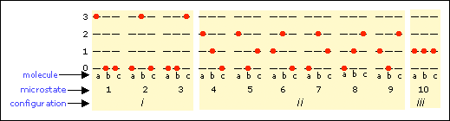

- As you see, we can give all the energy to one molecule and zero energy to the other two (configuration 1). There are 3 ways to do this. Each of these possible configurations is called a microstate.
- We can give 1 energy unit to one molecule, 2 energy units to another, and 0 to the third (configuration 2). There are 6 ways to do this.
- Finally, we can give 1 energy unit to each of the three molecules (configuration 3). There is only one way to do this.
  - Boltzmann relates the absolute entropy of a system to the number of microstates of the most probable configuration, Ω:
$S= k_{b}\ln{Ω}$ Eq.3.5 (3.26) Absolute entropy from analysis of microstates

- It is clear that the configuration with the most microstates is most likely representative of the energy distribution of the system. This is why energies are almost never uniformly distributed (only one microstate), but rather, follow a Boltzmann distribution (ex. Velocity distribution).
  - When dealing with systems containing large number of molecules, the most favorable configuration has so many microstates that it is realistically the only configuration you will ever observe.
  - Because of equation 3.5, entropy is the only state function whose absolute value can be known. It also shows that entropy is not zero under standard conditions, but is zero at absolute zero (3rd law of thermodynamics!)
  - Group ex. 3.8 in text

