1CHAPTER 1
Gases and equations of state

- If we consider a gas to be our thermodynamic “system” of interest, we can specify the state of the system by giving values to the following parameters: P, V, T, n
  - However, these parameters are not independent of one another. For example, we cannot arbitrarily assign a 0.5 mol sample of He(g) a volume of 10 dm³, a pressure of 100 kPa and a temperature of 500 K because this state cannot exist!!! If we accept the given values of n, V, and T, then the allowable value of P is 230 kPa.
  - Thus, the system obeys an equation of state. We can say that P depends on n, V, and T:
P = f(n, V, T) Eq. 1.1 (1.1)

  - Various relationships are used to relate these parameters--- the gas laws! Some are simple, but inaccurate, while others are complex but correct.
  - The equation of state for a gas at low pressure is known as the ideal gas law:
PV = nRT Eq. 1.2 (1.10) Ideal gas law

  - Note that R = $\frac{PV}{nT}=\frac{work}{amount*temp}$ R is the proportionality constant that dictates the amount of work that can be done by n moles of free particles at temperature T.
  - The ideal gas law is called as such because it describes how gases “should” behave. As P 0, equation 1.2 becomes increasingly accurate. Beyond P = 0, no gas is truly ideal, but some can are close enough to ideal character that they can be treated as such.
  - Although derived from the kinetic theory of gases, the ideal gas law is based on three observed laws: Boyle’s law, Charles’ law, and Avogadro’s law:
    - Boyle (P α 1/V at constant T)
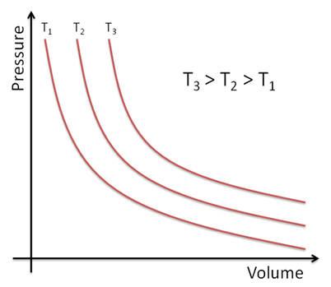
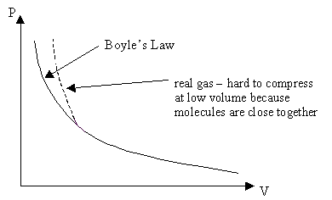

- Charles (V α T, constant P) For ideal gas, V = 0 at T = 0K. For real gas, V ≠ 0 at T = 0K

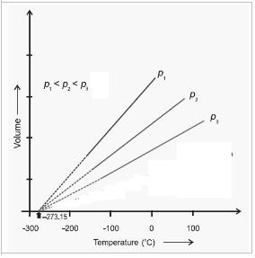
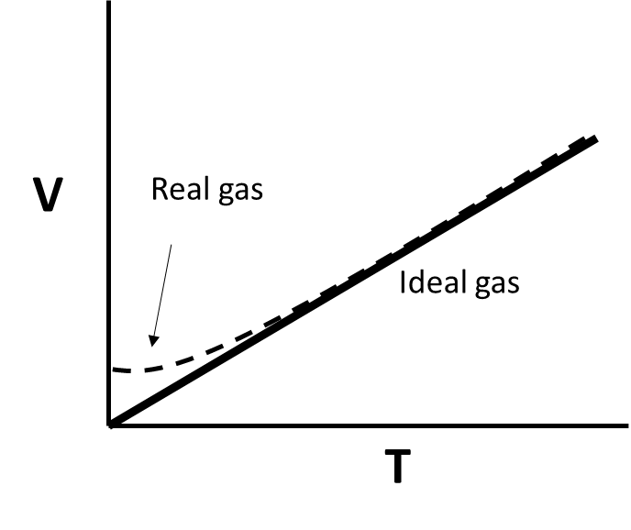

- Avogadro (V α n, constant T, P)
    - From this, we can introduce a new term called molar volume, which describes the volume occupied by one mole of a gas:
    - V_{m} = V/n Eq. 1.3a Molar volume of a gas

    - If n = PV/RT: $V_{m}=\frac{V}{\left(\frac{PV}{RT}\right)}=\frac{RT}{P}$ Eq. 1.3b.
- Equation 1.3b clearly suggest that all ideal gases at the same T and P should have the same molar volume, regardless of chemical identity. We use reference values of T and P to compare the properties of gases. standard temperature and pressure (P = 1 atm, T = 273 K)

Van-der Waals Equation for Real Gases
    - The kinetic theory of gases makes two very incorrect assumptions:
      - Gas particles are zero-volume points in space
      - Gas molecules experience no attractive or repulsive interactions with other gases

  - The Van der walls equation corrects for these fallacies:
$\left(P+\frac{an^{2}}{V^{2}}\right) \left(V-nb\right)=nRT$ Eq. 1.4 (1.20) The Van der waals equation

  - The term “a” is a correction for intermolecular attractions at that exist in the system, which slow the molecules down and weaken the force of collisions. This term is proportional to the square of the molarity (n/V). Less ideal gases have large values of “a”
  - “b” corrects for the space occupied by the molecules; large molecules have larger values of “b”

- Class work: By what percentage does the actual pressure of 1 mol of water vapor at 125ºC and a volume of 10L deviate from the pressure predicted by the ideal gas law?
Introduction to partial derivatives of gas paramaters

- Revisiting the concept of equations of state, we can use derivatives to evaluate how one state variable changes with respect to another. Ex. Suppose we need to know how the pressure of an ideal gas varies with temperature at constant V:

$${\left(\frac{∂P}{∂T}\right)}_{V,n}=\frac{∂}{∂T}{\left(\frac{nRT}{V}\right)}_{V,n}=\frac{nR}{V}\frac{∂}{∂T}\left(T\right)=\frac{nR}{V}$$

  - So we see that a plot of P vs T at constant V,n yields a linear trace with slope nR/V. Plugging in values of V and n, the rate of change for the expression $∂P/∂T$ can be expressed numerically.
- Group example: Use a partial derivative to evaluate Avogadro’s Law. Answer: ${\left(\frac{∂V}{∂n}\right)}_{T,P}=\frac{RT}{P}$

- Class work: 1.34b

Real gases

- If a gas is ideal: PV_{m}/RT = 1. For a real gas, this ratio may not be equal to 1. We can, instead, define the compressibility factor, Z:
$Z=\frac{PV_{m}}{RT}$ Eq. 1.5 (1.16) Compressibility factor, real gas

  - The value of Z represents the ratio between the real volume of a gas and the volume predicted from the ideal gas law. Thus, the further from unity Z is, the less “ideal” the gas.
  - At P ~ 0, all gases have Z =1. At extremely high pressures, all gases have Z >1, indicating that repulsive interactions are dominant. Many gases have Z <1 at moderate pressure due to attractive intermolecular forces.

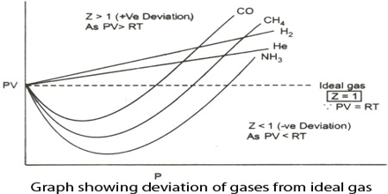

- In any instances where a simple law is known to be a good first approximation of a more complex value, the simple law can be treated as the first term in a power series of a specific variable. Because gases do exhibit ideal behavior at low pressures (high molar volumes), we can assert that the ideal gas law is, in fact, the first term in a power series expressed in terms of V_{m}
$$PV_{m}=RT\left(1+\frac{B}{V_{m}}+\frac{C}{V_{m}^{2}} ...\right)$$

$$Z=1+\frac{B}{V_{m}}+\frac{C}{V_{m}^{2 }}….$$

- In the power series above, a_{o} =1. x =1/V_{m}
- The equation above is known as the virial equation of state. B, C… are virial coefficients and depend on the identity and temperature of the gas. The constant that would be labeled “A” has a value of 1, so B is called the 2nd virial coefficient, and so on. These terms represent corrections for deviation from ideal behavior. Because the exponent of the denominator increases with each term, B is the most significant correction term (B/V_{m} >>> C/V_{m}²)
$Z=1+\frac{B}{V_{m}}$ Eq. 1.6 (1.17, modified) virial equation of Z

- Since the value of B varies with temperature, there must exist a temperature at which B = 0. This is called the Boyle temperature, T_{B}. At T=T_{B}, all gases behave ideally.

- Solving for P from eq 1.4:
$P=\frac{nRT}{V-nb}-\frac{an^{2}}{V^{2}}$ Plug into eq 1.5

$Z= \left(\frac{nRT}{V-nb}-\frac{an^{2}}{V^{2}}\right)\left(\frac{V_{m}}{RT}\right)$ for V_{m} = V/n :
$Z=\left(\frac{1}{1-\frac{b}{V_{m}}}\right)-\frac{a}{V_{m}RT}$
- The first term is a geometric series of the form $\frac{a}{1-r}$ where |r| = $\left|b/V_{m}\right|$<< 1; a =1; $\frac{1}{1-x}=\sum_{n=0}^{∞}{{ ar}^{k}}$

$Z=\left(1+\left(\frac{b}{V_{m}}\right)+\left(\frac{b^{2}}{V_{m}^{2}}\right)…\right)-\frac{a}{V_{m}RT}$ Refer back to eq. 1.6. Only the 2nd virial term matters!

$Z=\left(1+\frac{b}{V_{m}}\right)-\frac{a}{V_{m}RT}= 1+\left(b-\frac{a}{RT}\right)\left(\frac{1}{V_{m}}\right)$

Therefore: $B=b-\frac{a}{RT}$ eq. 1.7 (1.22) Correlation between virial term and VDW constants

Under ideal condition: T = T_{B} and B = 0

Therefore: $T_{B}=\frac{a}{bR}$ eq. 1.8 (1.23) Boyle temperature

Class Example: At what temperature is nitrogen gas predicted behave ideally? How does this value compare to the experimentally determined value in table 1.5 on pg 13?

Total differentials
Let’s consider a dependent state variable that depends on other independent variables. If the independent variables are all changing, how do we determine the effect on the dependent variable? We can define the total change, also called the total differential, in the dependent variable as the sum of the individual changes caused by each independent variable Ex. F(a, b, c)
$$dF= {\left(\frac{∂F}{∂a}\right)}_{b,c}da+{\left(\frac{∂F}{∂b}\right)}_{a,c}db+{\left(\frac{∂F}{∂c}\right)}_{a,b}dc$$
Thus, the change in a dependent variable is affected by the instantaneous values of the independent variable at the initiation of the process and the net change in those independent variables.
- Group ex. 1.32

Properties of gas that depend on partial derivatives
- For the derivative ${\left(\frac{∂A}{∂B}\right)}_{C}$ the cyclic rule of derivatives can be used to express one derivative as a fraction of others:

${\left(\frac{∂A}{∂B}\right)}_{C}=-\frac{{\left(\frac{∂C}{∂B}\right)}_{A}}{{\left(\frac{∂C}{∂A}\right)}_{B}}$ Eq. 1.9 (1.26) Cyclic rule

The usefulness of the cyclic rule cannot be understated. Let’s say, for instance, that A, B and C represent P, T and V. If we have a situation where the volume of a gas cannot be held constant, then an experimental evaluation of a constant volume differential (ex. ${\left(\frac{∂P}{∂T}\right)}_{V}$) cannot be made. We can, however, use constant pressure and temperature expressions to predict the value of the constant volume differential, as shown in the example below:

Predicted
Experimentally determined
$${\left(\frac{∂P}{∂T}\right)}_{V}=-\frac{{\left(\frac{∂V}{∂T}\right)}_{P}}{{\left(\frac{∂V}{∂P}\right)}_{T}}$$
  - The expansion coefficient, α, describes the change in volume as temperature is varied at constant P:
$α=\frac{1}{V}{\left(\frac{∂V}{∂T}\right)}_{P}$ Eq. 1.10a (1.27) Expansion coefficient

  - The isothermal compressibility, κ, describes the change in volume as the pressure changes at constant T:
$κ= -\frac{1}{V}{\left(\frac{∂V}{∂P}\right)}_{T}$ Eq. 1.10b (1.28) Isothermal compressibility

  - From eq. 1.9-1.11, we see that, for example:
$\frac{α}{κ}= -\frac{{\left(\frac{∂V}{∂T}\right)}_{P}}{{\left(\frac{∂V}{∂P}\right)}_{T}}= {\left(\frac{∂P}{∂T}\right)}_{V}$ Eq. 1.11

- Class work. Determine α and κ for an ideal gas. Then, calculate the ratio α/κ using eq. 1.11. Show that this result is equal to the result of simply dividing α by κ.

Molecular Thermodynamics and Energy Distributions

- Recall that the probability of a molecule in a system at temperature T having some energy E_{i} above a minimum energy is described by a Boltzmann distribution, and that the energy within a system is not uniformly distributed amongst the particles.
$p_{i}=e^{-\frac{∆E}{RT}}$ Eq. 1.12 (1.31) Probability of a species having energy ΔE above some minimum E at T

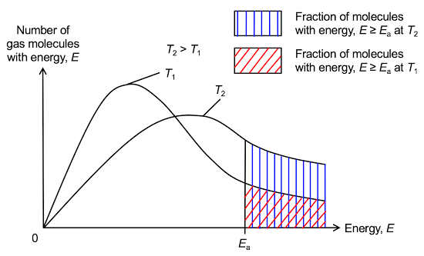

Degrees of Freedom in Gaseous Systems

- Gases have free motion and thus, exhibit all possible degrees of freedom: translational, rotational and vibrational motion. These degrees of freedom allow the molecules to disperse their thermal energy in order to produce entropy. A portion of a molecule’s total thermal energy is therefore allocated to each mode.
  - Translation
    - The average translational energy of a non-linear gas molecule is the kinetic energy. Thus, the portion of a molecules thermal energy that is allocated for translation is:
$〈E_{trans}〉=\frac{3}{2}RT$ Eq. 1.13 (1.34) Translational energy of a gas
  - Rotation
    - Monatomic gases do not have rotational motion!!!!!!
    - Average thermal energy allocated to rotational movement for a non-linear polyatomic gas molecule is:
$〈E_{rot}〉=\frac{3}{2}RT$ Eq. 1.14a (1.35) Rotational energy of non-linear gas
    - Average rotational energy of a linear polyatomic gas molecule is:
$〈E_{rot}〉=RT$ Eq. 1.14b (1.35) Rotational energy of a linear gas

  - Vibration
    - Monatomic gases do not have vibrational motion!!!!
    - For non-linear polyatomic molecules, there are 3N-6 different vibrational modes through which energy can be expended, where N is the number of atoms in the molecule.
    - For linear polyatomic molecules, there are 3N-5 different modes.
    - In ideal gases, the vibration energy levels are equally spaced by some interval E.
    - Average vibrational energy for each mode:
$〈E_{vib}〉=\frac{E}{e^{\left(\frac{E}{RT}-1\right)}}$ Eq. 1.15 (1.36) Energy of EACH vibrational mode

The expression above simplifies to 0 J (min) when E is large or T is very small. At low values of E or at extreme temperatures, it simplifies to RT (max)

- Class work: 1.74a,c. and 1.75

