CH 7

Liquid/Liquid Systems
- Let’s consider a binary system that is composed of two liquids that are not reacting. If the volume of liquid is equal to the volume of the system, then there is only one phase, liquid.
  - The mole fraction of each component is described by:
$x_{i}=\frac{n_{i}}{\sum_{i}{{ (n}_{i})}}$

- If the volume of the liquid is less than the volume of the container, then the empty space will be filled with the vapors of the liquid components. The vapor will attain some equilibrium pressure that is dependent on the liquid itself and the temperature. This is the vapor pressure.
  - Since the liquid and vapor are in equilibrium, their chemical potentials must be equal.
$$μ_{i}\left(l\right)=μ_{i}(g)$$

  - Recall that the chemical potential of the gas and liquid phase are related to some standard values plus a correction term which is related to either the fugacity or the activity:
$$μ_{i}\left(g\right)= μ_{i}^{o}\left(g\right)+RT\ln{\frac{f_{i}}{P^{o}}}$$
$$μ_{i}\left(l\right)= μ_{i}^{o}\left(l\right)+RT{\ln{a}}_{i}$$

  - We can relate the activity of the liquid components to their vapor pressures:
$a_{i}=\frac{P_{i}}{P_{i}^{*}}$ Eq. 7.1 (7.11) Activity of a liquid related to its vapor pressure
    - Here, $P_{i} and P_{i}^{*}$represent the partial pressures of vapor i in the binary system and the equilibrium vapor pressure of pure i, respectively.
    - From this, we can derive Raoult’s law, which states that the partial pressure of vapor i is proportional to its mole fraction in the liquid phase by the equilibrium vapor pressure of the pure component:
$P_{i}=x_{i}P_{i}^{*}$ Eq. 7.2 (7.13) Raoult’s Law

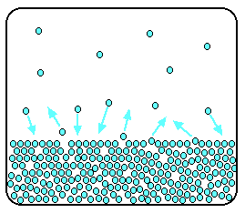
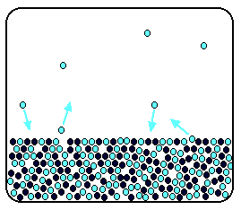
    - We can explain Raoult’s law based on the figures below. The leftmost figure shows a pure liquid. Molecules on the surface are able to escape randomly, and an equilibrium is established between molecules in the head space and molecules in the bulk. This is the origin of the equilibrium vapor pressure. The figure on the right shows a binary mixture. In this instance, solute molecules occupy a fraction of the surface sites. Because of this, the solvent molecules are less likely to escape. As you can see, lower mole fraction = lower partial pressure of the component. It is important to note that Raoult’s law is an ideal approximation and it ignores solute-solvent interactions.

- Raoult’s law represents a linear equation. The plot below shows the partial pressures of two components, A and B, as a function of x_{A}. The intercept and slope represent the equilibrium vapor pressures of the individual pure components.

$$P_{tot}= x_{A}P_{A}^{*}+x_{B}P_{B}^{*}$$
$P_{tot}= x_{A}P_{A}^{*}+(1-x_{A})P_{B}^{*}$
$P_{tot}=P_{B}^{*}+(P_{A}^{*}-P_{B}^{*})x_{A}$ Eq. 7.3 (7.17) Total vapor pressure related to mole fraction of liquid

- The mole fractions in the vapor phase are not the same as the mole fractions in the liquid phase. If we use y_{i} to represent vapor mole fractions.
$y_{A}=\frac{x_{A}P_{A}^{*}}{P_{B}^{*}+(P_{A}^{*}-P_{B}^{*})x_{A}}$ Eq. 7.4 (7.19) Mole fractions of the vapor phase

$P_{tot}=\frac{P_{A}^{*}P_{B}^{*}}{P_{A}^{*}+(P_{B}^{*}-P_{A}^{*})y_{A}}$ Eq. 7.5 (7.24) Total vapor pressure related to mole fraction of vapor

- Unlike a plot of P_{tot} vs x_{i}, which is linear, a plot of P_{tot} vs y_{i} is curved. See figure 7.5.
  - The top line, P_{tot} vs x_{i,} is the bubble point line. Above this line, vapor condenses into liquid.
  - The bottom line, P_{tot} vs y_{i}, is the dew point line. Below this line, liquid evaporates.
  - In the bound region, both liquid and vapor exist in equilibrium.
    - We can use such a diagram to determine the connection between the liquid and vapor phase compositions in this region.
      - Ex. Let’s say we have a point J that lies within the 2-phase region corresponding to a given P. To determine the mole fraction of A in the vapor phase, we can draw a vertical line from the x axis to the intersection of the bubble point line. Then, draw a horizontal line (tie line) to the intersection of the dew point line. A vertical line from that point to the x axis yields the mole fraction of A in the vapor phase.
      - The relative amounts of the components is normally of interest. For example, if the point J is closer to the bubble point line, then the system is mostly liquid, and visa versa.
        - We can consider the length of the line segment from point J to each boundary, and relate this to the relative moles of substance A in each state. This is the lever rule:
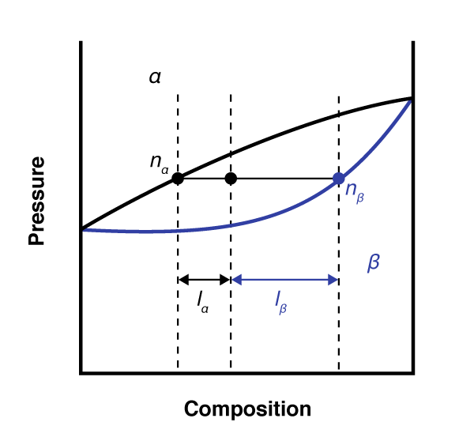
J

$\frac{n_{L}}{n_{V}}=\frac{I_{a}}{I_{β}}$ Eq. 7.6 Lever Rule

Temperature-dependent, multi-component phase diagrams
- When plotted against T instead of P, both the bubble point and dew point lines are curved. See figure 7.10.
  - The positions of the two lines are also switched.

Fractional Distillation
- If you set up a binary l/l system in a way that allows you to condense the vapor phase, what would the composition of the condensate be?
  - It would match the vapor! Once this “new liquid” is formed, it immediately establishes a new equilibrium with its vapor
    - This process can be repeated until the mole fraction of one of the components is lowered to 0, and a pure phase can be obtained. Each extraction/condensation step is called a theoretical plate.
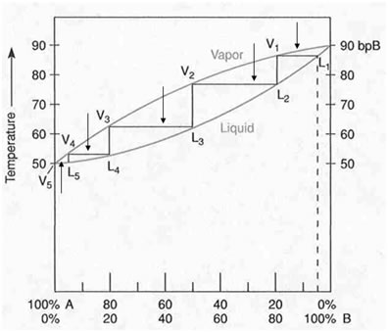

Partial Molar Volume
- Although 1 mol of a pure substance occupies a certain volume at some T,P, in a mixture, its partial molar volume can be very different depending on how the molecules pack together.
  - Ex. Adding 1 mole of water to a large volume of water increases the volume by 18 mL. Adding 1 mole of water to a large volume of ethanol increases the volume by 14 mL.
  - The total volume of a l/l solution is :
$V=n_{A}\overline{V_{A}}+n_{B}\overline{V_{B}}$ Eq. 7.7
  - In a mixture, the molar volume of a component is dependent on both temperature and mole fraction

Nonideal Liquid Solutions
- Liquid solutions are not ideal because$∆_{mix}V≠0$.
  - It is important to note that the molecules of a liquid interact differently with other liquids than they do with themselves. These interactions, which are ignored by Raoult’s law, lead to significant deviations from the predicted properties
    - Deviations can be positive or negative
      - Positive Deviations
        - In this instance, the true vapor pressure is higher than what is predicted by Raoult’s law. This means that the boiling point is lower.
        - This is due to the fact that the attractions between liquid A and liquid B are weaker than the interactions of A with A or B with B. The figure below shows a two component system.
        - Unlike an ideal plot, the BPL and DPL touch in the non-ideal model.
          - At this point, the liquid and vapor have the same mole fraction, and the system acts like a single component called an azeotrope. For a positive deviation from Raoult’s law, the boiling point of the solution is a minimum value, which is very close to the boiling point of the more volatile component.

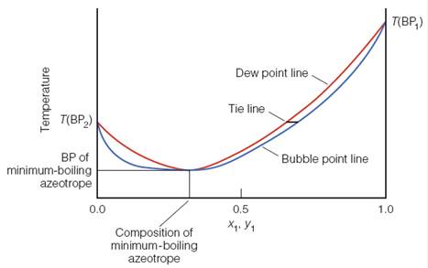
      - Negative Deviations
Vapor
Liquid
        - In this instance, the true vapor pressure is lower than what is predicted by Raoult’s law. This means that the boiling point is higher.
        - This occurs when the attractive forces between liquids A and B are greater than those of A with A, or B with B
        - The boiling point of the azeotrope is closer to that of the less volatile component.
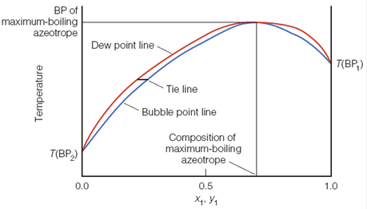

As the tie lines move from one composition to another, eventually either a pure compound is reached, or an azeotrope composition. Once an azeotrope is reached, there will be no further change in the composition of the vapor, and no further separation of the components.

Henry’s Law
- Gases dissolve in liquids. Raoult’s law does not apply to l/g solutions.
  - The amount of a gas that can be dissolved in a liquid is directly proportional to its vapor pressure above the liquid at low mole fraction by Henry’s constant, K
$P_{i}=K_{i}x_{i}$ Eq. 7.8 (7.31) Henry’s Law

  - The value of K is an intrinsic property of the gas. The term x_{i} is the mole fraction of gas in the liquid/gas solution.
  - Ex. 7.9 on page 200

Liquid/Solid
- What happens to a solution of a dissolved solid in liquid solvent when the solvent begins to freeze?
  - As the liquid freezes, its pure solid phase forms. The volume of the remaining liquid becomes increasingly concentrated with the solute. This increase in concentration continues until the solution becomes fully saturated.
  - Further concentrating causes simultaneous precipitation of the solute and solidification of the solvent.
  - The saturated solution can be considered to be in equilibrium with the pure solvent and pure solute
Solute(s) + Solvent (L) ⇌ Solute (solv)

    - At this equilibrium, the chemical potential of the pure solute is equal to that of the dissolved solute. We can use thermodynamics to approximate the solubility of the solute in a given solvent.

$ln{ x}_{solute}=-\frac{∆_{fus}H}{R}\left(\frac{1}{T}-\frac{1}{T_{MP, solute}}\right)$ Eq. 7.9 (7.39) Approximation of solubility in l/s

Ex. #7.10 in chapter

Solid/Solid
- Many solids are actually solutions. Ex. Stainless steel
- When a l/l solution reaches a freezing point, a pure solid phase begins to form. At this point, the system becomes analogous to the l/s system described previously, in which the remaining liquid becomes increasingly concentrated
- As this proceeds, the freezing point becomes depressed. Imagine a phase diagram like that shown in figure 7.21. for two liquids having different freezing points.
  - Starting from either end of the diagram, each pure component becomes increasingly unpure and the MP/FP drops. This curve represents a l/s boundary.
  - Where the curve meets, the substances acts as a single phase, like an azeotrope. Both substances freeze simultaneously.
    - The solid will have the exact same composition as the liquid from which it formed.
    - This is called a eutectic composition, and it forms only at the eutectic temperature.
    - This allows for metallic compounds to melt at very low temperatures!! Ex. Solder

Colligative Properties
- The properties of solutions are different from those of the pure solvent. We can consider the colligative properties of a solution, which include the following:
  - Vapor pressure
  - Boiling point
  - Freezing point
  - Osmotic pressure
    - What makes colligative properties interesting is that they are affected only by the amount of solute, not by the chemical identity of the solute.

- We have already discussed how vapor pressure is affected by the presence of solute. This is described mathematically by Raoult’s law

- A pure liquid has a well-define boiling point. If a nonvolatile solute is added, those molecules will impede the ability of the solvent molecules to escape from the liquid phase (as described previously regarding vapor pressure depression). As a result, more energy is required to make the solvent boil. This is called boiling point elevation.
- Similarly, nonvolatile solutes also make it harder for the solvent to crystallize upon freezing. Solute molecules simply do not fit well into the crystal structure of the solid solvent. The thermal energy of the solvent molecules needs to be lowered substantially in order for the intermolecular forces to facilitate crystallization. This is called freezing point depression.
  - Both the boiling and freezing point of a liquid are dependent on the vapor pressure. We can evaluate this thermodynamically by considering the chemical potential.
  - We can calculate the chemical potential of the solvent in the solution as:
$$μ_{i}\left(l\right)= μ_{i}^{o}\left(l\right)+RT{\ln{x}}_{i}$$
- Then, the difference in potential between the “impure” solvent and the pure (*) solvent is given by:
$$μ_{i}\left(l\right)-μ_{i}^{*}\left(l\right)=\left(μ_{i}^{o}\left(l\right)+RT{\ln{x}}_{i}\right)-\left(μ_{i}^{o}\left(l\right)+RT{\ln{a}}_{i}\right)=RT\ln{x_{i}}$$

- Because the solid solute does not appear in the gas or solid phase of the solvent, the chemical potentials of those phases are unaffected by the presence of the solute. Thus, we can see that the impact of the lowering of the vapor pressure of the liquid solvent by the solute is a reduction of the chemical potential by an amount RT ln xi, which is independent of the nature of the solvent.

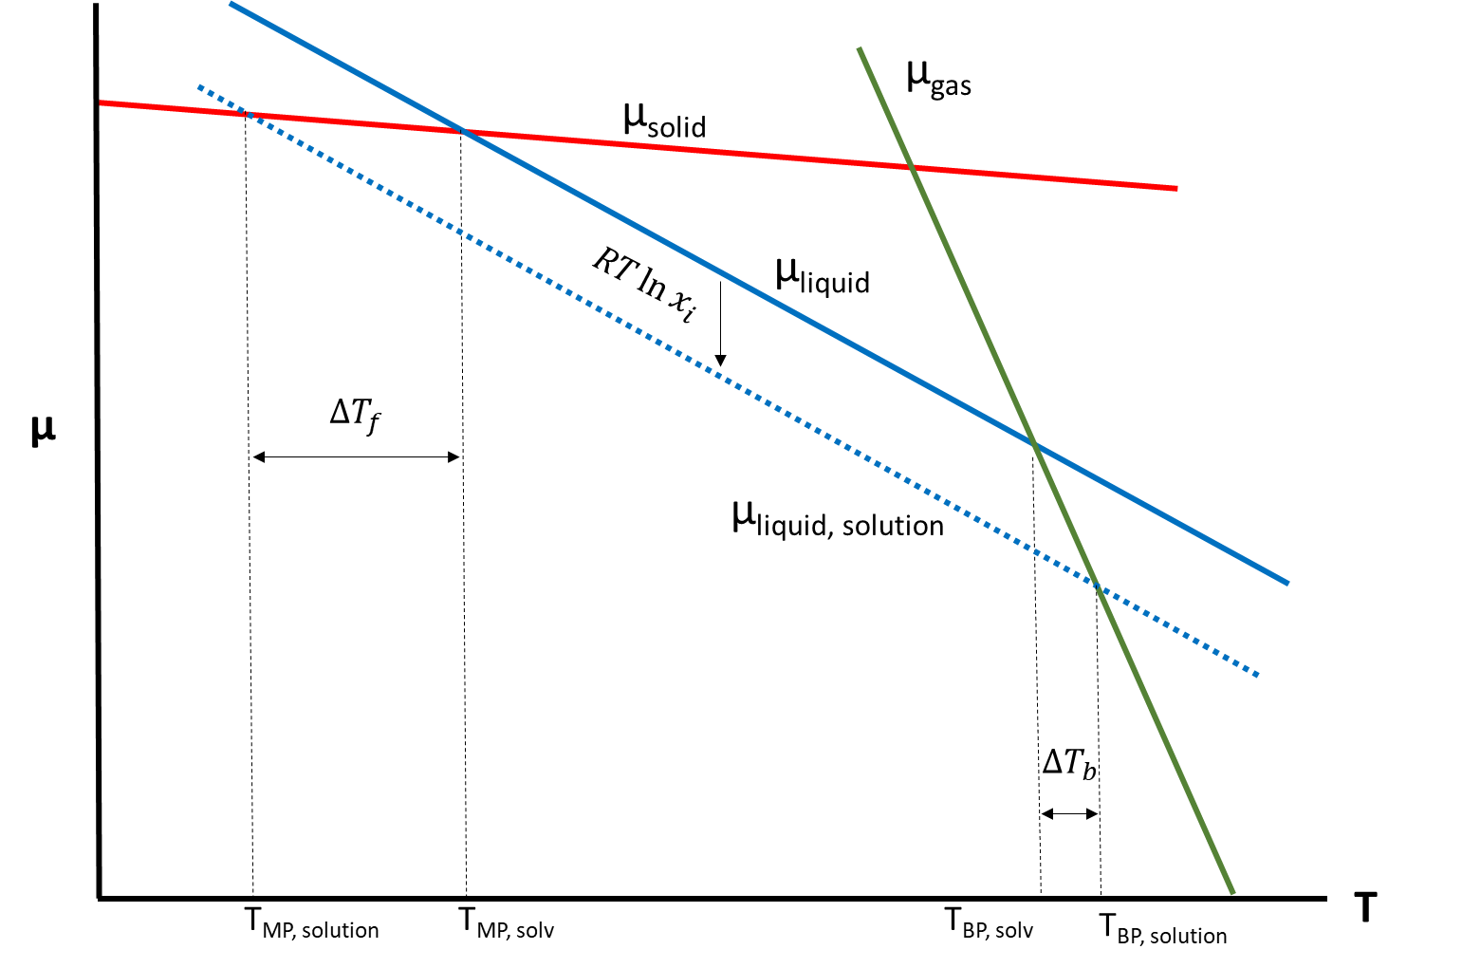

- The magnitude of the freezing point depression is greater than that of the boiling point elevation.
- We can quantify these shifts in boiling/freezing temperature:
$∆T_{b}= \frac{M_{solv} RT_{BP}^{2}}{ ∆_{vap}H}im_{solute}$ Eq. 7.10a (7.49) Boiling Point Elevation

$∆T_{f}= \frac{M_{solv} RT_{MP}^{2}}{ ∆_{fus}H}im_{solute}$ Eq. 7.10b (7.47) Freezing Point Depression

- In eq 7.10, M is the molar mass in kg/mol, m is the molality of the solute, and i is the Van’t Hoff factor which is equal to the number of ionic fragments of the solute that form upon dissolving (ex. MgCl₂, i=3). The fraction term in each equation can be represented as a constant K_{b} or K_{f} (boiling point elevation constant or freezing point depression constant)

- Consider a system constructed in two parts that are separated by a semipermeable membrane. One side is filled with pure solvent, the other with a solution. This membrane has the capability of allowing solvent molecules across, but not solvent.
  - The mole fraction of solvent molecules is higher on the pure solvent side. This gradient forces solvent to flow spontaneously across the membrane into the solution side. The entropy of mixing increases as the solute concentration on the solution side increases.
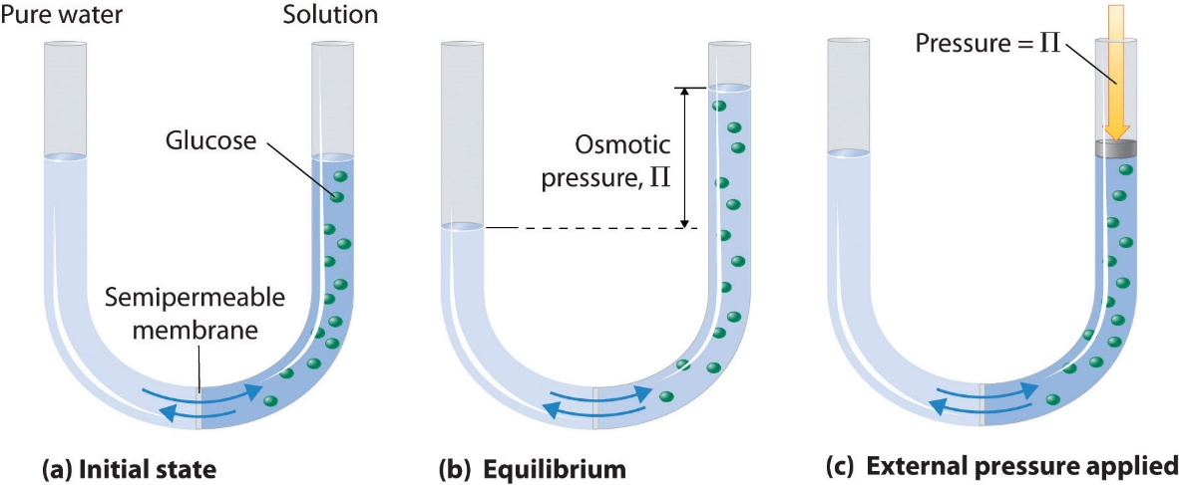

  - Solvent will flow until the chemical potentials of the two sides are equal. Recall from previous chapters that G becomes increasingly positive as pressure increases. As solvent flows across the membrane, as some point, the increased weight, or pressure, of fluid on the solution side prevents further flow of solvent. At this point, ΔG=0 because the flow of solvent is no longer favorable in any direction. This pressure is called osmotic pressure, П
    - Therefore, it is possible to prevent the flow of solvent altogether by applying the osmotic pressure externally.
    - This also means that applying a pressure higher than П to the solution side can reverse the direction of flow, separating the solvent from the solute. This is called reverse osmosis.
$Π V_{m, solv}={ix}_{solute}RT$ Eq. 7.11 (7.56) Osmotic pressure

- Ex. 7.15
  - In this example, we see that the osmotic pressure of this sample is 0.248 bar. This equals nearly 3.6 lbs/in². For a solution have a molality of only 0.01m, this is an incredible amount of pressure.
    - Ex. Seawater. Humans can’t drink saltwater because it actually dehydrates you! The osmotic pressure of seawater is massive, and would cause the cells to shrivel.

