Chemical Equilibrium

- Chemical equilibrium is the point during the course of a reaction where there is no further net change in the composition of the system
  - Very few systems are actually at equilibrium (e.g. biochemical processes)
    - So why do we study equilibrium? The thermodynamics of a system in an equilibrium can be used to as a basis to analyze non-equilibrium system
    - For any reaction, the reactant species change form to become products. Recall, we defined the change in Gibbs free energy with respect to amount as the chemical potential:
$$μ_{i}={\left(\frac{∂G}{∂n}\right)}_{T,P}$$

- But how far does a reaction proceed? We can define the extent of reaction, ξ
$ξ= \left|\frac{n_{i,t}-n_{i, 0}}{v_{i}}\right|$ Eq. 5.1 (5.1) Extent of reaction
  - where n_{i,0} is the initial moles of species i, n_{i,t} is the moles remaining after time t, and v_{i} is the stoichiometric coefficient of the species in the balanced reaction.

- Ex. 6H₂ (g) + P₄(s) 4PH₃ You have 2 mol of P₄. It is allowed to react completely in excess H₂, what is ξ?
$$ξ=\frac{2-0 mol}{1}=2 mol$$
- The value of ξ is the same no matter which species we reference. If we use H₂:
$$2 mol P_{4} used x \frac{6 mol H_{2}}{1 mol P_{4}}=12 mol H_{2} used$$
$$ξ=\left|\frac{n_{H_{2},t}-n_{H_{2}, 0}}{v_{i}}\right|=\left|\frac{{(n}_{H_{2},0}-12)-n_{H_{2}, 0}}{6}\right|=2 mol$$

- When a reaction proceeds, n_{i} obviously changes. We can express dn_{i} in terms of the extent:
$dn_{i}=v_{i}dξ$ Eq. 5.2 (5.2)
  - Recall, at constant T, P
$dG= \sum{μ_{i}}dn_{i}$ = $\sum{μ_{i}}v_{i}dξ$
$\left(\frac{dG}{dξ}\right)=$ $\sum{μ_{i}}v_{i}$ Eq. 5.3a (5.3)
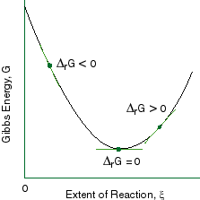
- For a system at equilibrium, we require dG=0. Thus, the expression above would also equal 0 at equilibrium. The derivative in eq. 5.3 is known as the Gibbs Energy of reaction, Δ_{rxn}Gº.

- At some extent of reaction, the Gibbs energy of reaction reaches a minimum. Consider a reaction aA ⇌ bB. Based on our equation, the Gibbs energy should change linearly from the Gibbs energy of pure A to that of pure B. So, why do we see a parabolic dependence on ξ ?
  - As reactants become products, a mixture forms. There is a Gibbs energy of mixing, similar to the entropy of mixing discussed in chapter 3. Mixing is always spontaneous:
$∆_{mix}G=RT \sum{n_{i}\ln\left(\frac{n_{i}}{n_{tot}}\right)}$ Eq. 5.4 Gibbs Energy of mixing

- The contribution of this term leads to the parabolic character of the curve

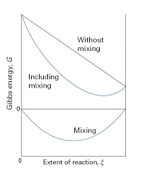
- Going back to our reaction, we can write Δ_{rxn}Gº as:
$\left(\frac{dG}{dξ}\right)=$ $\sum{μ_{i}}v_{i}= {bμ}_{B}-aμ_{a}$
  - The reactant term is negative because the moles of reactant decrease as the reaction proceeds. Recall that for the change in chemical potential:
$$∆μ=RT\ln\left(\frac{P_{F}}{P_{i}}\right)$$
  - If we let the initial state be at some standard pressure, we can denote this standard state using a symbol º. Then, the value of the chemical potential at this standard pressure Pº is µº.
$μ= μ^{o}+RT\ln\left(\frac{P}{P^{o}}\right)$ Eq. 5.5 (4.57)
$$∆_{rxn}G=b\left(μ_{B}^{o}+RT\ln\left(\frac{P_{B}}{P^{o}}\right)\right)-a\left(μ_{A}^{o}+RT\ln\left(\frac{P_{A}}{P^{o}}\right)\right)$$
$∆_{rxn}G=\left(bμ_{B}^{o}-{aμ}_{A}^{o}\right)+RT\ln\left(\frac{{\left(\frac{P_{B}}{P^{o}}\right)}^{b}}{{\left(\frac{P_{A}}{P^{o}}\right)}^{a}}\right)=∆_{rxn}G^{o}+RT\ln{Q}$ Eq. 5.5 (5.7)
- Eq 5.5 once again illustrates the usefulness of state functions. We can determine the change in the Gibbs energy of a system going to equilibrium from a non-standard standard state by adding the term (RT ln Q) to the value of the free energy change of a system going to equilibrium from a standard state. Here, the term Q is the reaction quotient, expressed in terms of partial pressures. The standard pressure is 1 bar. Thus, by dividing every partial pressure by the standard pressure, the value of Q is made unitless.

  - Δ_{rxn}Gº can be generalized as:
$∆_{rxn}G^{o}=\sum{∆_{f}G_{prod}^{o}-\sum{∆_{f}G_{prod}^{o}}}$ Eq. 5.6 (5.8) Calculation of Gibbs Energy of reaction
    - Here, Δ_{f}Gº represents the Gibbs energy of formation (these values are listed in the appendix), which is the free energy change when one mole of a substance is created from its base elements at 1 bar (thus, elements have Δ_{f}Gº values of 0).

- We must differentiate between Δ_{rxn}G and Δ_{rxn}Gº. Δ_{rxn}G can have an indefinite number of values depending on the exact conditions of the system at a given point in time. Δ_{rxn}Gº is the change in free energy between the products and reactants when both are in their standard states of pressure, phase, temperature, etc., and the value of Δ_{rxn}Gº for any given reaction is a fixed value. In other words, we calculate Δ_{rxn}G for any process that takes place under non-standard conditions.
  - Class Example: Ex. 5.4
  - For a system in equilibrium, we can manipulate eq 5.5 by setting Δ_{rxn}G = 0:
$$0=∆_{rxn}G^{o}+RT\ln{Q}$$
$$∆_{rxn}G^{o}=-RT\ln{Q}$$
    - At equilibrium, we define a characteristic value of Q called the equilibrium constant, which we denote as K
$∆_{rxn}G^{o}=-RT\ln{K}$ Eq. 5.7 (5.10) Calculation of K using Δ_{rxn}Gº
- The value of K gives insight into the extent of a reaction towards equilibrium. Large values of K indicate large extent, meaning that the equilibrium composition of the system is mostly products, and visa versa. We can easily show that, in terms of K and Q that equation 5.5 can be rewritten as:
$∆_{rxn}G=RT\ln\left(\frac{Q}{K}\right)$ Eq. 5.8 Determining the direction of shift toward equilibrium

    - Eq 5.8 is a useful tool because it allows you to determine which direction a reaction will shift to reach equilibrium from some non-standard state represented by Q. If the Gibbs energy of reaction is negative, then the reaction is spontaneous in the forward direction, and visa versa. A process is always spontaneous in the direction going towards equilibrium.
    - Remember that a reaction can never stop (3rd law of thermodynamics), so at some minimized value of G, the reverse process must proceed with equal kinetics to the forward one to ensure that the composition of the system remains constant.
      - Thus, the equilibrium state should be considered as the state of maximized disorder, leading to minimized free energy.

- Class example: Ex. 5.4
- K is used to calculate the extent of reaction on the path towards equilibrium.
  - Group Ex. 5.5
  - Group Ex. 5.6

Condensed Phases
- Up to this point, we have expressed Q and K in terms of pressures. Keep in mind that fugacities should be used for real gases.
  - However, solids, liquids, and dissolved solutes do not have significant pressures. So how do we represent them?
  - We introduce a new term called activity, a_{i}. We can consider it to be a concentration-version of fugacity. Like gases, other phases of matter exhibit non-ideal behavior that must be corrected for mathematically.
  - We can revisit our expression for the change in chemical potential, but in terms of activity:
$$μ_{i}=μ_{i}^{o}+RT ln⁡(a_{i})$$
    - Gases: $a_{i}=\frac{f}{P^{o}}$
    - Condensed phases: $a_{i}=1$ Eq. 5.9 (5.14) Activity of L/s phase

- Class example: Ex 5.7
  - You should see from this example that even at a pressure that is 100x normal atmospheric pressure, the activity of a liquid barely changes. We can reasonably expect that, for a solid, the change would be even more negligible.
    - For solids and liquids: a = 1

- For aqueous solutes, the activities are sensitive to concentration. We relate the activity to the molality of the solution:
  - Aqueous phases: $a_{i}=\frac{γ_{i}m_{i}}{m_{i}^{o}}$ Eq. 5.10 (5.15) Activity of aqueous solute
    - In the expression above, m is the molality of the solute, γ is the activity coefficient, and mº is the standard molality (1 mol/kg). At very low concentrations, γ = 1.
    - For a reaction aA + bB ⇌ cC + dD, the reaction quotient can be expressed as:
$Q= \frac{a_{C}^{c}a_{D}^{d}}{a_{A}^{a}a_{B}^{b}}$ Eq. 5.11 Reaction quotient of condensed phases
- Class ex. Write an expression for the equilibrium constant of the following:
2H₂O(L) + 4NO(g) + 3O₂(g) ⇌ 4H⁺(aq) + 4NO₃⁻(aq)

$$Q=\frac{{\left(\frac{γ_{H^{+}}m_{H^{+}}}{m^{0}}\right)}^{4}{\left(\frac{γ_{{NO_{3}^{-}}^{+}}m_{{NO}_{3}^{-}}}{m^{0}}\right)}^{4}}{{\left(1\right)}^{2}{\left(\frac{f_{NO}}{P^{o}}\right)}^{4}{\left(\frac{f_{O_{2}}}{P^{o}}\right)}^{3}}$$

Temperature dependence of K
- K values are temperature dependent! The Van’t Hoff equation relates K to the system temperature and the standard enthalpy change:
$\frac{∂\ln{K}}{∂ \left(\frac{1}{T}\right)}=\frac{-∆_{rxn}H^{o}}{R}$ Eq. 5.12a (5.19) Van’t Hoff equation

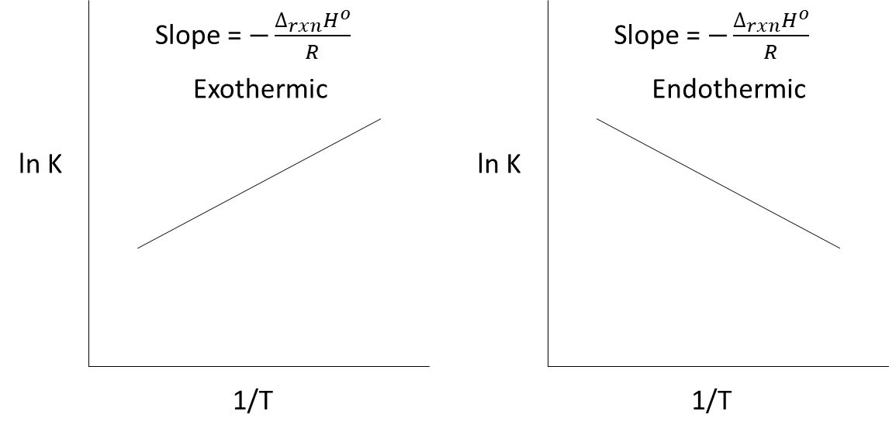
  - We see that, for exothermic reactions, K decreases with temperature, whereas for endothermic reactions, K increases with temperature. This is essentially the basis of LeChatlier’s principle, which will be discussed in the next section. We can expand the Van’t Hoff equation in order to determine the value of K at some new temperature T₂ from some initial K value at T₁:
$\ln\left(\frac{K_{2}}{K_{1}}\right)=\frac{∆_{rxn}H^{o}}{R}\left(\frac{1}{T_{1}}-\frac{1}{T_{2}}\right)$ Eq. 5.12b (5.20) Expanded Van’t Hoff eq.

    - **Class Ex. N₂O₄ (g) ⇌ 2NO₂ (g)
Calculate the value of the equilibrium constant for the given reaction at 100ºC.
DO I HAVE VALUES OF B’??

LeChatlier’s Principle
- For a system at equilibrium, any change to the system that disturbs the equilibrium will be offset by an opposing shift of the reaction to re-establish equilibrium
  - Ex. Going back to the Van’t Hoff relationship, let’s consider an endothermic process. By definition, an input of heat is required to drive an endothermic process, so we can treat heat as a reactant: Rxt + heat ⇌ prod
    - Increasing T essentially adds more heat, which disrupts the equilibrium. Therefore, according to LeChatlier, the reaction shifts rapidly to the right to initiate the formation of more products, which consumes the added heat.
    - Going back to our previous example of N₂O₄ (g) ⇌ 2NO₂ (g), what would happen if we compressed the system to half the original volume isothermally?
      - Both pressures would double.
      - K stays the same because ΔT = 0.
      - $K=\frac{{(P_{NO_{2}})}^{2}}{(P_{N_{2}O_{4}})}$
        - The numerator should increase at a faster rate than the denominator because K depends on the square of the numerator. In order for K to remain constant, the system must shift left to reduce the partial pressure of the product and increase the pressure of the reactant. In general, for a gas phase reaction, a decrease in volume (isothermally) causes the equilibrium to shift toward the side with less gas molecules, and an increase in volume causes a shift toward the side with more gas molecules.
        - Group ex. Problem 5.50

