CHEM123x Biochemistry Structures
Use any resource at your disposal to answer these questions. Please bring this work to class on Feb. 10th.
In this exercise, my goal is to walk you through how to think about biological molecules. In class, we did not have time to explore all of this together (which was my plan). Please give yourself sufficient time to work through this material and see me early and often for guidance.
- Draw a Lewis structure for each of these food/nutrition related molecules:

CO₂ (a product of fermentation) H₂O (….pretty much everything)

NO₃⁻¹ (nitrate – the building block of “nitrates”)

CH₃CHO (Acetaldehyde – the stuff hangovers are made of) – the two carbons are linked together. The 2nd carbon is bonded to the H and O.

CH₃CO₂H (you know it as the “vinegary taste) – The 2nd carbon has both oxygens bonded to it.

- Each of the structures below show a building block of a biological polymer. Deconstruct each molecule to show how the atoms combine to form bonds –please show all electrons in your work. An example is given.

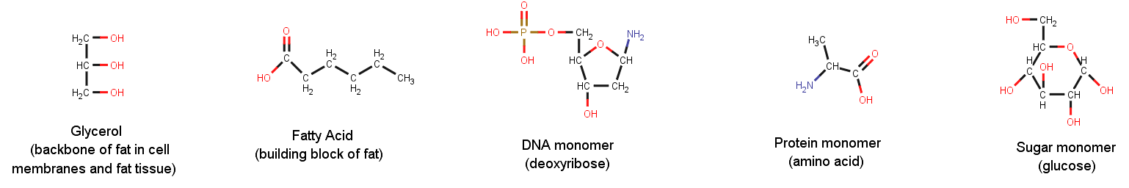
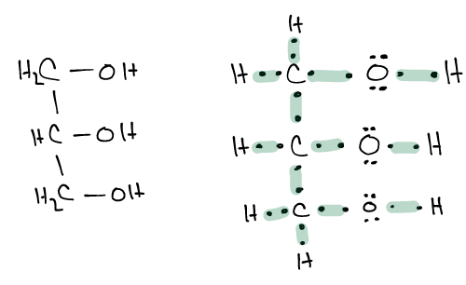
Example: Glycerol

- Molecules are commonly shown in “stick” form. This is a “lazy chemist” strategy to more quickly depict the structure of organic molecules. Since all organic molecules are built from carbon and hydrogen (and usually a lot of carbon and hydrogen atoms), these atoms are abbreviated. Hydrogen atoms are not shown if they are bonded to a carbon. Carbon atoms are shown as the end or bend in a line. The resulting structure is a bunch of lines with “heteroatoms” (anything that is not carbon or hydrogen) shown.

Please convert each of the structures in problem 2 to stick renderings. An example is given.
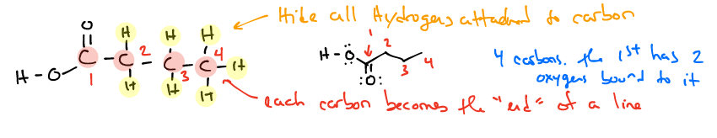
Please convert each of the following stick renderings to a complete Lewis dot structure. Glycerol is shown as an example.
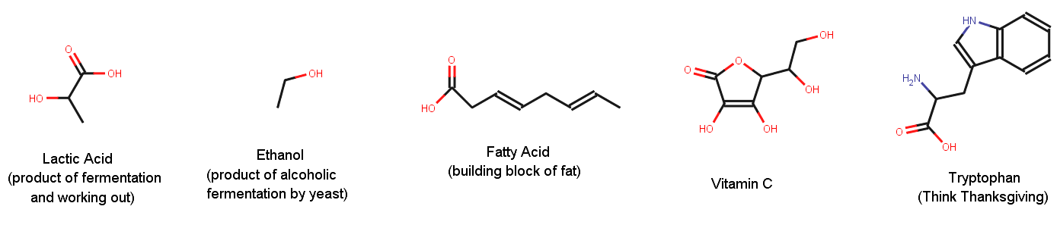
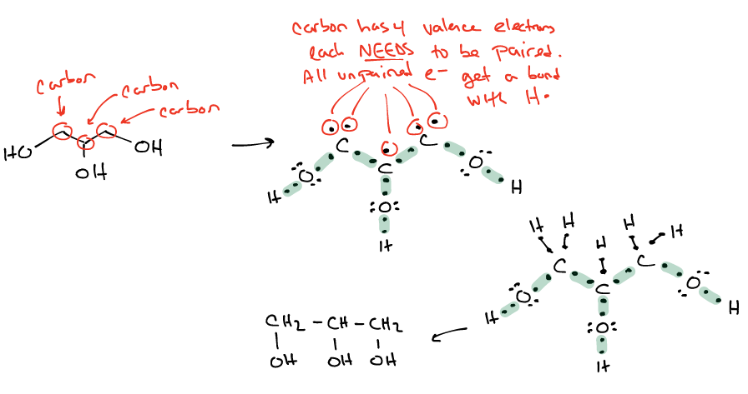

- As discussed in class, condensation reactions form the basis for the formation of most biopolymers. These reactions are named “condensation” because they generate H₂O as a product. In this exercise, you are shown the reactants and products. Your task is to identify which atoms in the reactants form a bond in the products. Additionally, show where all atoms in the water come from. An example is shown with two sugars (glucose and fructose) combining to form a disaccharide (sucrose). You are encouraged to redraw the stick rendering as a Lewis dot structure if it helps you.

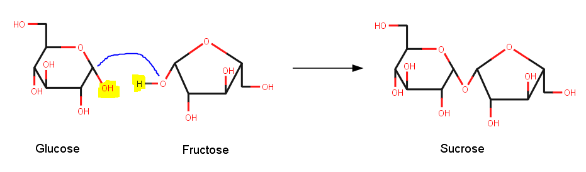
Water comes from here
Bond Forms Here

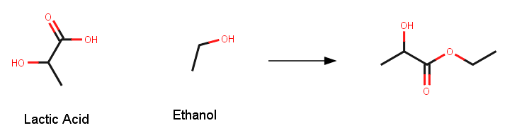

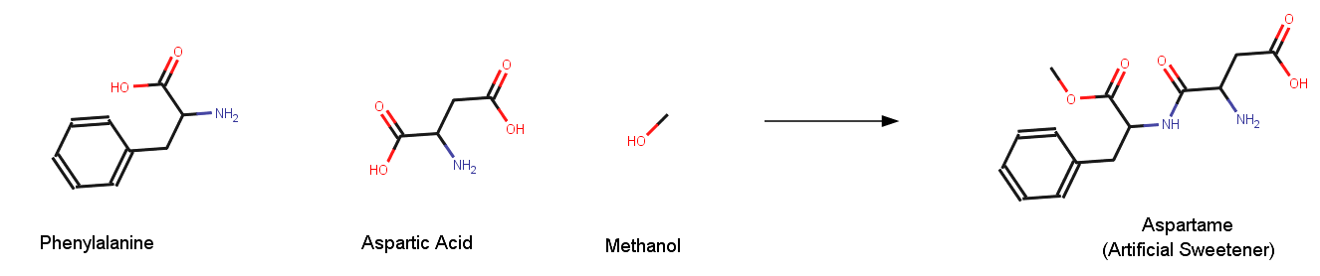

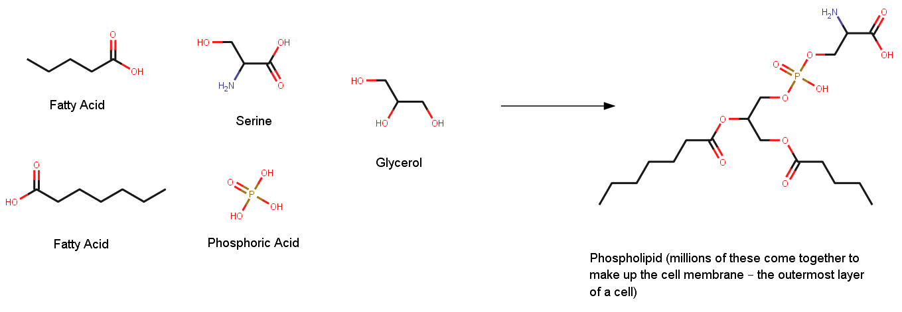

- Amino acids all have the same backbone: H₂N-CH-CO₂H. Several amino acids are used in problem 3 and 4. Name all four of these molecules.

